Zig Zag AFM Protocol Reveals Hidden Intermediate Folding States of Bacteriorhodopsin

Michael A. Nash ^{1,2}

¹ Institute for Physical Chemistry, Department of Chemistry, University of Basel, 4058 Basel, Switzerland
² Department of Biosystems Science and Engineering, ETH Zurich, 4058 Basel, Switzerland

NEW AND NOTABLE

Membrane proteins play a crucial role in cellular systems, performing diverse tasks including transport, signal transduction, surface adhesion and catalysis. Although ~30% of the proteins encoded by the human genome are either transmembrane or monotopic membrane proteins, the majority of pharmaceutical compounds are targeted toward membrane proteins simply because they are much more accessible than intracellular targets. Despite the importance of membrane proteins, our ability to study them with high-resolution quantitative methods has severely lagged behind those for globular soluble proteins. An article appearing in this issue of the Biophysical Journal by Jacobson et al.¹ represents a significant breakthrough on this front by demonstrating the ability to characterize membrane protein folding intermediate states with the atomic force microscope (AFM) at unprecedented resolution.

Membrane proteins are by their very nature amphiphilic molecules that exist at the interface. According to Wolfgang Pauli, “God created the bulk, but the interface is the work of the devil!” Amphiphilicity is unfortunately a necessary evil for membrane proteins that complicates structural characterization methods such as X-ray crystallography or solution NMR. Most membrane proteins are not soluble. They are not easily produced and purified from recombinant expression hosts, and hydrophobic regions can hinder crystallization. Convoluted strategies are used to coax membrane proteins into solubility, such as the use of detergents, or protein nanodiscs with embedded lipids. Consequently, only a fraction (<3%) of structures in the protein databank represent membrane proteins. In recent years cryo-electron microscopy has begun to bridge this gap, but alternative advanced methods for structural and functional characterization of membrane proteins are urgently needed.

Jacobson et al. combine three methodological improvements in a single-molecule force spectroscopy (SMFS) experiment with an atomic force microscope (AFM) that enabled them to identify new intermediate unfolding states in one of the most well-studied membrane proteins to date, the light-driven proton pump bacteriorhodopsin^{2,3} (Figure 1a). Their improvements included: (1) increasing occupancy time of folding intermediate states using a zig zag AFM protocol; (2) measuring forces with high precision and temporal resolution through the use of custom micromachined cantilevers; and (3) controlling mechanical loading coordinates and pulling from internal residues using site-specific biorthogonal attachment chemistry.

Like membrane proteins, AFM cantilevers are perfectly suited to work at hydrophobic-hydrophilic interfaces. What is typically a bug for other measurement modalities, the preference of membrane proteins for interfaces, becomes a feature when merged with the capabilities of the atomic force microscope to probe biomolecules at interfaces. SMFS is a measurement mode used with an AFM where single protein molecules are stretched between a surface (or biological membrane) and a force-transducing cantilever tip (Figure 1b). By calibrating the spring constant of the AFM cantilever, and controlling the position to within a fraction of a nanometer, experimentalists routinely observe folding/unfolding transitions of single protein molecules or even single secondary structural elements under ambient conditions in biological liquids. Simplifying assumptions about the observed transitions allow the application of theoretical models that researchers use to reconstruct the underlying free energy landscape governing protein folding, revealing mechanistically how these proteins perform their functions.

To understand the zig zag protocol described by Jacobson et al., it is worth noting the various measurements modes used in AFM-SMFS. Some of the earliest work⁴ used constant speed mode (Figure 1c), where the distance between the cantilever base and the surface (Figure 1b, z(t)) is increased at a constant rate. Constant speed mode is robust to small perturbations and instrument drift, and the data follow predictions of the force-extension behavior of entropic spring models for polymer elasticity such as the worm-like chain model. Alternatively to distance, the force signal can be used as a control variable in the AFM protocol. Force clamp and force ramp pulling protocols⁵ (Figure 1c) are implemented by measuring the difference between the force at a given time t and a set point chosen by the experimenter. This difference signal is then used in a feedback loop. If the current force is too low, the cantilever is actuated to move the probe further away from the surface, thereby increasing tension. If the force is too high, the cantilever is moved closer to the surface such that with high temporal precision, the protein feels constant tension. Force clamp and force ramp may be slightly more cumbersome to implement because feedback loop parameters must be tuned correctly, and instrument drift can be problematic, especially if long clamping times are desired. However, data analysis is simplified because one need only measure the dwell time distributions of the height plateaus to obtain energy landscape parameters.

Jacobson et al. now firmly establish the zig zag as an alternative AFM pulling protocol (Figure 1c, bottom). Similar to constant speed mode, the distance z(t) is used as the control parameter. The cantilever is moved in a biased zig zag pattern that gradually increases the distance between the surface and cantilever base in a manner analogous to the cliché ‘two steps forward, one step back’. Indeed periodic cantilever trajectories have been previously used^{6,7}, but here they used a much finer scale of motion (6-10 nm ramps) and low frequency (10 Hz.).

The advantage of this approach in resolving intermediate folding states can be understood by conceptualizing an energy landscape containing high and low energy barriers in series. If there exists a small barrier delineating a rare intermediate folding state immediately adjacent to a larger barrier delineating a primary intermediate state, then the existing modes of AFM operation will often miss the rare intermediate state as the systems jumps over the two barriers at once. Imagine jumping off a cliff with a parachute. Of course you wouldn’t notice the small ledge just below the top of the cliff as you fly past. By reversing direction, and tilting the energy landscape back, you can repopulate the rare intermediate by approaching it from the other side under a negative loading rate. If you climb back up the cliff, you will surely stop at that ledge for a moment and perhaps notice it for the first time.

But the zig zag protocol alone did not solve this problem. Enhanced force precision and temporal resolution were also necessary. This was achieved through the use of custom ultrashort (L=9 µm) cantilevers modified with a focused ion beam (FIB) to resemble the shape of a war hammer⁸. These cantilevers have low viscous drag and achieve 8.5-µs temporal resolution and sub-pN stability over 100 s, building on a series of cantilever innovations contributed in prior years by the same research group.

Finally, they implemented site-specific bioconjugation to control the loading geometry and pick up bacteriorhodopsin at the same residue every time. The nature of force as a vector and not a scalar quantity means molecular systems deform under mechanical load in very different ways depending on the geometric configuration through which force is applied. We need to grab the molecule in order to apply force, but what is the best way to grab a protein? The standard polyprotein approach applies tension to small globular domains between their N- and C-terminus. Site-specific linkage has in the past allowed controlling the loading geometry for receptor-ligand complexes⁹. For membrane proteins, grabbing a specific transmembrane loop can greatly enhance the information one obtains from such experiments. Indeed, the field should strive to bring the era of non-specific molecular pick-up procedures to an end.

Through this impressive combination of methodological innovations, Jacobson et al. were able to identify 31 distinct intermediate folding states in bacteriorhodopsin. To be fair, innovations are often accompanied with limitations, and one should be mentioned. The use of covalent attachment chemistry provides a stable linkage, but unfortunately it is irreversible. With a radius of curvature of ~5-10 nm, the number of molecules attached to the AFM tip is small (typically <10). This means that each cantilever is only useable for 5-10 force curves, after which the cantilever can be plasma cleaned and reused. However, this limits the throughput of the method. In general throughput is a persistent problem in AFM-SMFS experiments and future work addressing this limitation would be highly regarded in the community.

In the future, it will be exciting to see how new innovative methods in AFM-SMFS can enhance our measurement capabilities and provide in depth information on previously unobserved folding states, particularly for clinically relevant membrane proteins that could influence the development of biological therapeutics. For now, the community can appreciate this combination of a zig zag AFM pulling protocol, micromachined cantilever, and bioorthogonal site-specific attachment chemistry in enhancing our understanding of intermediate folding states in bacteriorhodopsin.

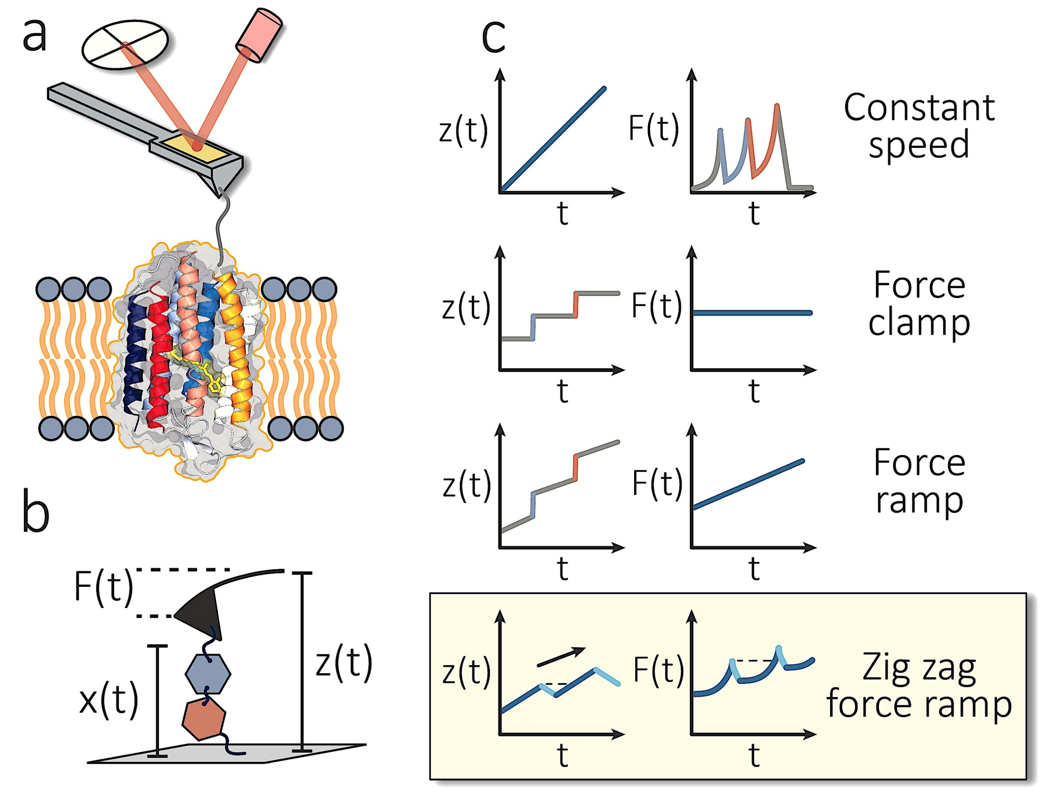
Figure 1. Innovations in AFM-SMFS. (a) Depiction of the experiment by Jacobson et. al. A modified cantilever in the shape of a warhammer is used to site-specifically pick up bacteriorhodopsin membrane proteins and pull the transmembrane helices one by one out of a supported lipid bilayer. The bioorthogonal site-specific attachment point is adjacent to a protease cutting site and enables pulling the membrane protein from a specific transmembrane helix. (b) Diagram showing the control parameters in an AFM-SMFS setup. F, force; z, distance; x, molecular extension; t, time. (c) Measurement protocols for AFM-SFMS. In constant speed, the distance parameter (z(t)) is increased at constant rate. In force clamp, feedback is used to hold the force value (F(t)) constant. In force ramp, the force is increased at constant rate. Jacobson et al. report a novel zig zag protocol which periodically ramps the distance parameter (z(t)) up and down with amplitudes of 6-10 nm and frequencies of 10 Hz.

REFERENCES
(1) Jacobson, D. R.; Uyetake, L.; Perkins, T. T. Membrane-Protein Unfolding Intermediates Detected with Enhanced Precision Using a Zigzag Force Ramp. Biophysical Journal 2019.
(2) Yu, H.; Siewny, M. G. W.; Edwards, D. T.; Sanders, A. W.; Perkins, T. T. Hidden Dynamics in the Unfolding of Individual Bacteriorhodopsin Proteins. Science 2017, 355 (6328), 945–950.
(3) Oesterhelt, F.; Oesterhelt, D.; Pfeiffer, M.; Engel, A.; Gaub, H. E.; Müller, D. J. Unfolding Pathways of Individual Bacteriorhodopsins. Science 2000, 288 (5463), 143–146.
(4) Rief, M.; Gautel, M.; Oesterhelt, F.; Fernandez, J. M.; Gaub, H. E. Reversible Unfolding of Individual Titin Immunoglobulin Domains by AFM. Science 1997, 276 (5315), 1109–1112.
(5) Oberhauser, A. F.; Hansma, P. K.; Carrion-Vazquez, M.; Fernandez, J. M. Stepwise Unfolding of Titin under Force-Clamp Atomic Force Microscopy. Proc. Natl. Acad. Sci. U. S. A. 2001, 98 (2), 468–472.
(6) Kessler, M.; Gottschalk, K.-E.; Janovjak, H.; Muller, D. J.; Gaub, H. E. Bacteriorhodopsin Folds into the Membrane against an External Force. J. Mol. Biol. 2006, 357 (2), 644–654.
(7) Janovjak, H.; Müller, D. J.; Humphris, A. D. L. Molecular Force Modulation Spectroscopy Revealing the Dynamic Response of Single Bacteriorhodopsins. Biophys. J. 2005, 88 (2), 1423–1431.
(8) Edwards, D. T.; Faulk, J. K.; LeBlanc, M.-A.; Perkins, T. T. Force Spectroscopy with 9-Μs Resolution and Sub-PN Stability by Tailoring AFM Cantilever Geometry. Biophys. J. 2017, 113 (12), 2595–2600.
(9) Ott, W.; Jobst, M. A.; Schoeler, C.; Gaub, H. E.; Nash, M. A. Single-Molecule Force Spectroscopy on Polyproteins and Receptor–Ligand Complexes: The Current Toolbox. J. Struct. Biol. 2016, 197 (1), 3–12.

