DOI: 10.1002/ ((please add manuscript number))

**Article type: Full Paper**

Investigation of horseradish peroxidase kinetics in an “organelle like” environment

Patric Baumann, Mariana Spulber, Ozana Fischer, Anja Car, Wolfgang Meier

Dr. P. Baumann, Dr. M. Spulber, Dr. O. Fischer, Dr. A. Car, Prof. Dr. W. Meier

Department of Chemistry, University of Basel, Klingelbergstrasse 80, 4056 Basel, Switzerland

E-mail: wolfgang.meier@unibas.ch

Keywords: nanoreactor, enzyme kinetics, macromolecular crowding, encapsulation efficiency

In order to mimic cell organelles, we have investigated artificial nanoreactors based on polymeric vesicles with reconstituted channel proteins (OmpF), and co-encapsulated enzymes horseradish peroxidase (HRP) along with a crowding agent (Ficoll or PEG) inside the cavity. Importantly, the presence of macromolecules has a strong impact on the enzyme kinetics, but no influence on the integrity of vesicles up to certain concentrations. This particular design allows for the first time the determination of HRP kinetics inside nonreactors with crowded milieu. The values of the Michaelis-Menten constant (Km) measured for HRP in a confined space (encapsulated in nanoreactors) in the absence of macromolecules are ~50 % lower than in free conditions, and the presence of a crowding agent resulted in a further pronounced decrease. These results clearly suggest that activities of enzymes in confined spaces can be tuned by varying the concentrations of crowding compounds. The present investigation represents an advance in nanorector design by considering the influence of environmental factors on enzymatic performance, and it demonstrates that both encapsulation and the presence of a crowding environment increase the enzyme-substrate affinity.

1. Introduction

In nature, activity and processes are optimized by separating different tasks into individual compartments, and in living cells compartmentalization involves organelles [1], such as nuclei, mitochondria or lysosomes. Organelles are separated from other cellular materials by a lipid bilayer. Mimicking such organelles is a major challenge, but necessary for better understanding the complexity of cellular environments [2].

Lipid bilayers can be synthetically mimicked by amphiphilic block copolymers [3, 4], and amphiphilic polymeric membranes can form vesicular structures called polymersomes with stabilities superior to those of lipid vesicles, [5-7]. Encapsulation of enzymes inside polymersomes leads to compartmentalization of enzymatic reactions if exchange of molecules (substrates and products) through the membrane is possible [8], and this can be accomplished by decorating the polymeric membrane with channel proteins that allow transport of molecules [9]. Controlling the permeability of polymeric membranes with channel proteins ensures that the enzyme does not leak out of the polymersome, whilst the enzyme substrate and the reaction product can passively diffuse through the membrane. Functional structures made of polymersomes containing membrane proteins and enzymes are called nanoreactors and can be regarded as the simplest type of artificial organelle. Simple artificial organelles based on polymersomes have been designed for enzyme replacement in therapeutic applications [1, 2, 10-12]. Inside polymersomes, enzymes are protected from degrading agents and their stabilities are improved [13, 14]. Furthermore, by measuring changes in the kinetic parameters (*Km* or *kcat*) it has been shown that the encapsulation of enzymes can enhance activity compared to the free enzymes [15]. However, all enzymes characterized inside polymersomes until now were analysed in buffer solutions containing inorganic salts, and did not consider that inside cells enzymes work in a very complex environment (the cytosol). Now we have expanded the artificial organelle concept and introduced a new component, namely a macromolecule to mimic the natural setting of an enzyme, to the simple artificial organelle based on polymersomes, enzymes and membrane channel proteins. In the present work this is based on nanoreactors made of poly(2-methyloxazoline)-*block*-poly(dimethylsiloxane)-*block*-poly(2-methyloxazoline) (PMOXA5-PDMS22-PMOXA5) polymer with outer membrane protein F (OmpF) as a gate and the enzyme horseradish peroxidase (HRP).

Furthermore, for a closer approach to real biological system, crowding agents were co-encapsulated to simulate a cellular environment, which is known to influence the enzyme kinetics [16, 17]. In a living system, enzymes are exposed to 200-400g/L of other macromolecules [18, 19] the cytosol contains various proteins, nucleic acids, and oligosaccharides, which influence on each other’s stability, mobility, and activity [17]. Highly soluble macromolecules, including Ficoll, polyethylene glycol (PEG), dextran, or proteins such as BSA are used to simplify and mimic the cytosol [17].

The Michaelis-Menten constant (Km) is a parameter that indicates the affinity of enzymes towards substrates. Since the presence of 100 g/L dextran has been shown to result in a decrease in Km for the oxidation of 2,2'-azinobis (3-ethylbenzothiazoline-6-sulfonic acid)-diammonium salt (ABTS) by HRP from 32 µM to 22 µM [16], the environment must not be neglected in studies of enzyme kinetics. This concept was also supported experimentally by determining the activity of HRP entrapped in the confined space of agarose hydrogels with different agarose concentrations [20]. However, entrapment in a hydrogel may influence the freedom of rotation or influence the structural changes during enzymatic reaction. Therefore, nanoreactors additionally containing a macromolecule (Figure 1) represent a more advanced simulation of the cellular environment than a hydrogel.

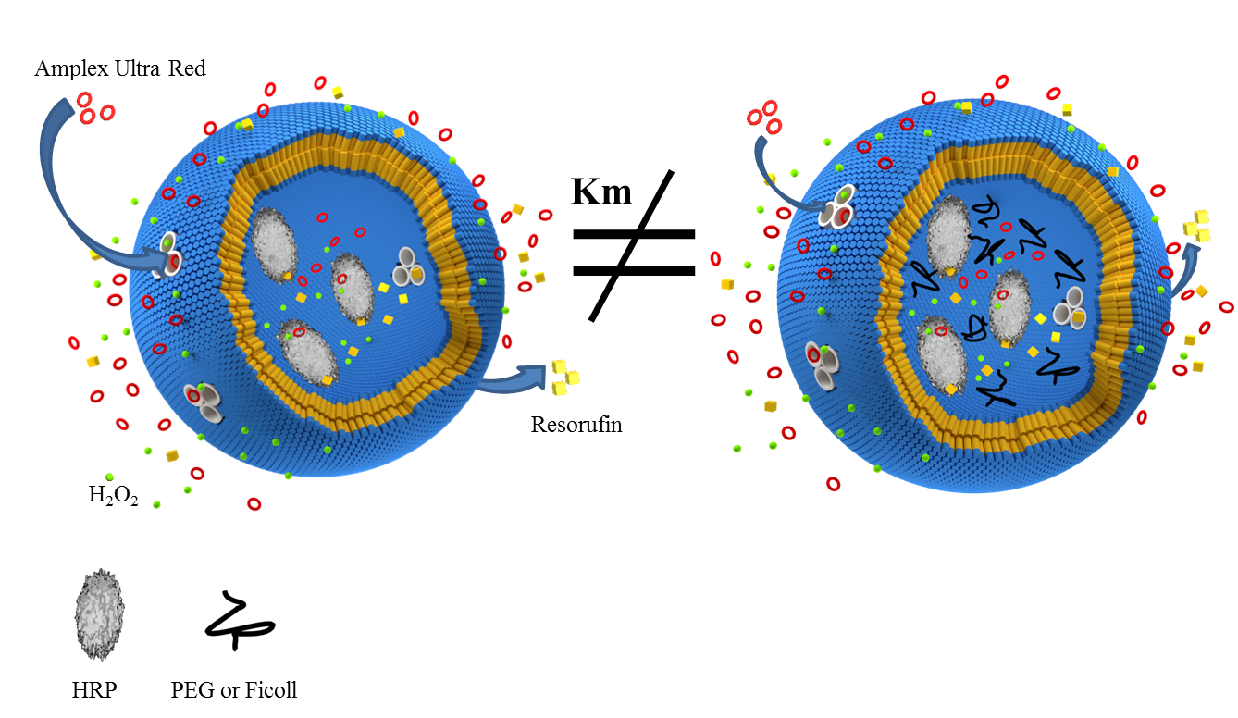

Figure 1: The concept of enzymatic reactions inside nanoreactors in presence of a crowding agent.

In this paper we describe for the first time an analysis of the enzyme activity inside nanoreactors in a crowded environment based on PEG or Ficoll, and compare it with the activity of the free (non-encapsulated) enzyme. The efficiency of crowding agent encapsulation was determined using electron paramagnetic resonance (EPR), whilst the HRP encapsulation efficiency was followed by fluorescence correlation spectroscopy (FCS). Within nanoreactors having diameters of around 200 nm we encapsulated three to four enzymes with an excess of crowding molecules, whilst reconstituted membrane proteins (OmpF) assisted the exchange of educts and products from the intra vesicular enzymatic reaction.

2. Result and Discussion

Ficoll PM70 and PEG 3000 were chosen as crowding agents, as both Ficoll and PEG are highly water-soluble and have already been used in several studies to mimic a crowded environment [17, 21]; additionally they do not self-react or inhibit the reaction of HRP with Amplex Ultra Red. Furthermore, due to the difference in molecular weights of the crowding agents, the effect of the excluded volume on enzyme kinetics can be observed. The concentration of the crowding agent (0-30 mg/mL) was chosen according to the limitation of vesicles formation in crowded aqueous solutions; higher crowding agent concentrations inhibit the self-assembly process of the nanoreactors.

HRP was chosen as model enzyme for the following reasons: it is well characterized in terms of structure and kinetic parameters [22], and it is often used in bio-sensing [16, 23] and biotechnological applications [24]. To measure the enzyme kinetics, Amplex Ultra Red was selected due to its sensitivity and independence of pH changes in the measured buffer (PBS pH 7.2). Additionally, Amplex Ultra Red (≈300 Da) is able to cross the membrane through the inserted channel protein (OmpF, cut-off 600 Da [25], and is oxidized by HRP to the fluorescent resorufin, a molecule that is able to diffuse out of the nanoreactor.

**2.1. Encapsulation Efficiency**

**2.1.1 Crowding agents**

By co-encapsulating the spin probe 5-doxyl stearic acid (5-DSA) together with the crowding agent, intravesicular concentrations of Ficoll or PEG were able to be determined *in situ* by EPR spectroscopy without modifying the crowding agent or destroying the nanoreactors. The EPR spectra of 5-DSA in 0.1 M NaOH, free PEG solution (with concentration of 60 mg/mL in water), in empty vesicles and in vesicles loaded with PEG are shown in Figure 2. Free 5-DSA in water shows a typical isotropic triplet with an aN value of 15.9 G, and g value of 2.008, which are similar to values reported in the literature [26], and no additional broad signal caused by aggregation. In the presence of 60 mg/mL PEG the EPR spectrum remained isotropic, with a hyperfine coupling constant aN of 15.7 G, and a gyromagnetic factor g of 2.008 indicating free rotation of the spin probe even in the presence of a high concentration of PEG, due to a better solubilisation of the spin probe, induced by the surfactant nature of PEG [27]. For 5-DSA encapsulated in empty vesicles, an anisotropic EPR pattern was obtained with the parallel and perpendicular hyperfine coupling constants well separated, and was simulated with co-axial g and hyperfine tensors. Hyperfine coupling constants Axx, Ayy of 2.3 G and Azz of 27 G and the values of the gyromagnetic tensor gx 2.008, gy 2.006 and gz 2.002 were determined by simulating the experimental spectrum with Bruker SIMFONIA in a third-order perturbation theory approach (with an error of 10%). The values of the EPR parameters are similar to that described in the literature for lipid bilayers [28], and indicate that the nitroxide spin probe is immobilized in the vesicles membrane on the timescale relevant for CW-EPR. 5-DSA encapsulated in PEG loaded vesicles produced a more complex signal that consisted of a superposition of an anisotropic EPR pattern associated with the entrapment in the membrane siloxane layer (see above), and an isotropic pattern similar to that observed in both 0.1 M NaOH and 60 mg/ml PEG solution. The isotropic component of the EPR spectrum is assigned to encapsulated 5-DSA in the aqueous compartment of the vesicles, and was further employed to determine the rotation correlation time (τc), corresponding to the PEG solution encapsulated in nanoreactors. Similar results (Axx, Ayy of 2.32 G and Azz of 27.1 G and the values of the gyromagnetic tensor gx 2.008, gy 2.0058 and gz 2.0019) were obtained for 5-DSA encapsulated in Ficoll loaded vesicles (see SI, FigureS1).

To measure the average concentration of the crowding agent inside the nanoreactors, τc was first determined from the EPR spectra of 5-DSA in PEG solutions in the range 0 - 30 mg/mL. This was calculated to be 0.77 nsec for 5-DSA in NaOH, which is similar to literature values [29], and in presence of PEG, τc increased linearly from 0.91 to 2.84 nsec as the PEG concentration was increased from 0.5 to 30 mg/mL. A standard curve was used for determining the PEG concentration inside nanoreactors (Figure 3a). τc for the 5-DSA in PEG-loaded polymer vesicles (for PEG initial concentration of 30 mg/mL) was determined to be 2.27 nsec, and corresponds to an intra-vesicular PEG concentration of 21 mg/mL (Figure 3a).

Similar experiments were performed using 20 and 10 mg/mL PEG during film rehydration and formation of the vesicles, and these gave τc values for 5-DSA encapsulated in the nanoreactors of 1.79 nsec and 1.19 nsec, respectively. These values correspond to final concentrations of encapsulated PEG of 13.3 mg/mL and 4.1 mg/mL, respectively for the starting solutions with 20 and 10 mg/mL PEG (Figure 3a).

A similar approach was used to produce a standard curve for the variation of τc for 5-DSA in presence of Ficoll in the range 0.5-50 mg/mL (Figure 3b). With a starting Ficoll concentration of 30 mg/mL, τc for 5-DSA in Ficoll loaded polymer vesicles was calculated to be 1.25 nsec, and corresponds to a Ficoll concentration of 9.3 mg/mL. The values for τc of 5-DSA in nanoreactors loaded with starting concentrations of 10 and 20 mg/mL Ficoll were 0.93 and 0.97 nsec, and correspond to local Ficoll concentrations of 2.1 and 2.8 mg/mL, respectively. Thus the encapsulation efficiency (EE%) was in the range 14 - 31 % for Ficoll and 41 - 70 % for PEG. The standard curves are not linear in the dilute regime as the differences in EPR in presence of low concentrations of crowding agent (up to to 1 mg/mL) in terms of spin probe rotation are very small. The dependence is linear in the presence of the higher concentrations of crowding agent (from 1 to 60 mg/mL), where the concentration inside nanoreators was determined in this linear region so that no additional error in the crowding agent concentration determination is introduced.

2. 1.2 HRP

HRP was either encapsulated alone or together with a crowding agent. To determine the number of HRP molecules per nanoreactor, HRP was labelled with the fluorescent dye Oregon Green using a labelling kit. Following the protocol provided by the company, the degree of labelling was 0.7. The diffusion times of free dye, the labelled enzyme, and encapsulated labelled enzyme were measured with time FCS. Since the diffusion time is directly correlated with the Brownian motion of the fluorescent particles, labelled HRP and encapsulated fluorescent molecules show larger diffusion times than the free dye; the diffusion time increased from 48.8 µs for free Oregon Green to 256 µs for the labelled HRP. Nanoreactors containing HRP with and without crowding agent had the diffusion time up to approximately 2600 µs. The diffusion times were calculated using a three component fitting procedure, and showed that no minor populations of the free dye or labelled HRP were present after purification using size exclusion chromatography. The number of HRP per vesicle was calculated by comparing the brightness of the fluorescent components in the free dye and nanoreactors (SI, FigureS3, Table S1). In all cases (with and without crowding agent) the nanoreactors contained an average of 3-4 HRP molecules. Entrapment of the enzymes during self-assembly is a statistical process, and considering the low degree of labelling (0.7), it is possible that more than 3-4 enzymes co-exist in one nanoreactor. Additional errors associated to intermolecular interactions (quenching effects by aromatic amino acid residues) would not influence the HRP / vesicle concentration, since the brightness of labeled HRP (count per molecules) was compared to the brightness of the nanoreactors. Quenching effects that would influence the measurement would therefore have to come due to interaction of enzyme bound fluorophore with the polymer membrane, which is unlikely due to the steric hindrance of the enzyme macromolecule. Nevertheless, the number of HRP molecules per nanoreactor is in good agreement with other similar systems and labelled enzymes [30, 31].

The encapsulation efficiency of HRP compared to the starting concentration is between 9.7% and 11.2%. This is in the range typically found for PMOXA-PDMS-PMOXA based nanoreactors produced by film rehydration [31-33].

**2.2. Vesicle characterisation**

**Transmission electron microscopy (TEM)**

Vesicles with and without a crowding agent were imaged with a transmission electron microscope (Figure 4) to observe any structural changes in the nanoreactors as a result of the presence of crowding agents. However, no significant changes in the structure or size were observed for the empty and crowded nanoreactors; the average diameter of the vesicles being around 220 nm. The collapsed structures show that the interior of the nanoreactor was not completely filled. With a maximum concentration of 21 mg/mL PEG inside the nanoreactors only about 2 % w/v was occupied with the crowding agent, and the rest with buffer molecules.

**Dynamic and static light scattering (DLS/SLS)**

Dynamic and static light scattering measurements were performed for empty and Ficoll- or PEG-filled nanoreactors. Angle and concentration dependent SLS data were analyzed using Berry plots and used to determine the apparent molecular weight of self-assemblies (Mw), *Rg*, and the second virial coefficient (*A2*) of the polymersomes (Figure 5). A non-linear decay-time analysis supported by regularized inverse Laplace transform (CONTIN algorithm) was used to analyze the DLS data and to evaluate the apparent *Rh* of polymersomes. No significant differences in the light scattering data were observed, and the value of the ratio between *Rg* to *Rh* is close to 1 (Table 1), which indicates hollow spherical structures [34] as expected for similar PMOXA-PDMS-PMOXA-based block copolymers with reconstituted OmpF [31, 32, 35]. The sizes are slightly smaller than those observed from TEM images (Figure 4), possibly because of method preparation specific for electron microscopy where dry collapsed and immobilized structures are produced but overall they are in a good agreement with the DLS and SLS data obtained in solution. (Figure 5 and Figure S4).

The measured viscosity (Table 2) of the crowding agent allows calculation of the maximum number of macromolecules per nanoreactor: 21 mg/mL PEG (7 mM) corresponds to 48000 PEG molecules per nanoreactor, whereas 9.1 mg/mL Ficoll (130 µM) corresponds to 900 Ficoll molecules per nanoreactor (equation in SI). Compared with 3-4 HRP molecules per nanoreactor, these numbers of crowding molecules cannot be neglected when considering the enzyme kinetics. Although, the concentration of macromolecules in the cytosol is up to 10 times higher than calculated for our nanoreactors, the present system offers the possibility of investigating HRP kinetics in conditions closer to nature than in systems reported previously.

**2.3. Kinetic measurements**

To compare the enzymatic behaviour in free condition and compartmentalized environments (nanoreactors), the Michaelis-Menten constant Km (defined as ½ of Vmax) was determined. The Km value for free HRP reported in the Brenda database (the BRaunschweig ENzyme Database, an enzyme information system) is 81 µM for similar conditions [36]. It is shown that HRP kinetics measured in free conditions are strongly affected by a crowding environment. Km is influenced by the presence of Ficoll or PEG (Figure 6), and decreased from 55 µM for the free enzyme to 31 µM in the presence of 30 mg/ml of Ficoll and to 25 µM in case of PEG (at 30 mg/ml). In the concentration regime between 10 mg/ml and 30 mg/ml no pronounced of Km change as a function of crowding agent was observed. The Km obtained under encapsulation conditions lead to an additional decrease due to confinement of HRP in the polymersome`s cavity (25 µM). The presence of Ficoll or PEG caused an additional decrease in Km values with a similar trend compared to kinetic measurements performed with the enzyme in free conditions The lower values obtained for Km inside nanoreactors means that the enzyme-substrate affinity is almost doubled, because of the increased probability of reaction between enzyme and substrate when both are entrapped in a confined space [37]. In case of Ficoll, Km was decreased to about 10 µM, and for PEG to 5 µM. Thus the combination of the encapsulation technique and the presence of a crowding agent can tune the Km value and decrease it by an order of magnitude without making any changes at the molecular level of the enzymes. Furthermore, our present results show that the environment has a large influence on the kinetic behaviour of HRP, and both encapsulation and the presence of a crowding environment lead to an increase in enzyme-substrate affinity.

3. Conclusion

Macromolecular crowding is known to affect protein folding, interaction with nucleic acids, enzymatic activity, *etc.* in the cell. It is almost impossible to find a single protein-related feature that would not be affected by the presence of other macromolecules. Thus, macromolecular crowding is extremely important for proper functionality of a cell. To this end, HRP reaction kinetics of reactions in free conditions do not reflect the behaviour of the enzyme in biological systems. To function as in nature, enzymes need a confined space, substrate molecules, and an environment similar to that of the cytosol [38]. Our mimic of artificial organelles is based on a polymeric membrane, HRP enzyme and reconstituted membrane protein (OmpF). Nanoreactors were successfully produced by self-assembly of PMOXA-PDMS-PMOXA block-copolymers in crowded milieu with encapsulation concentration up to 21 mg/ml without changing their morphology. This particular design enables for the first time measurement of HRP kinetics inside confined space with co-encapsulated macromolecules, and show that the combined effect of encapsulation and the presence of a crowding environment inside artificial organelles lower the Michaelis-Menten constant values compared to free HRP or for HRP present in Ficoll or PEG solutions. Thus the HRP activity is dependent on the chemical structure and concentration of the crowding media.

This work represents the first example of polymeric structures that mimic cell-like organelles by taking into account the natural surroundings of enzymes. This artificial organelle can be further exploited for characterizing other enzymes in milieu similar to their native environments, and for testing the activities of engineered enzymes in near natural environments. Moreover, the activities of encapsulated enzymes can be tuned with the help of crowding agents, and represents a smart approach to improving enzyme kinetics, which is an important parameter in the design of artificial organelles for enzyme replacement therapy.

4. Experimental Section

Chemicals were purchased from Sigma-Aldrich at the highest purity available, and used without further treatment. Peroxidase, from horseradish (HRP) (Lot#090M77151V) type VI-A was used to perform the kinetic measurements, Octyl-POE was acquired from Enzo Life Science, Switzerland, and Oregon Green from Thermo Fischer Scientific.

**4.1. OmpF expression and extraction**

Expression and purification of the membrane protein OmpF was performed according to the protocol of Grzelakowski et al. [35]. Briefly, *E. Coli* was cultured at 37 °C in LB medium containing 100 µg/L ampicillin, and when OD600 reached 0.6 expression was induced with isopropyl-β-D-1-thiogalactopyranoside (IPTG) with a final concentration of 0.4 mM. After six hours, cells were harvested by centrifugation and resuspended in 20 ml Tris-HCl pH 8.0/g cell. The cells were disrupted using a French press (Avestin, Canada), and the mixture was centrifuged (60 min at 4 °C, 22000 rpm). The resulting pellet was dissolved in 20 mM phosphate buffer (pH.7.4) containing 0.125 % Octyl-POE) and incubated for 1 h at 37 °C. The membrane fraction was again centrifuged (60 min at 4 °C, 40000 rpm) and the pellet was resuspended in 20 mM phosphate buffer containing 3% Octyl-POE, and incubated for 1 h at 37 °C for OmpF extraction. In a final centrifugation step (40 min at 4 °C, 40000 rpm), the membrane fraction was separated from the solubilised OmpF, and the purity of the extracted protein was verified by SDS-acryl amide gel electrophoresis (12 %), (Figure S2)

**4.2. Nanoreactor formation**

The film rehydration method [39] was used to prepare vesicles with encapsulated HRP and reconstituted OmpF. In a 20 ml flask, 2 mg of PMOXA5-PDMS22-PMOXA5 polymer were dissolved in 0.5 mL EtOH. The flask was then connected to a Rotavap (Büchi, Switzerland) and EtOH was evaporated at 40 °C and 150 mbar for 30 min, and additionally for 10 min at 40 °C and 100 mbar to obtain a thin uniform polymer film on the bottom of the flask. To form nanoreactors, 1 ml pre-prepared PBS solution containing 2,6 µM OmpF and 4.5 µM HRP, with the crowding agent if needed, was stirred for 24 h at 4 °C. The activity of HRP is optimum at low temperature [40], and HRP was always freshly dissolved before nanoreactor formation to keep the time between dissolution and kinetic measurement below 48 h to avoid loss of activity of the enzyme. For comparison the kinetics for reaction of free HRP were measured after stirring the free enzyme solution for 24 h at 4 °C.

For EPR experiments 100 µM 5-DSA was additionally encapsulated in nanoreactors without OmpF. After nanoreactor formation the obtained solutions were extruded 11 times with a LiposoFast-Basic extruder (Avestin, Canada) through a 0.2 µm Nucleopore Track-Etch membrane from Whatman. The solution was then applied to a Sepharose 2B column and connected to an Äkta prime plus equipped with a UV detector (GE Healthcare, UK) to separate the vesicles from free HRP and crowding agent.

**4.3. Vesicle characterisation**

*4.3.1. TEM*

Solutions containing 10 µL of vesicles were negatively stained with 2 % uranyl acetate and deposited on a carbon-coated copper grid before examination with a transmission electron microscope (Philips Morgani 268 D) operated at 80 kV.

*4.3.2. Light scattering (DLS/SLS)*

An ALV goniometer (ALV GmbH, Germany) equipped with a linearly-polarized He-Ne laser (JDS Uniphase, wavelength λ=632.8 nm) was used to perform DLS and SLS experiments. Solutions of vesicles (1.0, 0.66, 0.5 and 0.4 mg mL-1) were measured in a 10 mm cylindrical quartz cell at scattering angels (*θ*) ranging from 30° to 150° at 293 ± 0.1 K using the ALV/Static & Dynamic FIT and PLOT program version 4.31 10/10. Static light scattering data were processed according to the Berry model [41].

The influence of crowding agent on the size polymersomes was additionally investigated with a Nano ZSP zetasizer (Malvern Instruments) equipped with a 10 mW He–Ne laser at a wavelength of 633 nm and a detection angle of 173°. The correlation functions were integrated using the CONTIN algorithm in order to obtain the intensity-averaged size distributions of the self-assemblies and polydispersity indices. The temperature during measurements was kept at 25.0 ± 0.1 °C. Typical DLS distribution curves are presented in SI (Figure S4).

*4.3.3. EPR measurements*

EPR measurements were performed on a Bruker CW EPR Elexsys-500 spectrometer. The spectra were recorded 298 K with the following parameters: 100 KHz magnetic field modulation, microwave power 2 mW, conversion time 61.12 ms, number of scans 20, resolution 2048 points, modulation amplitude 0.4 G, sweep width 100 G.

The 2*a*N values correspond to the distance (in Gauss) between the low-field and high-field lines of the motion averaged spectra (triplets), and the 2Azz values are measured as a distance between the last minimum and the first maximum (extreme separation) in the rigid limit spectra recorded for when the spin probe immobilized in vesicles. The relation to obtain the isotropic value for the nitrogen hyperfine coupling constant: *a*N = (Axx+Ayy+Azz)/3 (where Axx and Ayy are the other eigenvalues of the hyperfine tensor). Note that the two experimentally determined parameters (*a*N and Azz) are sensitive to the local polarity in the probe neighborhood: higher polarity leads to a higher spin density at 14N, so the hyperfine coupling increases [42]. The isotropic nitrogen hyperfine coupling constant (aN) was determined directly from the spectra with an error limit of 5%.

The microviscosity in the proximity of the nitroxide free-radical probe was determined by using the correlation time τc, (Eq. 1) which is related to the rotational reorientation of the probe:

$τ_{c }= 6.5*e^{-10}*{∆H}_{0}* \left\{\sqrt{\frac{I_{0}}{I_{+1}}}-1\right\}$ (1)

, where ΔH0 is the linewidth of the 0 transition, I0, I+1, I-1 are the peak to peak heights of the 0, +1 and -1 transitions [29].

*4.3.4. Control experiments*

In order to determine the dependence of τc for the spin probe on the concentrations of both PEG and Ficoll, we also measured a series of solutions containing 0.1 mM 5-DSA in 0.1 M NaOH, PEG solutions with 0.5 - 30 mg/mL, or Ficoll solutions with 0.5 - 50 mg/mL. Standard curves were produced showing the dependence of τc on PEG or Ficoll concentration.

*4.3.5. Fluorescence labelling of HRP*

HRP was labelled with the fluorescent probe Oregon Green according their protocol described in the Thermo Fischer Scientific 488 Protein Labeling Kit (O-10241) . The labelling efficiency was calculated according to the given protocol using the specific absorbance of HRP at 403 nm and the absorbance of Oregon Green at 496 nm measured using a Nanodrop 200c (ThermoScientific, USA) spectrophotometer.

*4.3.6. Fluorescence correlation spectroscopy (FCS)*

A Zeiss510/Confocor2 laser scanning microscope equipped with an argon laser (488nm) and a 40 x water-immersion objective (C-Apochromat 40X, NA 1.2) with a pinhole adjusted to 70 µm was used in FCS mode to measure separately at room temperature solutions of Oregon Green, labelled HRP, and vesicles encapsulating labelled HRP. FCS autocorrelation curves were recorded over 10 s and repeated 30 times. For the autocorrelation function and fitting, the LSM510/confocor software package version 4.2 SP1 was used; the structure factor and diffusion times of individually measured free dye and labelled HRP were fixed for the fitting procedure with the values measured. Counts per molecule from labelled HRP were compared to the count per molecule of HRP loaded polymersomes to give the average amount of HRP per nanoreactor (more details see supporting information).

*4.3.7. Kinetic measurement* [43]

Amplex ultra red (AR) (Invitrogen, US) was dissolved in DMSO to obtain a 10 mM stock solution. A 96-well microplate (BD Bioscience, US) was used to perform 8 parallel kinetics measurements for each substrate concentration. The wells were filled up to 200 uL with PBS containing nanoreactors with encapsulated HRP, AR (2, 4, 8 or 12 µM) and an excess of H2O2 (20 µM). The HRP kinetics were recorded at 25 °C with a SpectraMax M5e (MolecularDevices, US) measuring the fluorescence signal of AR (570nm/595nm) every 20 sec with intermittent shaking. To calculate of the Michaelis-Menten-constant (*Km*) the initial rate was determined by linear regression analysis of the slope (R2>0.99).

**Supporting Information**

Supporting Information is available from the Wiley Online Library or from the author.

Acknowledgements

The National Centre of Competence in Research “Molecular Systems Engineering” is acknowledged for financial support. The authors thank Prof. Cornelia Palivan (University of Basel) for useful discussions, Gabriele Persy (University of Basel) for TEM measurements and Gregor Ferk for artistic illustration of the concept.

Received: ((will be filled in by the editorial staff))  
Revised: ((will be filled in by the editorial staff))  
Published online: ((will be filled in by the editorial staff))



**Figure 2**. EPR spectra of 5-DSA in 0.1 M NaOH experimental (1) and simulated (2), in PEG 60 mg/mL aqueous solution experimental (2) and simulated (4), in self-assembled empty vesicles exprimental (5) and simulated (6), and in PEG containing vesicles experimental (7), simulated (8) obtained from isotropic component (9) and anisotropic component (10) in the proportions indicated in text.



(b)

(a)

**Figure 3.** Standard curve for the dependence between (a) PEG concentration and τc of dissolved 5-DSA, and (b) Ficoll concentration and τc of dissolved 5-DSA.

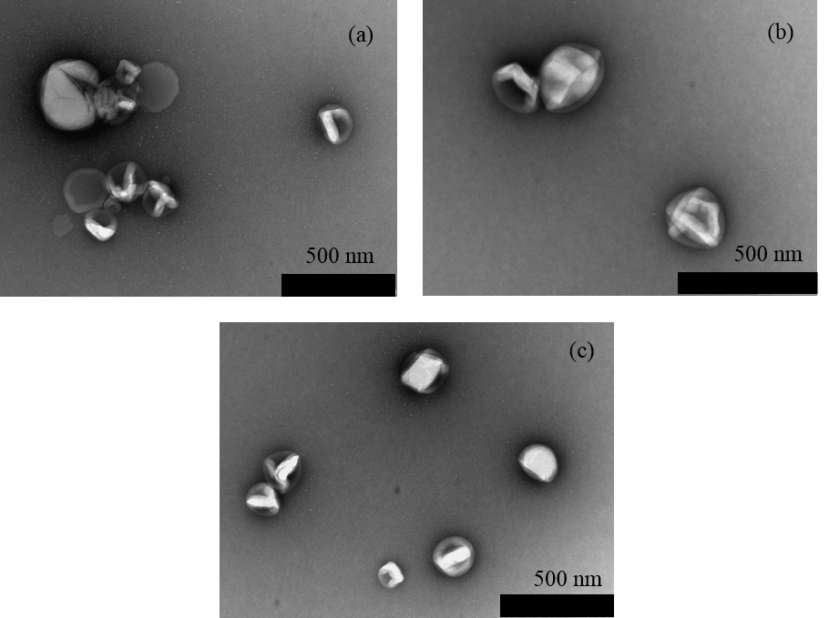

**Figure 4.** (a) TEM micrograph of empty nanoreactors, (b) TEM micrograph of nanoreactors prepared with 30 mg Ficoll/mL starting concentration and (c) TEM micrograph of nanoreactors prepared with 30 mg PEG/mL starting concentration

 

(b)

(a)

**Figure 5.** (a) Berry plot of nanoreactors prepared with 30 mg Ficoll/mL starting concentration. (b) DII plot of the same nanoreactors.



(b)

(a)

**Figure 6.** Michaelis-Menten constant of HRP in the presence of different (a) Ficoll concentrations (black) and encapsulated with different Ficoll concentrations (red) and (b) PEG concentrations (black) and encapsulated with different PEG concentrations (red). Lines added to guide the eye.

Table 1. Light scattering data for nanoreactors containing HRP in the presence of crowding agents.

|  |  |  |  |  |  |
| --- | --- | --- | --- | --- | --- |
|  | *Rg* (nm) | *Rh* (nm) | *Mw* g mol-1 | *A2* mol dm3g-2 | *Rg/Rh* |
| ABA empty | 144 | 136 | 1.55 x 109 | 5.35 x 10-10 | 1.05 |
| ABA 30 mg Ficoll | 145 | 136 | 1.24 x 109 | 4.98 x 10-10 | 1.07 |
| ABA 30 mg PEG | 146 | 141 | 1.52 x 109 | 5.36 x 10-10 | 1.04 |

Table 2. Crowding agent concentration (mg/mL) inside nanoreactors and its corresponding viscosity (m2s-1)

|  |  |  |  |  |  |  |
| --- | --- | --- | --- | --- | --- | --- |
| Starting concentration (mg/ml) | Viscosity Ficoll (m2s-1) | Viscosity PEG (m2s-1) | Ficoll concentration (mg/mL) | Viscosity  (m2s-1) | PEG concentration (mg/mL) | Viscosity  (m2s-1) |
| 10 | 1.018 | 1.022 | 2.2 | 0.932 | 4.1 | 0.942 |
| 20 | 1.129 | 1.158 | 2.8 | 0.938 | 13.3 | 1.067 |
| 30 | 1.240 | 1.293 | 9.3 | 1.010 | 21.0 | 1.171 |

Copyright WILEY-VCH Verlag GmbH & Co. KGaA, 69469 Weinheim, Germany, 2013.

Supporting Information

Investigation of horseradish peroxidase kinetics in an “organelle like” environment

Patric Baumann, Mariana Spulber, Ozana Fischer, Anja Car, Wolfgang Meier



**Figure S1.** EPR spectra of 5 DSA in Ficoll aqueous solution experimental (1) and simulated (2), and in Ficoll loaded polymeric vesicles, experimental (3), and simulated (4) obtained from the sum of the isotropic component (5) and anisotropic component (6).

HRP labelling

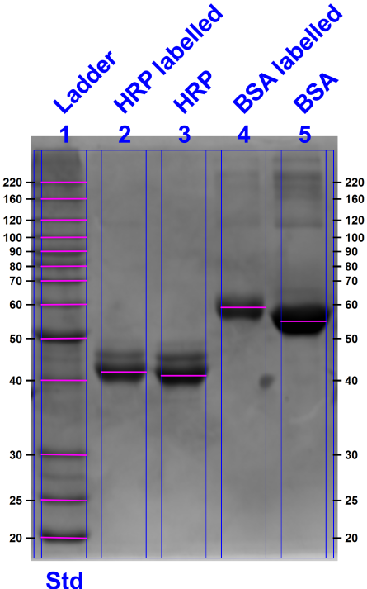

**Figure S2.** SDS Page of labelled HRP and BSA. In both cases the labelling caused a shift towards higher molecular weight. For HRP the shift is smaller due to the smaller degree of labelling.

Fluorescence correlation spectroscopy **(**FCS)



**Figure S3.** Normalized autocorrelation curves for nanoreactors loaded with labelled HRP, labelled HRP and free Oregon Green and the corresponding fitting curves.

Table S1. Data obtained from FCS measurement, where values marked with * are fixed, so that only one component could be determined per measurement.

|  |  |  |  |  |  |  |  |  |
| --- | --- | --- | --- | --- | --- | --- | --- | --- |
|  | Count rate [kHz] | CPM [kHz] | C1 [µs] | C1 % | C2 [µs] | C2 % | C3 [µs] | C3 % |
| Oregon green | 77 | 13.2 | 48.8 | 100 |  |  |  |  |
| Oregon Green in PEG | 77 | 15.2 | 53.2 | 100 |  |  |  |  |
| Oregon Green in Ficoll | 76 | 14.7 | 53.8 | 100 |  |  |  |  |
| HRP labelled | 22 | 10.7 | *48.8 | 70 | 265 | 30 |  |  |
| ABATH encapsulating labelled HRP | 18 | 36.5 | *48.8 | ≈0 | *265 | ≈0 | 2555 | 100 |
| ABATH Ficoll encapsulating labelled HRP | 26 | 39.0 | *48.8 | ≈0 | *265 | ≈0 | 2607 | 100 |
| ABATH PEG encapsulating labelled HRP | 8 | 36.5 | *48.8 | ≈0 | *265 | ≈0 | 2512 | 100 |

Number of HRP per vesicle

$\frac{{CPM}_{free dye}}{{DOL×CPM}_{nanoreactor}}=\#{HRP}_{per nanoreactor}$

Where the CPM (counts per molecules) for Oregon Green in absence and presence of crowding agent was taken and a degree of labelling (DOL) of 0.7.

# HRP per ABA nanoreactor: 3.95

# HRP per ABA nanoreactor co-encapsulating Ficoll: 3.79

# HRP per ABA nanoreactor co-encapsulating PEG: 3.43

EE% HRP

$$EE\%=\frac{100*\#HRP per NR}{C_{0}* N_{A}*V_{NR}}$$

where C0 is the initial concentration, NA Avogadro Number and VNR the volume of the nanoreactor.

EE% ABA nanoreactors: 11.2 %

EE% ABA nanoreactors co-encapsulating Ficoll: 10.7%

EE% ABA nanoreactors co-encapsulating PEG: 9.7%

Molecules per nanoreactor

$${\# {molecules}_{per nanoreactor} =C}_{NR}*N_{A}*V_{NR}$$

where C is the concentration inside the nanoreactor, NA Avogadro Number and VNR the volume of the nanoreactor.

**Figure S4.** Intensity-based DLS distribution curves of empty polymersomes and polymersomes in the presence of crowding agent.

1. Peters, R. J. R. W.; Louzao, I.; van Hest, J. C. M., *Chemical Science* **2012,** *3* (2), 335-342. DOI 10.1039/c2sc00803c.

2. van Dongen, S. F. M.; Verdurmen, W. P. R.; Peters, R. J. R. W.; Nolte, R. J. M.; Brock, R.; van Hest, J. C. M., *Angewandte Chemie-International Edition* **2010,** *49* (40), 7213-7216. DOI 10.1002/anie.201002655.

3. Discher, D. E.; Eisenberg, A., *Science* **2002,** *297* (5583), 967-973.

4. Marguet, M.; Bonduelle, C.; Lecommandoux, S., *Chemical Society Reviews* **2013,** *42* (2), 512-529. DOI 10.1039/c2cs35312a.

5. Kita-Tokarczyk, K.; Itel, F.; Grzelakowski, M.; Egli, S.; Rossbach, P.; Meier, W., *Langmuir* **2009,** *25* (17), 9847-9856. DOI 10.1021/la900948a.

6. Najer, A.; Wu, D.; Vasquez, D.; Palivan, C. G.; Meier, W., *Nanomedicine* **2013,** *8* (3), 425-447. DOI 10.2217/nnm.13.11.

7. Renggli, K.; Baumann, P.; Langowska, K.; Onaca, O.; Bruns, N.; Meier, W., *Advanced Functional Materials* **2011,** *21* (7), 1241-1259. DOI 10.1002/adfm.201001563.

8. Zhang, X.; Lomora, M.; Einfalt, T.; Meier, W.; Klein, N.; Schneider, D.; Palivan, C. G., *Biomaterials* **2016,** *89*, 79-88. DOI 10.1016/j.biomaterials.2016.02.042.

9. Einfalt, T.; Goers, R.; Dinu, I. A.; Najer, A.; Spulber, M.; Onaca-Fischer, O.; Palivan, C. G., *Nano Lett.* **2015,** *15* (11), 7596-7603. DOI 10.1021/acs.nanolett.5b03386.

10. Ben-Haim, N.; Broz, P.; Marsch, S.; Meier, W.; Hunziker, P., *Nano Letters* **2008,** *8* (5), 1368-1373. DOI 10.1021/nl080105g.

11. Tanner, P.; Balasubramanian, V.; Palivan, C. G., *Nano Letters* **2013,** *13* (6), 2875-2883. DOI 10.1021/nl401215n.

12. Onaca-Fischer, O.; Liu, J.; Inglin, M.; Palivan, C. G., *Current Pharmaceutical Design* **2012,** *18* (18), 2622-2643.

13. Axthelm, F.; Casse, O.; Koppenol, W. H.; Nauser, T.; Meier, W.; Palivan, C. G., *J. Phys. Chem. B* **2008,** *112* (28), 8211-8217. DOI 10.1021/jp803032w.

14. Langowska, K.; Palivan, C. G.; Meier, W., *Chem. Commun. (Cambridge, U. K.)* **2013,** *49* (2), 128-130. DOI 10.1039/c2cc36345c.

15. Ranquin, A.; Versees, W.; Meier, W.; Steyaert, J.; Van Gelder, P., *Nano Letters* **2005,** *5* (11), 2220-2224. DOI 10.1021/nl051523d.

16. Pitulice, L.; Pastor, I.; Vilaseca, E.; Madurga, S.; Isvoran, A.; Cascante, M.; Mas, F., *J Biocatal Biotransformation* **2013,** *2* (1). DOI <http://dx.doi.org/10.4172/2324-9099.1000107>.

17. Voepel, T.; Makhatadze, G. I., *Plos One* **2012,** *7* (6). DOI 10.1371/journal.pone.0039418.

18. Ellis, R. J., *Trends in Biochemical Sciences* **2001,** *26* (10), 597-604. DOI 10.1016/s0968-0004(01)01938-7.

19. Zimmerman, S. B.; Trach, S. O., *Journal of Molecular Biology* **1991,** *222* (3), 599-620. DOI 10.1016/0022-2836(91)90499-v.

20. Kunkel, J.; Asuri, P., *PLoS One* **2014,** *9* (1), e86785/1-e86785/6, 6 pp. DOI 10.1371/journal.pone.0086785.

21. Norris, M. G. S.; Malys, N., *Biochem. Biophys. Res. Commun.* **2011,** *405* (3), 388-392. DOI 10.1016/j.bbrc.2011.01.037.

22. Dunford, H. B. In *Horseradish peroxidase: structure and kinetic properties*, CRC: **1991**; pp 1-24.

23. Patel, A. C.; Li, S. X.; Yuan, J. M.; Wei, Y., *Nano Letters* **2006,** *6* (5), 1042-1046. DOI 10.1021/nl0604560.

24. Azevedo, A. M.; Martins, V. C.; Prazeres, D. M. F.; Vojinovic, V.; Cabral, J. M. S.; Fonseca, L. P., *Biotechnol. Annu. Rev.* **2003,** *9*, 199-247. DOI 10.1016/S1387-2656(03)09003-3.

25. Cowan, S. W.; Garavito, R. M.; Jansonius, J. N.; Jenkins, J. A.; Karlsson, R.; Konig, N.; Pai, E. F.; Pauptit, R. A.; Rizkallah, P. J.; Rosenbusch, J. P.; Rummel, G.; Schirmer, T., *Structure* **1995,** *3* (10), 1041-1050. DOI 10.1016/s0969-2126(01)00240-4.

26. Zhou, L.; Schlick, S., *Polymer* **2000,** *41* (12), 4679-4689. DOI 10.1016/S0032-3861(99)00605-9.

27. Witte, F. M.; Engberts, J. B. F. N., *J. Org. Chem.* **1988,** *53* (13), 3085-8. DOI 10.1021/jo00248a033.

28. Nakagawa, K., *Lipids* **2007,** *42* (5), 457-62. DOI 10.1007/s11745-007-3048-2.

29. Beghein, N.; Rouxhet, L.; Dinguizli, M.; Brewster, M. E.; Arien, A.; Preat, V.; Habib, J. L.; Gallez, B., *J Control Release* **2007,** *117* (2), 196-203. DOI 10.1016/j.jconrel.2006.10.028.

30. Onaca, O.; Hughes, D. W.; Balasubramanian, V.; Grzelakowski, M.; Meier, W.; Palivan, C. G., *Macromolecular Bioscience* **2010,** *10* (5), 531-538. DOI 10.1002/mabi.200900379.

31. Tanner, P.; Onaca, O.; Balasubramanian, V.; Meier, W.; Palivan, C. G., *Chemistry-a European Journal* **2011,** *17* (16), 4552-4560. DOI 10.1002/chem.201002782.

32. Langowska, K.; Palivan, C. G.; Meier, W., *Chemical Communications* **2013,** *49* (2), 128-130. DOI 10.1039/c2cc36345c.

33. Baumann, P.; Balasubramanian, V.; Onaca-Fischer, O.; Sienkiewicz, A.; Palivan, C. G., *Nanoscale* **2013,** *5* (1), 217-224. DOI 10.1039/C2NR32380J.

34. Pecora, R.; Aragon, S. R., *Chem. Phys. Lipids* **1974,** *13* (1), 1-10. DOI 10.1016/0009-3084(74)90037-1.

35. Grzelakowski, M.; Onaca, O.; Rigler, P.; Kumar, M.; Meier, W., *Small* **2009,** *5* (22), 2545-2548. DOI 10.1002/smll.200900603.

36. Glettenberg, M.; Niemeyer, C. M., *Bioconjugate Chemistry* **2009,** *20* (5), 969-975. DOI 10.1021/bc800558g.

37. Chen, Q.; Schoenherr, H.; Vancso, G. J., *Small* **2009,** *5* (12), 1436-1445. DOI 10.1002/smll.200801455.

38. Kuchler, A.; Yoshimoto, M.; Luginbuhl, S.; Mavelli, F.; Walde, P., *Nat. Nanotechnol.* **2016,** *11* (5), 409-420. DOI 10.1038/nnano.2016.54.

39. Battaglia, G.; Ryan, A. J., *Journal of Physical Chemistry B* **2006,** *110* (21), 10272-10279. DOI 10.1021/jp060728n.

40. Lu, S.; Wang, X.; Lu, Q.; Hu, X.; Uppal, N.; Omenetto, F. G.; Kaplan, D. L., *Biomacromolecules* **2009,** *10* (5), 1032-1042. DOI 10.1021/bm800956n.

41. Berry, G. C., *J. Chem. Phys.* **1966,** *44* (12), 4550-64. DOI 10.1063/1.1726673.

42. Ristori, S.; Maggiulli, C.; Appell, J.; Marchionni, G.; Martini, G., *J. Phys. Chem. B* **1997,** *101* (20), 4155-4165. DOI 10.1021/JP963745T.

43. Fruk, L.; Mueller, J.; Niemeyer, C. M., *Chemistry-a European Journal* **2006,** *12* (28), 7448-7457. DOI 10.1002/chem.200501613.