How do the properties of amphiphilic polymer membranes influence the functional insertion of peptide pores?
Andrea Belluati^{1&}, Viktoria Mikhalevich^{1&}, Saziye Yorulmaz Avsar¹, Davy Daubian¹, Ioana Craciun¹, Mohamed Chami², Wolfgang P. Meier¹*, Cornelia G. Palivan¹*
¹Department of Chemistry, University of Basel, Mattenstrasse 24a, BPR 1096, 4058 Basel, Switzerland
²BioEM lab, Biozentrum, University of Basel, Mattenstrasse 26, 4058 Basel, Switzerland
KEYWORDS
synthetic membranes, polymersomes, amphiphilic block copolymers, antimicrobial peptides, melittin insertion, membrane curvature, membrane permeability

&Authors with equal contribution

ABSTRACT
Pore-forming peptides are of high biological relevance particularly as cytotoxic agents, but their properties are also applicable for the permeabilization of lipid membranes for biotechnological applications, which can then be translated to the more stable and versatile polymeric membranes. However, their interactions with synthetic membranes leading to pore formation are still poorly understood, hampering the development of peptide-based nanotechnological applications, such as biosensors or catalytic compartments. To elucidate these interactions, we chose the model peptide melittin, the main component of bee venom. Here we present our systematic investigation on how melittin interacts with and inserts into synthetic membranes, based on amphiphilic block copolymers, to induce pore formation in three different setups (planar membranes, micrometric and nanometric vesicles). By varying selected molecular properties of block copolymers and resulting membranes (e.g. hydrophilic to hydrophobic block ratio, membrane thickness, surface roughness, membrane curvature) and the stage of melittin addition to the synthetic membranes we gained a deeper understanding of melittin insertion requirements. In the case of solid-supported planar membranes, melittin interaction was favored by membrane roughness and thickness, but its insertion and pore formation was hindered when the membrane was excessively thick. The additional property provided by micrometric vesicles, curvature, increased functional insertion of melittin, which was evidenced by the even more curved nanometric vesicles. Using nanometric vesicles, allowed us to estimate the pore size and density, and by changing the stage of melittin addition, we overcame the limitations of peptide-polymer membrane interaction. Mirroring the functionality assay of planar membranes, we produced glucose-sensing vesicles. The design of synthetic membranes permeabilized with melittin opens a new path toward the development of biosensors and catalytic compartments based on pore-forming peptides functionally inserted in synthetic planar or three-dimensional membranes.

INTRODUCTION
Biological membranes are essential complex boundaries that protect cellular components and control passive and active transport of ions or molecules through membrane proteins. Phospholipid- and amphiphilic block copolymer- based membranes have been introduced as models of biological membranes,^{1, 2} to understand how they interact with biomolecules or to support applications in water purification³ and biosensing.² The block copolymer-derived synthetic membranes, as planar membranes or boundaries of 3D compartments, are particularly appealing because they provide greater structural and mechanical stability compared to the phospholipid-based membranes due to a higher membrane thickness obtained from the macromolecular nature of the amphiphilic copolymers.^{4, 5} However, the increased stability of the compartment membranes limits their use for applications in which reactions have to take place in situ inside the cavity of these compartments because the molecular transport across the membrane is significantly decreased.⁶⁻⁸ Similarly, in the case of planar membranes, a high thickness might obstruct the insertion of proteins, which require a flexible environment in order to remain functional.⁹
When membranes must allow the flow of molecules, they are permeabilized using specific copolymers resulting in porous membranes,¹⁰ or responsive polymers that undergo conformational changes in the presence of external stimuli such as pH, temperature, and light,¹¹⁻¹³ or by addition of photosensitizers into the polymer membranes that become slightly more hydrophilic under light irradiation.^{14,15} While resulting in permeable membranes by inducing changes in their morphology to allow the diffusion of ions or molecules, these approaches do not allow a precise control of the size of the pores^{16, 17} or a permeability adjusted towards specific molecular species. A complementary approach to obtain synthetic membranes with a controlled permeability is to mimic cell membranes by insertion of biopores, protein channels or ion transporters.¹⁸⁻²⁰ Depending on the intrinsic properties of the biomolecules, their insertion in synthetic membranes of compartments can be achieved either by spontaneous insertion or by addition of the proteins stabilized in detergent, followed by a detergent removal using biobeads or dialysis.^{21, 22} While generally these methods for biopore/membrane protein insertion are similar for synthetic and lipid membranes, the conditions and associated difficulty of insertion in synthetic membranes arise from their difference in properties, such as the increased thickness and decreased fluidity.⁹ The advantage of using membrane proteins for permeabilization of membranes is based on the specificity of the biomolecule, such as a molecular cut-off (OmpF allows diffusion of the molecules up to 600 Da²³) or a chemical selection (aqpZ is a facilitator of water diffusion,²⁴ and TsX mediates the transport of nucleosides and nucleotides²⁵). The specific permeability achieved by insertion of biomolecules together with a control of the degree of permeability by the number of pores/membrane cannot be obtained with chemically permeabilized membranes.
To date, various membrane proteins (outer membrane protein F (OmpF),¹⁹ aquaporin Z (aqpZ),²⁶ nucleoside-specific protein (Tsx),²⁷ ferrichrome-iron receptor (FhuA),²⁸ glycerol facilitator (GlpF)²⁹ and proteorhodopsin (PR)³⁰) and biopores (gramicidin³¹ and alpha-hemolysin (αHL)³²) and DNA nanopores³³ have been functionally inserted in synthetic compartment membranes with flexible membranes overcoming the significant hydrophobic mismatch between the membrane thickness and size of the protein.³⁴ In the case of planar synthetic membranes, the insertion of membrane proteins (aqpZ³⁵ and the cyclic nucleotide-modulated potassium channel MloK1³⁶) or biopores (αHL³⁷) was possible only by prior destabilization of the membrane, and the conditions required for a functional insertion proved to be quite different than for their lipid counterparts. Inserting pores in polymer membranes is generally a difficult task due to the requirement to preserve the integrity and functionality of the biomolecule⁹ which, in some cases, is completely hindered by the membrane.³⁸ There are only scarce reports addressing the influence of specific synthetic membrane molecular properties on the insertion of biopores³⁸or membrane proteins,³⁴ mainly taking into account micrometer- and nanometer-sized vesicles but not planar membranes or the combination of different properties and types of membranes (planar, curved).
Here, we propose an integrative approach on the functional insertion of biopores in synthetic membranes, by investigating various molecular characteristics of the amphiphilic block copolymers (ratio between the hydrophilic and hydrophobic domains, copolymer dispersity, and block length), membrane properties (membrane thickness, roughness and curvature) and insertion conditions (before/after the formation of the membrane). In this respect we selected a small library of poly (2-methyl-2-oxazoline)-block-poly (dimethylsiloxane)-block-poly (2-methyl-2-oxazoline) (PMOXA_{x}-PDMS_{y}-PMOXA_{x}) triblock copolymers with different hydrophobic domain lengths and different mass ratios between the hydrophilic and the hydrophobic domains (f-fraction). Such copolymers have already been proven to allow functional insertion of biopores and membrane proteins up to a significant hydrophobic mismatch between the size of the biomolecules and the membrane thicknesses of vesicles (micron-sized vesicles, named giant unilamellar vesicles, GUVs³⁴ or nanometer-sized vesicles, usually named polymersomes).^{19, 38-40} We go into more details regarding the molecular factors affecting a successful biopore insertion by: I) looking at the curvatures of membranes, II) analyzing the role of the insertion conditions and III) probing the functional insertion of the biopores by the same assay based on glucose diffusion, as the basis for further biosensing applications. We selected for the pore formation melittin, an amphiphilic peptide; such peptides spontaneously insert into natural and synthetic membranes and form pores (ion channels).^{41, 42} Melittin, as the main component of bee venom, induces cell membrane permeabilization, by changing its conformation from a random coil in aqueous solutions to an α-helical bent rod when it comes into contact with lipid bilayers, thus inducing the rapid loss of ions and small molecules through the formation of melittin pore.⁴³⁻⁴⁵ Due to its importance as antimicrobial, and generally cytotoxic peptide,⁴⁶⁻⁴⁸ its insertion in model lipid membranes has been thoroughly investigated,⁴⁹ with an interaction dependent on the melittin bulk concentration and the composition of the lipid membrane.⁵⁰⁻⁵² However, as there are no reports on the interaction of melittin and its ability to permeabilize synthetic membranes, we decided to evaluate its behavior in a synthetic environment, a crucial prerequisite to further develop bio-hybrid membranes.
First, the synthetic membranes were characterized before melittin addition in terms of their thickness and membrane integrity: I) solid supported planar membranes by a combination of ellipsometry, BAM and AFM, II) polymersomes by transmission electron microscopy (TEM and cryo-TEM) and light scattering, and III) GUVs by confocal laser scanning microscopy (CLSM). The interaction of melittin with these membranes was evaluated with methods specific for each type of membrane: quartz crystal microbalance with dissipation (QCM-D) for solid supported synthetic membranes, CLSM to follow the influx of dyes in GUVs and fluorescence correlation spectroscopy (FCS) to quantify the amount of melittin interacting with polymersomes and the efflux of an encapsulated dye upon melittin addition, by monitoring the change in fluorescence intensity. Finally, the functionality of melittin in solid supported membranes and polymersomes was assayed by monitoring glucose diffusion through the formed pores. Our analysis of several molecular factors affecting the interaction and functional insertion of melittin into synthetic membranes with different architectures offers an integrative perspective on bio-hybrid membranes, as an essential step for development of new synthetic membrane based-biosensors and enzyme delivery platforms (Scheme 1).
Scheme 1. Addition of melittin to membranes resulting from the self-assembly of different PMOXA-b-PDMS-b-PMOXA block copolymers leads to adsorption and eventual insertion of the melittin into the membrane, forming pores.

MATERIALS AND METHODS
Materials
BODIPY 630/650 and ATTO 488-NHS ester were purchased from ThermoFisher Scientific (USA). FITC-melittin was purchased from Genscript (USA). All other reported compounds were purchased from Sigma-Aldrich (USA) unless otherwise stated.
Sample preparation
The synthesis of the amphiphilic block copolymers and the standard methods herein used for the production of planar membranes, GUVs and polymersomes are presented in the Supporting Information.
Contact angle (CA) measurements
Once transferred, the wetting properties of the copolymer membranes were determined with a contact angle goniometer CAM 100 (LOT quantum design), using a CDD camera with 50 mm optics. Droplets of ultrapure water were placed with a micro-syringe on the supported-polymer membranes. The recorded images were analyzed by automatic curve fitting (Young-Laplace equation) performed by the instrument software. The droplet volume was kept constant for all measurements; measurements were taken on five different areas on each slide, and average values and standard deviation were calculated.
Atomic force microscopy (AFM)
The surface topography of the copolymer membranes was monitored by atomic force microscopy (AFM) before and after deposition of the copolymers by using a JPK NanoWizard 3 AFM (JPK Instruments AG). All measurements were performed in the AC mode in air, using silicon cantilevers (Tap150 Al-G, Budget Sensors) with a nominal spring constant of 10−130 N m⁻¹ and a resonance frequency of 300 kHz. The images were analyzed with the data analysis software JPK Data Processing (v. 5.0).⁵³
Quartz crystal microbalance with dissipation (QCM-D) monitoring
A Q-sense E1 instrument (Biolin Scientific, Sweden) was used to monitor adsorption of melittin by recording changes in frequency and dissipation as a function of time. Silicon oxide coated QCM-D sensors (model no: QSX303) were rinsed with water and ethanol. After gentle drying, oxygen plasma was used for 3 min at the maximum radiofrequency power to remove additional contaminants from the sensor’s surface. Subsequent to plasma cleaning, the block copolymer films were transferred to silicon dioxide sensors by LB technique using the mini-trough, which lead to the formation of a planar copolymer membrane on the silicon oxide. The membrane coated silicon oxide was placed in the QCM-D measurement chamber. Then, phosphate buffer saline (PBS) buffer was injected into the chamber and the measurement baseline was established under continuous flow of 100 μl min⁻¹ until the frequency signal fluctuation was below ±1 Hz. Then, 15 µM melittin (in PBS, pH 7) was injected to the chamber for different periods of time (30 min to 2 hours). After the frequency and dissipation signals reached a minimum fluctuation, the membranes were rinsed with PBS. For all experiments, liquid samples were added under continuous flow at a rate of 100 μl min⁻¹ as regulated by a Reglo digital peristaltic pump (Ismatec, Glattbrug). The QCM-D measurement data were collected at 3rd, 5th, 7th, 9th, and 11th odd overtones and the reported QCM-D data were obtained at 5th overtone due to stability of the obtained signal. In order to estimate the adsorbed mass of melittin, the Sauerbrey equation was applied.⁵⁴ This equation converts frequency shifts into mass density values as follows: Δm = -CΔf, where Δm is the adsorbed mass, C is the proportionality constant (17.7 ng cm⁻²), Δf is the frequency shift.
Functionality of melittin upon insertion into planar membranes
Melittin was added to the planar copolymer membranes in two ways: I) before the membrane transfer and II) after the membrane transfer. Using the first approach, the barriers in the LB trough were closed until surface pressure 30 mN m⁻¹ was reached, then 20 µl of 15 µM melittin in PBS was added while stirring. After 10 min, the barriers were closed until the final surface pressure was reached and then transferred on the solid support. Using the second approach, the 15 μM in PBS solution of melittin was added after the film transfer and incubated for 1h.
In order to check the functionality of melittin, CLSM was employed. The samples were examined with a Zeiss 880 CLSM (Zeiss, Germany) on a water-immersion objective (C-Apochromat 40x/1.2 W Korr FCS M27). For the CLSM, we used copolymers labeled with a fluorescent dye, sulforhodamine B acid chloride (SRB), which was linked to the hydroxyl end group of the copolymer to observe the fluorescence of the resulting copolymer membrane. For the channel analyzing the SRB labeled copolymer membrane, a 561 nm DPSS 5561-10 laser with 645-704 nm filter was used. For the channel analyzing FITC labeled melittin, a 488 nm argon laser was used, with 493-629 nm filters. In order to monitor the exchange between Alizarin Red S and glucose, CLSM was used with a 488 nm argon laser with 499-643 nm filters. The data were analyzed by ImageJ in order to calculate the fluorescence intensity: the fluorescence intensity of the whole image was captured and calculated with the program.
Confocal laser scanning microscopy (CLSM) of GUVs
GUVs were visualized in plasma-activated Nunc® Lab-Tek 8-well chambers (Thermo Fisher Scientific, USA), using Zeiss 880 CLSM microscope (Zeiss, Germany) with a water-immersion objective (C-Apochromat 40x/1.2 W Korr FCS M27).5 μL of GUV suspension was added to a final 5 µM solution of BODIPY 630/650 and, respectively i) 200 µM of carboxyfluorescein (CF), ii) 200 µM of sulforhodamine B (SRB), iii) 200 µM of ATTO 488 NHS ester iv) 0.1 mg mL⁻¹ fluorescein isothiocyanate (FITC) conjugated to dextran 4000, v) FITC-dextran 10000 Da and vi) FITC-melittin in a total of 200 μL of PBS.
GUVs (diameter ≥ 1 µm) were imaged, by BODIPY 630/650 staining the membrane to discriminate between hollow vesicles and spherical polymeric aggregates. To image the GUVs, 488 nm argon laser, 561 nm DPSS 5561-10 laser and 633 nm HeNe laser were used. For CF, ATTO 488-NHS ester and FITC, an argon laser (488 nm) was used, with 493-629 nm filters, MBS 488; for SRB a DPSS (561 nm) with 563-629 nm filters, MBS T80/R20; for BODIPY, a diode laser (633 nm) was used, MBS 488/561/633. Pinhole aperture was always 39 µm except for SRB experiments, where it was 41 µm. An n = 30 vesicles per sample was imaged and the fraction of filled vesicles was calculated.
The hydrodynamic radius R_{h} of CF (MW 376 Da), SRB (MW 558 Da) and ATTO 488-NHS ester (981 Da) was estimated according to the empirical ratio for small molecules, where MW is the molecular weight⁵⁵
$R_{h}=0.00083327 × MW+0.18$ [1]
The R_{h} for FITC-dextrans (4 kDa, 10 kDa) was obtained from Sigma Aldrich specifications.
Light scattering of polymersomes
The dynamic light scattering (DLS) measurements to determine the hydrodynamic radius (R_{h}) were performed on a Zetasizer Nano ZSP at 25 °C. 5 µL of polymersomes were added to an 800 µL PBS solution in the cuvette. The measurement angle was 173° and the data was analyzed by number distribution.⁵⁶ Multi-angle DLS was performed on a setup from LS instruments (Switzerland), equipped with a He-Ne 21 mW laser (λ = 632.8 nm) at scattering angles from 30° to 150° at 25 °C. Second order cumulant analysis of the data for various angles was performed to obtain the R_{h}.
Static light scattering (SLS) measurement for A₃B₂₂A₃ was performed on a setup from LS instruments (Switzerland), equipped with a He-Ne 21 mW laser (λ = 632.8 nm) at scattering angles from 30° to 150° at 25 °C. The radius of gyration (R_{g}) was obtained from the SLS data using a MIE fit. The Intensity versus angle curve of a diluted sample (to suppress multiple scattering) was fit using the Mie scattering model (MiePlot, UK) for η=1.35 and 5% polydispersity. R_{g} was then calculated using the obtained R and the formula for a spherical structure: R_{g}²= (3/5)R².
Transmission electron microscopy (TEM)
4 μL of polymersomes (1:4 dilution) were absorbed on copper grids with 400 mesh square. The grids were further stained with 2% uranyl acetate and the negatively stained image of nanostructures was performed on a transmission electron microscope (Philips CM100) at an acceleration voltage of 80 kV.
Fluorescence correlation spectroscopy (FCS)
FCS measurements were obtained with a Zeiss 880 laser-scanning microscope in FCS mode. All measurements were performed at room temperature (RT) using a sample volume of 12 μL on a 22x50 mm, 1.5 mm thick glass slide. Free FITC-melittin was measured with a 488 nm argon laser, MBS 488, 1% attenuator, pinhole 34 µm, thirty repetitions for 2 seconds each. At the same conditions, 12 µL of FITC-melittin vesicles (prepared by “co-dried”, “in rehydration buffer” and “ex post” procedures) were measured.
Experimental autocorrelation curves were fitted using: i) a one-component model including triplet state for the “co-dried” and “in rehydration buffer” preparation methods and ii) a two-component fit for “ex post” preparation method. The software ZEN 2.3 was used for analysis of the data by taking into account:
$G\left(τ\right)=1+\left(1+\frac{T}{1-T}e^{-\frac{τ}{τ_{trip}}}\right)\frac{1}{N}\left(\frac{f_{1}}{1+\frac{τ}{τ_{D1}}\sqrt{1+R^{2}\frac{τ}{τ_{D1}}}}+\right)$ [2]
$G\left(τ\right)=1+\left(1+\frac{T}{1-T}e^{-\frac{τ}{τ_{trip}}}\right)\frac{1}{N}\left(\frac{f_{1}}{1+\frac{τ}{τ_{D1}}\sqrt{1+R^{2}\frac{τ}{τ_{D1}}}}+\frac{f_{2}}{1+\frac{τ}{τ_{D2}}\sqrt{1+R^{2}\frac{τ}{τ_{D2}}}}\right)$ [3]
f₁ and f₂ are respectively the fraction of the particles of the corresponding component 1 (free FITC-melittin) and 2 (vesicles), respectively. τ_{D1} represents the diffusion time of FITC-melittin and τ_{D2} the diffusion time of the vesicles, T the fraction of the fluorophores in triplet state with triplet time τ_{trip}, N is the number of particles and R the structural parameter(fixed at 5). The τ_{trip} and τ_{D} of the free melittin were determined independently, and subsequently fixed in the fitting procedure for vesicle-interacting melittin.
The ratio of the resulting average counts per molecules (CPM) yielded the average melittin monomers per vesicle m_{v}:
$m_{v}= \frac{\frac{{CPM}_{melittin}}{4}}{{CPM}_{vesicles}}$ [4]
CPM_{melittin} was divided by 4 as in solution melittin assembles into a tetramer. The maximal amount of melittin pores was obtained based on the minimal number of peptides per pore (3).
$n_{polymersome}= \frac{m_{v}}{3}$ [5]
For melittin added to the copolymer film and to the rehydration buffer, the maximal number of pores in GUVs was simply extrapolated using:
$n_{GUV}= \frac{R_{GUV}×n_{polymersome}}{R_{polymersome}}$ [6]
With R_{GUV} being the average radius measured from CLSM micrographs.
For melittin added to pre-formed polymersomes (“ex post”), a linear regression curve was fitted through the average number of polymersomes with different sizes and extrapolated to obtain the corresponding R_{GUV}, which was then multiplied by the permeabilization efficiency of GUVs to SRB to obtain the curvature-corrected number of pores.
Dye leakage assay
4 mg mL⁻¹ of copolymer was dried and then rehydrated with 1 mL of 250 µM solution of SRB. The solution was then extruded with 200, 100 and 50 nm filters and purified by SEC (Sepharose 2B, 20 cm column). Melittin solution in PBS (15 µM final concentration) was added to the polymersome suspension. SRB fluorescence intensity (excitation 565 nm / emission 586 nm) was measured using a Spectramax M5 microplate reader (Molecular Devices, USA), in a flat bottom black 96-well plate (Thermo Fisher Scientific), final volume of the sample 200 µL. The increase in fluorescence intensity was monitored after 20 minutes and related to the fluorescence of the same sample treated with 1% Triton X-100, yielding the maximum fluorescence value that would be achieved if the dye was completely free to diffuse.
Catalytic nanocompartment (CNC) characterization
After CNC formation, all solutions were extruded with 200 nm filters and then purified by SEC as described in the SI. The non-encapsulated enzyme fraction, separated by SEC, was then recovered and measured at 280 nm with a Nanodrop 2000 UV-Vis spectrophotometer (Thermo Fisher Scientific, USA). The amount of un-encapsulated protein was multiplied by the volume recovered from the column and then subtracted from the amount initially added to the rehydration solution, yielding the total amount of enzyme molecules within the polymersomes, divided by the volume of the polymersome (first fraction), i.e. the final concentration of the protein. The calculation of the number of enzyme/polymersome was performed on samples with no melittin, because the presence of the hydrophobic peptide does not influence the encapsulation efficiency of hydrophilic enzymes. The concentration of GOX enzymes was obtained as 60 µg mL⁻¹ in all cases.
All enzymatic tests were performed using the same concentration for the free and encapsulated enzymes (concentrations specified below), respectively with a fluorescence endpoint measurement after 5 minutes.
D-glucose (final concentration, 10 µM) and the fluorogenic Amplex Ultra Red (Thermo Fisher Scientific, USA) (final concentration 2.5 µM) were used to measure the activity of GOX-CNCs (Spectramax M5e, fluorescence excitation 570 nm / emission 595 nm). GOX, either free or encapsulated, and free HRP were used at final concentration of 1.5 µg mL⁻¹ and 50 ng mL⁻¹, respectively.

Cryogenic transmission electron microscopy (Cryo-TEM)
A 4 µL aliquot of polymersome solution was adsorbed onto holey carbon-coated grid (Lacey, Tedpella, USA), blotted off with Whatman 1 filter paper and vitrified into liquid ethane at -178 °C using a Leica GP plunger (Leica, Austria). Frozen grids were transferred onto a Talos electron microscope (FEI, USA) using a Gatan 626 cryo-holder. Electron micrographs were recorded at an accelerating voltage of 200 kV and a nominal magnification of 57000 x, using a low-dose system (20 e⁻ Å⁻²) and keeping the sample at low temperature. Micrographs were recorded on a CETA camera. Micrographs were obtained and the membrane thickness was measured as previously described.⁵⁷ Briefly, the polymersome micrographs were analyzed with ImageJ, measuring 30 times the length of the darker portion of the membrane. The pixel size on the images corresponds to 2.02 Å.

Statistical analysis of the datasets
Multiple two-sample t-tests were performed using Origin 2016 software, comparing datasets, without assuming constant standard deviation (SD). Statistical significance (p < 0.05) was corrected using the Holm-Sidak method. Significance was marked as * p < 0.05, ** p < 0.01, *** p < 0.001, sample size was n = 30 for single imaged GUVs and 3 replicates for polymersome experiments.

RESULTS AND DISCUSSION
An integrative approach for understanding the effect of molecular factors on functional insertion of biopores in synthetic membranes
To investigate the interaction and insertion of melittin into the copolymer membranes, we selected four PMOXA_{x}-b-PDMS_{y}-b-PMOXA_{x} triblock copolymers,^{58, 59} further referred to as A₃B₂₂A₃, A₆B₃₄A₆, A₆B₄₄A₆, and A₅B₅₆A₅, as membrane forming block copolymers. In this notation A represents the PMOXA domain, while B represents the PDMS domain, with x as the number of repeating units in the A block (3, 5 and 6, respectively) and y as the number of repeating units in the B block (22, 34, 44 and 56, respectively)(Table 1). These block copolymers have different characteristics in terms of the molecular weight, ratio between the hydrophilic domain and the copolymer domain (f-fraction) and dispersity, molecular factors that influence the resulting properties of the copolymer membrane. We created three different polymer membrane platforms: I) solid supported polymer membranes (considered as zero curvature), II) giant unilamellar vesicles, GUVs (small curvature) and III) polymersomes (high curvature).
Solid-supported polymer membranes were employed to probe the effects of copolymer molecular parameters (e.g. f-fraction and dispersity) and derived membrane properties (e.g. surface roughness and membrane thickness) on interaction and insertion of melittin. GUVs and polymersomes were used to understand both the effect of membrane curvature and membrane thickness on melittin-membrane interactions and melittin-mediated pore formation. Melittin, an amphiphilic peptide composed of 26 amino acids was selected as a model pore forming peptide when interacts with lipid bilayers⁴³⁻⁴⁵ or cell membranes. As the composition of the lipid bilayer influences the interaction with melittin,⁵⁰⁻⁵² we expect that this effect will be significant when the membrane is synthetic.
Table 1. Library of amphiphilic triblock copolymers with their respective characteristics (molecular weight (M_{n}), dispersity (Ð), f-fraction and membrane thickness, measured with cryo-TEM)
Code | Block length | M_{n} (g mol⁻¹) | Ð | f-fraction | Vesicle membrane thickness (nm)
A₃B₂₂A₃ | PMOXA₃-PDMS₂₂-PMOXA₃ | 2300⁵⁸ | 1.75⁵⁸ | 0.22⁵⁸ | 6.6 ± 0.6
A₆B₃₄A₆ | PMOXA₆-PDMS₃₄-PMOXA₆ | 3750⁵⁸ | 1.67⁵⁸ | 0.27⁵⁸ | 9.2 ± 0.5 ⁵⁷
A₆B₄₄A₆ | PMOXA₆-PDMS₄₄-PMOXA₆ | 4500⁵⁸ | 1.71⁵⁸ | 0.23⁵⁸ | 10.7 ± 0.7 ⁵⁷
A₅B₅₆A₅ | PMOXA₅-PDMS₅₆-PMOXA₅ | 6750⁵⁹ | 2.4⁵⁹ | 0.13⁵⁹ | 11.5 ± 0.9

Solid supported polymer membranes
Planar copolymer membranes were created on solid supports by Langmuir-Blodgett method (named solid-supported polymer membranes) to evaluate their interaction with melittin. First, we investigated the behavior of the copolymers at the air-water interface by compression of Langmuir monolayers, in order to determine the transfer point for the preparation of a solid supported membrane. The clean silica substrate was immersed in water and then the polymer dissolved in chloroform was spread on the air-water interface in the trough. Once the chloroform was evaporated, two barriers compressed the copolymer resulting in highly stable two-dimensional monolayers at the air-water interface. The same procedure, without the transfer was used to obtain the Langmuir isotherms of the distinct copolymers (Figure S1 A). The Langmuir isotherms had similar aspect, with a distinct plateau zone where the copolymers rearranged at the air-water interface until the monolayers collapsed. For example, the A₅B₅₆A₅ copolymer had a lift-off area at 1448 Å² and its collapse point was reached at a surface pressure of 44 mN m⁻¹, at the mean molecular area of 75 Å². The Langmuir isotherm of A₅B₅₆A₅ showed the longest plateau compared to other polymers, meaning that the transition from a liquid-expanded to a liquid-condensed state occurred more slowly, due to the higher molecular weight and length of the polymer. The copolymer covered less area per polymer chain when PDMS domain was smaller, leading to a thicker packing. All four polymers formed homogenous monolayers throughout the whole compression as shown by BAM images (Figure S1B).⁵³ Afterwards, the monolayers were transferred from the air-water interface to silica slides at a surface pressure of 38 mN m⁻¹ to obtain defect-free copolymer membranes. The surface pressure of 38 mN m⁻¹ was chosen according to the Langmuir isotherms, since it showed a solid-like state of the copolymer monolayer, while being still flexible enough to allow the insertion of biomolecules. In order to understand the effect on melittin insertion, the membrane properties before insertion were examined by ellipsometry (membrane thickness), contact angle (the hydrophilic/hydrophobic balance), and atomic force microscopy (for the surface topography and roughness) (Table 2).

Table 2. Properties of planar polymer membranes on solid support.
Code | Planar membrane thickness (nm)ª | Contact angle  (°) | RMS  (nm)^{b}
A₃B₂₂A₃ | 2.7 ± 0.1 | 52 ± 0.1 | 0.47 ± 0.14
A₆B₃₄A₆ | 3.6 ± 0.1 | 57 ± 0.1 | 0.69 ± 0.04
A₆B₄₄A₆ | 3.7 ± 0.1 | 55 ± 0.2 | 0.45 ± 0.16
A₅B₅₆A₅ | 4.7 ± 0.2 | 55 ± 0.1 | 0.96 ± 0.32
ªThe membrane thickness was obtained by ellipsometry. ^{b}Root mean square (RMS, roughness) of the membrane was determined by AFM.

The thickness of the synthetic membrane increased, with increasing number of PDMS units in the hydrophobic domain and molecular weight of the copolymer. As expected, the copolymer with the lowest M_{n} and the shortest PDMS domain (A₃B₂₂A₃) formed the thinnest membrane (2.7 ± 0.1 nm), while the copolymer with the longest PDMS domain and the highest M_{n} (A₅B₅₆A₅) formed the thickest membrane (4.7 ± 0.2 nm); the increase was less noticeable between A₆B₃₄A₆ and A₆B₄₄A₆ , possibly due to the higher surface roughness of the former. Furthermore, contact angle measurements showed an increase of that the contact angle from 29 ± 2° of non-treated surfaces to 52-57° after the transfer of the copolymer membranes, indicating that the polymer chains exhibited similar directional arrangements, regardless of the copolymers, with the hydrophilic PMOXA domain oriented towards water and silica. We then investigated the surface topography of the different polymer membranes by AFM. All copolymers formed smooth membranes on silica (Figure S2), as indicated by the values of the Root Mean Square (RMS) roughness (Table 2). Compared to the roughness of the bare silica (0.14 ± 0.01 nm), the copolymer with the longest PDMS domain led to the highest roughness of the solid-supported membrane (0.96 ± 0.32 nm) while the copolymer with shortest PDMS domain induced formation of solid-supported membranes with the least roughness (0.47 ± 0.14 nm).
Interaction of melittin with the solid-supported planar copolymer membranes
We monitored the interaction of melittin within supported polymer membranes using QCM-D.⁶⁰ Simultaneous changes in the resonance frequency (ΔF_{n}) and energy dissipation (ΔD_{n}) were recorded as a function of time, thus reflecting the mass and viscoelastic properties of the adsorbed material, respectively, upon addition of melittin (Figure S3). Melittin adsorption led to a negative frequency shift, which represents an increase of adsorbed melittin mass on the sensor. Additionally, by taking into account the molecular weight of melittin, the average surface density of melittin monomers was determined using the Sauerbrey equation. We determined that the average surface density of melittin monomers on solid-supported polymer membrane of A₂B₂₂A₃ corresponds to 70 ± 9 ×10¹² cm⁻², a higher value compared to the other copolymer membranes (Figure 1A).^{36, 53} In addition to the average surface density of the melittin monomers, other factors, such as the dispersity and f-fraction of the copolymer chains and the properties of the resulting membranes (surface roughness) should be considered to explain the interaction with solid-supported polymer membranes. Dispersity of the copolymers affects the interaction of melittin because a higher value increases the probability of the peptide to insert into regions with a lower hydrophobic mismatch, whilst the f-fraction can influence the electrostatic interactions between the polymer membrane and melittin. In addition, a higher roughness of the membrane means a larger interface for the melittin interaction. Therefore, we included the melittin surface density together with these molecular factors in a more appropriate model and calculated the volumetric density (ρ_{eff}) of melittin inside solid-supported polymer membranes with the equation:
$ρ_{eff}=\frac{σ×f×Ð}{RMS}$, [7]
where $ρ$_{eff} is the volumetric density of melittin, $σ$ is the surface density of melittin, f is the ratio between the molar mass of the hydrophilic block and total molar mass of the block copolymer, Ð is the dispersity of the block copolymer, defined as the ratio of the weight to number average molar masses, and RMS is the root mean square roughness obtained from AFM measurements.
Furthermore, the relationship between $ρ$_{eff} and membrane thickness (θ) shows an exponential decay (Figure 1B), equal to:
$ρ_{eff}=6.20×e^{0.03(\frac{-θ}{1.11})}$, (r²=0.99), [8]
where Ɵ is the membrane thickness (in nm). The trend, as exponential decay, indicates that the ability of melittin to insert into the synthetic membranes drops sharply with increasing membrane thicknesses (from 0.57 melittin monomers nm⁻³ for a thickness of 2.7 nm to 0.12 melittin monomers nm⁻³ for 4.7 nm). Overall, the interaction and adsorption of melittin on planar membranes is favored for membranes with a higher roughness (higher surface area), whereas melittin insertion is favored for membranes with a lower thickness (ease of penetration). Our model is the first molecular description of the interface interaction between copolymer membranes and peptides.
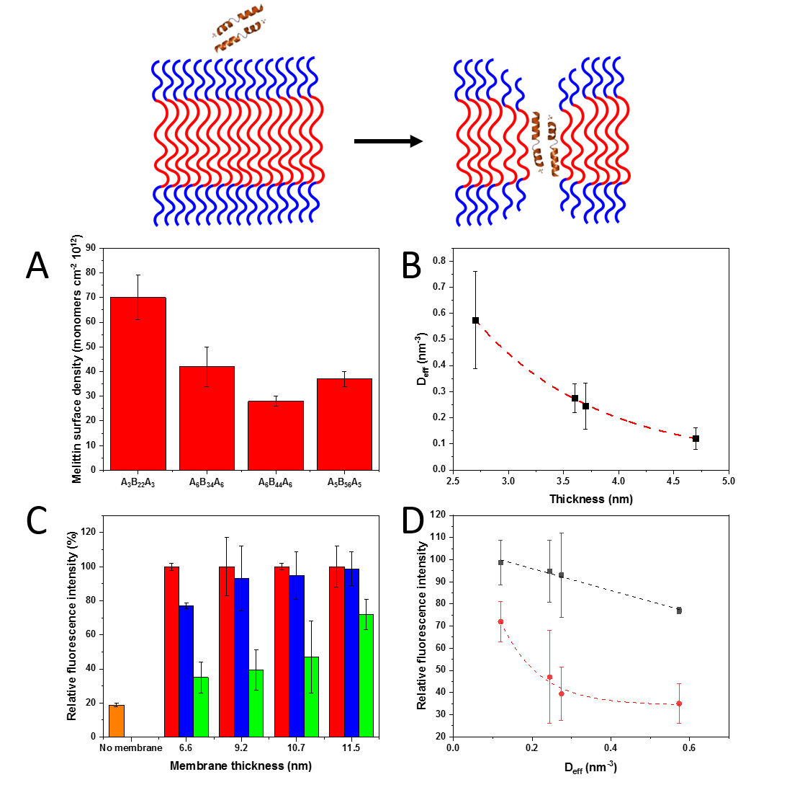

Figure 1. (A) Number of melittin monomers cm⁻² 10⁻¹². (B) $ρ$_{eff} dependence of membrane thickness, which follows an exponential decay as the membrane thickness increases. (C) Remaining mean relative fluorescence intensity of the Alizarin Red S-boronic acid complex, after addition of glucose to Alizarin-functionalized surfaces: without a membrane (orange), with a copolymer membrane without melittin (red), with a copolymer membrane to which melittin was added after the membrane transfer (blue) and with a copolymer membrane to which melittin was added before the membrane transfer (green). A lower relative intensity corresponds to a higher glucose permeation. (D) Relative fluorescence intensity dependence to $ρ$_{eff}, for melittin added: before the polymer membrane transfer (red) and after the polymer membrane transfer (black). The starting relative fluorescence intensity was normalized to 100 % for each sample. Error bars given as ± SD, n = 3.
Functionality of the melittin pores inside the solid-supported planar polymer membranes
In order to test the functionality of the melittin pores inside the planar membranes, we prepared glass slides functionalized with a fluorescent complex, formed by Alizarin Red S and boronic acid. This complex is well-known for being fluorescent in the absence of glucose. Once added, glucose substitutes Alizarin in the complex causing a drop in the fluorescence intensity.⁶¹ The idea behind this assay was that, when a homogeneous membrane is transferred on top of the Alizarin Red S complex, there would be no observable drop in the fluorescence intensity after addition of glucose, since the membrane shields the complex. When pores are formed by melittin insertion inside the planar copolymer membrane, glucose is expected to diffuse through and exchange with Alizarin in the complex, resulting in a drop in the fluorescence intensity. Thus, glucose was added to various Alizarin-modified surfaces: I) surfaces with no copolymer membrane, II) surfaces with copolymer membranes without melittin, III) surfaces with copolymer membranes with melittin, which was added before the membrane formation and IV) surfaces with copolymer membranes and melittin added after the membrane transfer. The fluorescence intensity associated with Alizarin Red S was monitored by CLSM (Figure 1C, Figures S4-S6). In order to compare the effect of glucose addition on different membranes with and without melittin, the initial fluorescence intensity was normalized to 100%. The fluorescence intensity decreased dramatically for Alizarin Red S-based surfaces without membranes, down to 18% in 1h, due to the unhindered diffusion of glucose and exchange with Alizarin. No decrease in fluorescence intensity was obtained for polymer membranes without melittin, indicating that the membranes were stable and without defects, thus preventing the passage of glucose. When melittin was added before the copolymer membrane transfer, the thinnest membrane showed the lowest residual fluorescence (35% after 1 h), while the thickest membrane retained most of the fluorescence intensity (73% after 1 h). The membranes with intermediate thickness allowed a mean decrease in the fluorescence intensity to 39% and 47%, respectively. These results show that melittin added before the transfer of the copolymer membranes remained functional and the insertion efficiency decreased with the increase of the membrane thickness. The thinner membrane led to the highest number of functionally inserted melittin peptides and favored the formation of pores.
A different behavior was obtained for the planar membranes when melittin was added after their transfer on solid support: only the thinnest membrane exhibited a significant decrease in the fluorescence intensity of Alizarin Red S due to the glucose diffusion through (77% in 1 h). For all other thicker membranes, no significant decrease in the fluorescence intensity of Alizarin Red S complex was observed after 1 h (A₆B₃₄A₆: 93%; A₆B₄₄A₆: 95%; A₅B₅₆A₅: 98%). Therefore, the insertion of melittin is more difficult in a less dynamic state of the membrane, as is the case after the membrane transfer on a solid substrate. Interestingly, we could observe a linear correlation between ρ_{eff} and the membrane thickness for melittin added before the transfer and an exponential correlation when melittin was added afterwards (r² = 99 for both) (Figure 1D).
Insertion of melittin in GUVs
We reckon that the curvature, together with membrane thickness, plays a significant role in peptide-membrane interaction, as in the case for lipids^{52, 62} but, up to now, there are no reports about its influence on bio-synthetic membranes. Therefore, we used vesicles with a significant difference in size and thus in their curvature, and estimated the pore density. We first selected GUVs, as their micrometer size is analogous to the cell size and thus resemble the curved membranes melittin encounters in nature, impermeable to most hydrophilic molecules.⁴⁰ In addition, we were interested to determine the size of the melittin pores inside the synthetic membrane because, as established with lipid membranes, melittin does not have a defined pore size, unlike other biopores or channel porins, such as αHL or OmpF.^{63, 64} Thus, the diameter of the melittin pore can vary depending on how many peptide monomers assemble together.⁶⁵⁻⁷⁰
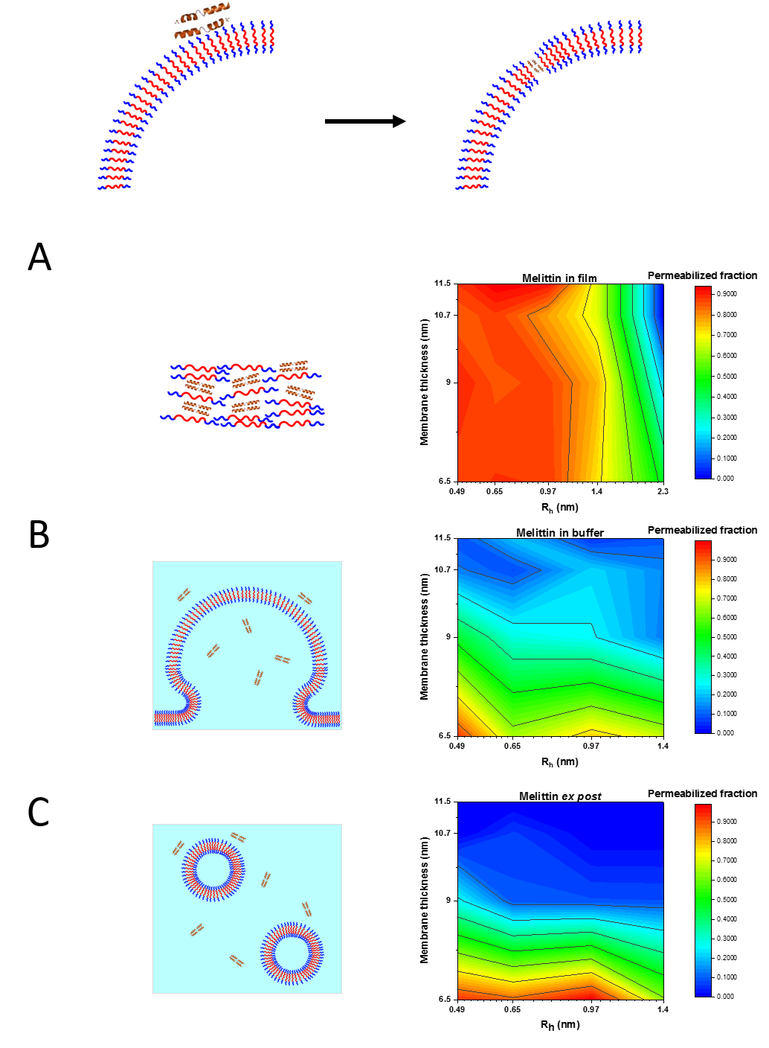
Figure 2. Schemes of melittin addition in the process of vesicle formation (left) and contour graphs of relative GUV permeabilization (right) when melittin is: (A) co-dried with the polymer film before the process of GUV formation, (B) added to the rehydration buffer of the polymer film before GUV formation and (C) added to the prior-formed GUVs. Contour graphs are plotted as hydrodynamic radius R_{h} vs membrane thickness to indicate the molecular properties of the GUV, which influence the fraction of inserted melittin molecules and resulting fraction of permeabilized GUVs.
First, we evaluated the interaction of fluorescently labeled melittin with the GUVs’ membrane using CLSM (Figure S7). We formed melittin-GUVs by adding the peptide at three stages of the vesicles formation: I) co-drying melittin with the copolymer followed by self-assembly via rehydration method (“co-dried”), II) addition of melittin to the rehydration buffer used for the self-assembly of GUVs (“in rehydration buffer”) and III) addition of melittin to pre-formed GUVs (“ex post”). Fluorophore molecules of increasing molecular weights were added to the outside of melittin-GUVs and their diffusion into the cavity of GUVs was determined to evaluate the permeabilization fraction as function of the GUVs properties (membrane thickness and size of the GUVs) and the insertion approaches.
When melittin was co-dried with the copolymers and then self-assembled by addition of the rehydration buffer (“co-dried” approach), the peptide was able to interact with the polymer during the self-assembly process. This resulted in a functional insertion even for the thickest polymer membrane of A₅B₅₆A₅ (11.5 nm) with more than 80% permeability for molecules with sizes up to R_{h} = 0.97 nm (ATTO 488 NHS ester) (Figure 2A). We obtained a substantial permeabilization (70%) for molecules with R_{h} = 1.4 nm (4000 Da) for all copolymer membranes, while only the thinnest membrane (based on A₃B₂₂A₃ copolymer) showed permeabilization of around 44% for bigger molecules (R_{h} = 2.3 nm). These results show that the size melittin pores is thickness dependent, with bigger pores (≥1.4 nm) hindered in thicker membranes.
Addition of melittin in the rehydration buffer used to self-assemble GUVs,⁴⁰ resulted in a noticeable decrease in the permeabilization of the melittin-GUVs’ membranes. Molecules with R_{h} above 0.5 nm were able to diffuse only through A₃B₂₂A₃ and A₆B₃₄A₆ GUVs’ membranes (6.5 to 9 nm thickness) (Figure 2B), while for A₅B₅₆A₅ membranes only 40% of the melittin-GUVs allowed passage of molecules with R_{h} = 0.5 nm.
When melittin was added to pre-formed GUVs (ex post approach), after 1 h, only the thinnest polymer membranes showed permeabilization above 70% for molecules with molecular weights of 4000 Da (R_{h} = 1.4 nm). For all other GUV membranes with thicknesses above 9 nm, only 10% or less of the GUVs contained functional melittin pores with a radius of up to 0.65 nm that did not increase in size over time (Figure 2C).
The ability of melittin to insert and form pores depends on its capability to interact strongly enough with the membrane and eventually change its orientation parallel to the chains, thus allowing the formation of the pore.⁷¹ As PMOXA_{x}-b-PDMS_{y}-b-PMOXA_{x} membranes are more stable and thicker than lipid membranes,⁷² our results indicate that the precise moment of melittin addition is crucial, because the peptide insertion becomes more strenuous the later melittin comes into contact with the polymer chains, during the self-assembly process. We can thus state that the size of the pore follows a distribution that depends on the membrane thickness and the stage at which melittin is added. The insertion of melittin monomers is likely a cooperative process, where the presence of peptides favors the insertion of additional ones.^{73, 74} In our case, the pore radius varied between 0.5 nm, which is smaller than the lower limit of about 1.3 nm reported in lipids,⁷⁵⁻⁷⁸ to a maximum of 2.3 nm, which is in line with the maximum size reported by neutron and X-ray diffraction,^{66, 79} while smaller than the pore size reported for the synthetic variant MelP5.^{80, 81}
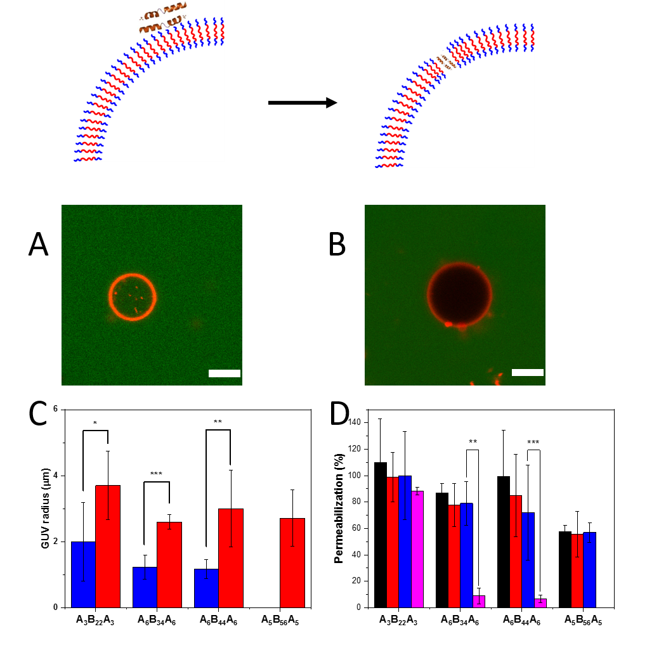
Figure 3. (A) CLSM micrograph of an A₃B₂₂A₃ ATTO488-filled GUV (pre-formed GUV). (B) CLSM micrograph of an empty A₃B₂₂A₃ GUV, with higher radius than the filled GUV (pre-formed GUV). (C) Average diameter of permeabilized (blue) and unpermeabilized (red) GUVs. (D) Percentage of permeabilized vesicles as function of their average radius (obtained after extrusion with cut offs 50, 100 and 200 nm): ~30 nm (black), ~45 nm (red), ~80 nm (blue), >0.5 µm (GUVs, magenta). No permeabilization was observed for A₅B₅₆A₅ GUVs. Scale bar: 5 μm. Error bars given as ± SD, n = 30 for GUVs (single vesicles), n = 3 (replicates). Significance levels: p < 0.5 (*), p < 0.01 (**), p < 0.001 (***).
Curvature dependence of functional melittin insertion in copolymer membranes
The interaction of melittin with membranes is not the only factor affecting the insertion and the membrane curvature should be considered as a key factor as well. The ability of melittin to render lipid membranes permeable has been shown to depend on the membrane curvature^{51, 82} with a mechanism favored by a positive curvature (i.e. outwards). In the case of synthetic membranes, the addition of melittin to pre-formed GUVs resulted in higher insertion efficiency for smaller GUVs (Figure 3A and 3B). To get more insight into the effect of the curvature, we selected the fluorescent dye SRB (R_{h} 0.65 nm) as a model molecule representative for the size range of small biomolecules and evaluated its penetration upon melittin insertion in the membrane of pre-formed GUVs. By measuring the size distribution of the pre-formed GUVs, we observed that melittin-GUVs permeable for molecules such as SRB had radii 1.5 up to 3 times smaller than empty, non-permeabilized GUVs. This indicates that membranes from pre-formed vesicles with smaller radii -higher curvature- favor melittin insertion and functionality (Figure 3C). On the contrary, melittin-GUVs formed by addition of melittin before the polymer film formation (“co-dried”) and by melittin addition in the rehydration buffer did not result in a significant GUV size difference between empty GUVs and melittin-GUVs. Therefore, the functional insertion of melittin does not depend on membrane curvature when it takes place during the membrane formation, while, when added to pre-formed GUVs, its insertion is favored by a higher curvature of the membrane. In addition, the presence of melittin does not influence the self-assembly process of GUV formation (Figure S8).
To further investigate the role of the membrane curvature on functional insertion of biopores, we produced polymersomes with sizes less than 200 nm (Figure S9-S11). The triblock copolymer A₃B₂₂A₃ was able to form polymersome, with a ρ-factor of 1.01 as determined by DLS and SLS (Figure S10). The other triblock copolymers (A₆B₃₄A₆, A₆B₄₄A₆ and A₅B₅₆A₅) were previously reported to form polymersomes with membrane thicknesses ranging from 6.6 up to 11.5 nm (Table 1, Figure S11).^{31, 59, 83}
We encapsulated SRB within the polymersomes cavity at self-quenching concentration and evaluated its release after addition of melittin to the pre-formed polymersomes, based on the increase in its fluorescence due to dilution (Figure 3D). By using polymersomes, we retroactively confirmed that the sucrose used to form GUVs did not perturb the membrane stability (Figure S12). In order to study the effect of increasing the membrane curvature on melittin insertion, we decreased the polymersomes’ radii by extrusion (Figure S13).
The permeabilization percentage for polymersomes with R_{h} of 120-130 nm was between 90% and 100% for membranes based on A₃B₂₂A₃. Interestingly, for A₆B₃₄A₆ and A₆B₄₄A₆ polymersome membranes, which were only slightly permeabilized (10%) by melittin insertion in GUVs, in the case of polymersomes, permeabilization increased to 70% and 65%, respectively. Moreover, while A₅B₅₆A₅ membranes of GUVs could not be permeabilized, in the case of A₅B₅₆A₅ polymersomes, 57% permeabilization was attained. The comparison of % permeabilization ability of melittin in GUV membranes and polymersome membranes clearly indicates the importance of the membrane curvature on the insertion and pore formation inside synthetic membranes. Further extrusion of polymersome solutions to obtain polymersomes with smaller average radii (circa 45 and 30 nm) did not significantly increase the permeabilization process (Figure 3D). As the diffusion through the pore is passive, gradient-driven, there was no difference between SRB “entering into” (GUV assay) and “being released from” (dye leakage assay in polymersomes), enabling the direct comparison of the effect of different curvatures even though the experimental setups were different.

Quantification of the number of melittin pores per polymersome membrane
FITC-melittin was used to quantify the amount of peptide monomers per polymersome by using FCS. Melittin was inserted by the three approaches presented above: I) co-drying with the polymers and rehydration (co-dried), II) addition to the rehydration buffer (in rehydration buffer) and III) addition to pre-formed polymersomes (ex post). We compared the brightness of single vesicles passing through the confocal volume to that of the free peptides in solution. When melittin was co-dried with the copolymer prior to their rehydration and self-assembly process, the highest number of peptide monomers/polymersome (213 ± 23) was obtained for A₃B₂₂A₃ membranes, while the lowest number (95 ± 2) was determined for A₆B₄₄A₆ membranes. Similarly, when melittin was added in the rehydration buffer, prior to the self-assembly process, the highest number of peptide monomers/polymersome (182 ± 27) was obtained for A₃B₂₂A₃, whereas the lowest number was obtained for A₅B₅₆A₅ (94 ± 19) (Figure 4A). While in the case of the thinnest membrane (A₃B₂₂A₃) there is a difference in the melittin insertion efficiency as a function of the addition approach (melittin co-dried with the copolymer prior to the rehydration and self-assembly process compared to its addition in rehydration buffer), for A₅B₅₆A₅ and A₆B₃₄A₆ copolymers this difference is minimal. Interestingly, in the case of A₆B₄₄A₆ copolymer, the addition of melittin in the rehydration buffer supports a better insertion compared to the “co-dried” approach. When melittin was added to pre-formed polymersomes, the number of melittin monomers decreased with the decrease of the polymersomes’ radius (e.g. from 47 ± 14 to 25 ± 10 monomers/polymersome for A₃B₂₂A₃), due to the smaller polymersome surface and thus reduced interface available to interact with melittin molecules (Figure 4B). The analysis of the number of melittin monomers inserted/polymersome as function of the melittin addition procedure during the polymersome formation indicates that, the earlier melittin is added (e.g. co-dried and in rehydration buffer vs ex post), the more is incorporated into the membrane. This can be explained by the membrane formation process, which supports an efficient insertion in its early stage when the membrane stability is lower than its maximum achieved once the polymersomes are completely formed.
Using the membrane thickness measured by cryo-TEM (Table 1, Figure S11) and assuming the same membrane roughness as measured by AFM (as a limit behavior of the membrane), we calculated the ρ_{eff} of melittin per vesicle by the same model used for planar membranes [eq. 8]. We observed again an inverse proportional dependence of ρ_{eff} as function of the membrane thickness (Figure 4C), more pronounced when melittin was inserted by co-dying with the copolymer or added in rehydration buffer then when added after the polymersome formation. Note that the higher dispersity of A₅B₅₆A₆ compensates for its increased thickness, which explains the number of melittin per vesicle comparable with those for thinner membranes. In addition, when the surface density increased (smaller radius, thus higher curvature), the decay was exponential, confirming the importance of the membrane curvature for the peptide insertion (Figure 4D).
If we consider the surface density of melittin on planar membranes and relate it to the surface density on a model vesicle with a radius of 100 nm, we can calculate a melittin density between 1800 times (for A₃B₂₂A₃) to 10000 times (for A₆B₄₄A₄) higher than what we measured by FCS. This discrepancy indicates that the biopore formation is favored when the synthetic membrane is solid-supported because the support provides more stability to the membrane even for high amounts of biopore, while in the case of vesicles, such huge number of pores would completely perturb the self-assembly process. Note that we could only infer the number of melittin pores per vesicle, because we could not take into account their structure, which depends on the number of monomers per pore. Melittin ranged from 1 to 15 pores per vesicle depending on the polymersome radius for the preparation procedure in which melittin was added to pre-formed polymersomes (ex post), while addition of melittin before the polymer film formation and rehydration induced up to 71 melittin pores per vesicle. We extrapolated these calculations for vesicles with the dimensions our GUVs have and found that A₃B₂₂A₃ based GUVs would reach more than 350 pores per GUV, while the thicker A₆B₃₄A₆ and A₆B₄₄A₆ based GUVs would have less than 50 per GUV (Section S5 and Figure S14).
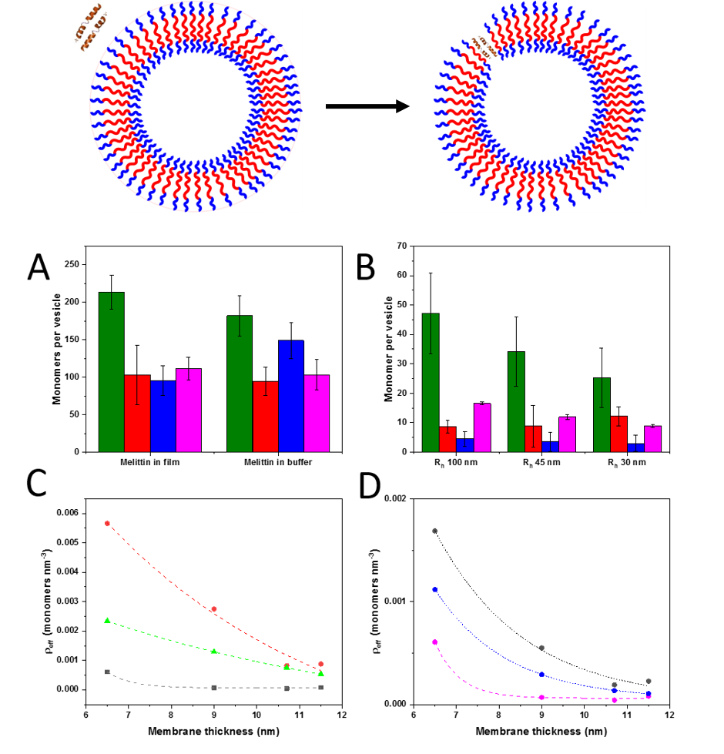
Figure 4. (A) Number of melittin monomers when melittin is added, either co-dried or in the rehydration buffer, to A₃B₂₂A₃ (green), A₆B₃₄A₆ (red), A₆B₄₄A₆ (blue) and A₅B₅₆A₅ (magenta) polymersomes. (B) Number of melittin monomers when melittin is added to pre-formed polymersomes with different R_{h} : A₃B₂₂A₃ (green), A₆B₃₄A₆ (red), A₆B₄₄A₆ (blue) and A₅B₅₆A₅ (magenta). (C) ρ_{eff} dependence of the amount of melittin on membrane thickness when melittin was: “co-dried” with the copolymer (red), added “in rehydration buffer” (green) and “ex post” (R_{h} 100 nm) (grey). (D) ρ_{eff} dependence of number of melittin monomers on membrane thickness when melittin was added ex post to polymersomes with size of: R_{h} 80 nm (magenta), R_{h} 45 nm (blue) and R_{h} 30 nm (grey) (D). Error bars given as ± SD, n = 30.

Melittin-permeabilized catalytic nanocompartments (CNCs)
A crucial aspect of melittin insertion in curved membranes is the functionality by pore formation. By encapsulating the enzyme glucose oxidase (GOX) into polymersomes, we obtained nanocompartments where the enzyme is able to perform its activity only when glucose added in the environment of the polymersomes can penetrate into the cavity. These GOX catalytic nanocompartments (GOX-CNCs) produce hydrogen peroxide by the in situ reaction of GOX. H₂O₂ produced inside is released into the environment if the polymersome membrane contains melittin pores and its production can be determined using a second enzyme, horseradish peroxidase (HRP) present in the surroundings GOX-CNCs. The released H₂O₂ together with Amplex Ultra Red take part in the enzymatic reaction catalyzed by HRP resulting in a highly fluorescent product resorufin, which can be easily detected. The catalytic efficiency of GOX-NCNs, relative to the same enzyme concentration free in solution, was close to 100% for A₃B₂₂B₃ based CNCs, regardless of the moment of the melittin addition, indicating that the number of melittin pores was significant, such to not affect the in situ catalysis by decreasing the diffusion of the substrates/products. For other polymers, the activity with “co-dried” melittin had a minimum of 75%. The polymersomes with a thicker membrane showed a decreased catalytic activity when melittin was added in the rehydration buffer, especially pronounced for A₅B₅₅B₅, which only reached only 40% catalytic activity. When melittin was added to pre-formed polymersomes, both GOX-CNCs with a thicker membrane (A₆B₄₄B₆ and A₅B₅₅B₅) had a lower activity, down to 25% for the latter. These results confirm that melittin inserts with different degrees of ease depending on the polymer characteristics, while the insertion strategy influences the amount of functional pores. In the absence of melittin, we observed only trace residual activity, stemming from either the autoxidation of Amplex Ultra Red or polymer-enzyme unspecific binding (Figure 5), already reported for enzymatic CNCs.⁸³ This enzymatic reaction allowed us to verify the functional insertion of melittin in polymersomes irrespective of the melittin insertion approach. In addition, the functionality assay based on GOX-CNCs has high potential for glucose sensing or anticancer ROS therapy.⁸⁴⁻⁸⁶
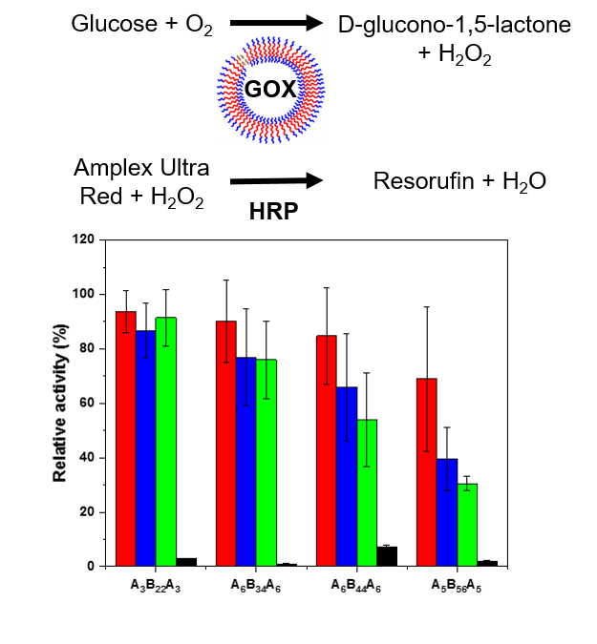
Figure 5. Reaction scheme and activity of GOX-CNCs when melittin was: “co-dried” (red), “in rehydration buffer” (blue), added “ex post” (green) and without melittin (black). Error bars given as ± SD, n = 30.

CONCLUSION
The insertion of biopores and membrane proteins in synthetic membranes has to take into account a more complex scenario than is the case for lipid membranes due to the significant difference in membrane properties (thickness and fluidity). Here we propose an integrative approach to understand the molecular factors influencing the interactions and functional insertion of biopores in synthetic membranes with different architectures (planar membranes, micrometer vesicles and nanometer vesicles) and by biopore addition at different stages of the membranes formation. In this regard, melittin was used as a model peptide to elucidate the molecular factors (characteristics of the copolymer chains, architecture and properties of the membranes) that affect a functional insertion into PMOXA-b-PDMS-b-PMOXA membranes. We studied the “natural” insertion route that happens in cells, i.e. insertion into already-formed membranes (ex post), and the insertion when the membrane is not fully formed (peptide “co-dried” with the copolymer prior to the rehydration and peptide added “in rehydration buffer” before the self-assembly process). The insertion strongly depended on inherent copolymer characteristics (hydrophilic ratio, dispersity) and membrane properties (thickness, roughness, and assembly-specific curvature). Interestingly, we were able to show how the increase in curvature (from planar membranes, to GUVs down to polymersomes) affects the insertion efficiency for the same copolymer. We quantified the melittin surface density and estimated the pore diameters by using the release of molecules with specific sizes. This is the first time that such molecular parameters are related to peptide-polymer assemblies as a crucial step in understanding the molecular factors and conditions that govern bipore insertion and functionality in synthetic membranes, such to provide optimum conditions for further applications, such as biosenzing or catalytic nanocompartments. In this respect, the permeabilization towards glucose selected as a functionality assay is, in addition, a proof-of-concept that such bio-hybrid membranes can serve as a platform for translational applications. Our results show that melittin as a model biopore permeabilizes, in a controlled manner, both planar membranes and micro-, nano-compartments. The concept of our integrative approach can be extended to other biopores and membrane proteins by taking into account the inherent specificities of the biomolecules and synthetic membranes together with the conditions in which these are interfaced.

ASSOCIATED CONTENT
Supporting Information.
Information on solid-supported polymer membrane characterization, formation and characterization of GUVs and polymersomes and estimation of melittin pore number. (PDF)
AUTHOR INFORMATION
Corresponding Author
Wolfgang Meier wolfgang.meier@unibas.ch , Cornelia G. Palivan cornelia.palivan@unibas.ch
Author Contributions
The manuscript was written through contributions of all authors. All authors have given approval to the final version of the manuscript. A.B. and V.M. contributed equally. A.B. produced and characterized GUVs and polymersomes, studied their interaction with melittin, modeled the interaction parameters in planar and vesicular membranes, and calculated the pore number in both systems. V.M. was responsible for the production and characterization of planar membranes and their interaction with melittin. S.Y.A. validated the experiments on planar membranes. D.D. characterized the polymersomes by SLS/DLS and was responsible for the graphical presentation. I.C. contributed to the data treatment and presentation of experiments. M. C. performed the cryo-TEM experiments. W.M. and C.G.P. contributed with overall supervision and guidance of the project.
Funding Sources
The work presented here was supported with funds from the Swiss National Science Foundation, NCCR Molecular Systems Engineering and the University of Basel.

ACKNOWLEDGMENT
The authors acknowledge the Swiss National Science Foundation, NCCR Molecular Systems Engineering and the University of Basel for the finances supporting this project. The authors thank Dr. Samuel Lörcher, Dr. Adrian Dinu and Sven Kasper for the synthesis of the copolymers, Gabriele Persy for the TEM micrographs and Frida Terne for the assistance with the preliminary experiments.

REFERENCES
1. Garni, M.; Wehr, R.; Avsar, S. Y.; John, C.; Palivan, C.; Meier, W., Polymer membranes as templates for bio-applications ranging from artificial cells to active surfaces. Eur. Polym. J. 2018, 112, 346-364.
2. Yorulmaz Avsar, S.; Kyropoulou, M.; Di Leone, S.; Schoenenberger, C.-A.; Meier, W. P.; Palivan, C. G., Biomolecules Turn Self-Assembling Amphiphilic Block Co-polymer Platforms Into Biomimetic Interfaces. Front. Chem. 2019, 6, 645.
3. Kumar, M.; Grzelakowski, M.; Zilles, J.; Clark, M.; Meier, W., Highly permeable polymeric membranes based on the incorporation of the functional water channel protein Aquaporin Z. Proc Natl Acad Sci U S A 2007, 104, (52), 20719-24.
4. Discher, B. M.; Won, Y.-Y.; Ege, D. S.; Lee, J. C.; Bates, F. S.; Discher, D. E.; Hammer, D. A., Polymersomes: tough vesicles made from diblock copolymers. Science 1999, 284, (5417), 1143-1146.
5. Antonietti, M.; Förster, S., Vesicles and Liposomes: A Self-Assembly Principle Beyond Lipids. Adv. Mater. 2003, 15, (16), 1323-1333.
6. Dziubla, T. D.; Shuvaev, V. V.; Hong, N. K.; Hawkins, B. J.; Madesh, M.; Takano, H.; Simone, E.; Nakada, M. T.; Fisher, A.; Albelda, S. M., Endothelial targeting of semi-permeable polymer nanocarriers for enzyme therapies. Biomaterials 2008, 29, (2), 215-227.
7. Larrañaga, A.; Lomora, M.; Sarasua, J.-R.; Palivan, C. G.; Pandit, A., Polymer capsules as micro-/nanoreactors for therapeutic applications: Current strategies to control membrane permeability. Prog. Mater Sci. 2017, 90, 325-357.
8. González-Pérez, A.; Stibius, K. B.; Vissing, T.; Nielsen, C. H.; Mouritsen, O. G., Biomimetic triblock copolymer membrane arrays: a stable template for functional membrane proteins. Langmuir 2009, 25, (18), 10447-10450.
9. Garni, M.; Thamboo, S.; Schoenenberger, C.-A.; Palivan, C. G., Biopores/membrane proteins in synthetic polymer membranes. Biochim. Biophys. Acta - Biomembranes 2017, 1859, (4), 619-638.
10. Spulber, M.; Baumann, P.; Saxer, S. S.; Pieles, U.; Meier, W.; Bruns, N., Poly (N-vinylpyrrolidone)-poly (dimethylsiloxane)-based polymersome nanoreactors for laccase-catalyzed biotransformations. Biomacromolecules 2014, 15, (4), 1469-1475.
11. Gaitzsch, J.; Appelhans, D.; Wang, L.; Battaglia, G.; Voit, B., Synthetic bio‐nanoreactor: mechanical and chemical control of polymersome membrane permeability. Angew. Chem. Int. Ed. 2012, 51, (18), 4448-4451.
12. Kim, K. T.; Cornelissen, J. J.; Nolte, R. J.; van Hest, J. C., A Polymersome Nanoreactor with Controllable Permeability Induced by Stimuli‐Responsive Block Copolymers. Adv. Mater. 2009, 21, (27), 2787-2791.
13. Liu, F.; Kozlovskaya, V.; Medipelli, S.; Xue, B.; Ahmad, F.; Saeed, M.; Cropek, D.; Kharlampieva, E., Temperature-sensitive polymersomes for controlled delivery of anticancer drugs. Chem. Mater. 2015, 27, (23), 7945-7956.
14. Mabrouk, E.; Bonneau, S.; Jia, L.; Cuvelier, D.; Li, M.-H.; Nassoy, P., Photosensitization of polymer vesicles: a multistep chemical process deciphered by micropipette manipulation. Soft Matter 2010, 6, (19), 4863-4875.
15. Le Meins, J.-F.; Sandre, O.; Lecommandoux, S., Recent trends in the tuning of polymersomes’ membrane properties. Eur. Phys. J. E 2011, 34, (2), 14.
16. Rodríguez-García, R.; Mell, M.; López-Montero, I.; Netzel, J.; Hellweg, T.; Monroy, F., Polymersomes: smart vesicles of tunable rigidity and permeability. Soft Matter 2011, 7, (4), 1532-1542.
17. Meng, F.; Zhong, Z.; Feijen, J., Stimuli-responsive polymersomes for programmed drug delivery. Biomacromolecules 2009, 10, (2), 197-209.
18. Lomora, M.; Itel, F.; Dinu, I. A.; Palivan, C. G., Selective ion-permeable membranes by insertion of biopores into polymersomes. PCCP 2015, 17, (24), 15538-15546.
19. Nardin, C.; Thoeni, S.; Widmer, J.; Winterhalter, M.; Meier, W., Nanoreactors based on (polymerized) ABA-triblock copolymer vesicles. Chem. Commun. 2000, (15), 1433-1434.
20. Marguet, M.; Bonduelle, C.; Lecommandoux, S., Multicompartmentalized polymeric systems: towards biomimetic cellular structure and function. Chem. Soc. Rev. 2013, 42, (2), 512-529.
21. Kuang, L.; Fernandes, D. A.; O’Halloran, M.; Zheng, W.; Jiang, Y.; Ladizhansky, V.; Brown, L. S.; Liang, H., “Frozen” block copolymer nanomembranes with light-driven proton pumping performance. ACS nano 2013, 8, (1), 537-545.
22. Graff, A.; Fraysse‐Ailhas, C.; Palivan, C. G.; Grzelakowski, M.; Friedrich, T.; Vebert, C.; Gescheidt, G.; Meier, W., Amphiphilic Copolymer Membranes Promote NADH: Ubiquinone Oxidoreductase Activity: Towards an Electron‐Transfer Nanodevice. Macromol. Chem. Phys. 2010, 211, (2), 229-238.
23. Rostovtseva, T. K.; Nestorovich, E. M.; Bezrukov, S. M., Partitioning of differently sized poly(ethylene glycol)s into OmpF porin. Biophys. J. 2002, 82, (1 Pt 1), 160-169.
24. Verkman, A. S., Aquaporins at a glance. J. Cell Sci. 2011, 124, (13), 2107.
25. Ye, J.; van den Berg, B., Crystal structure of the bacterial nucleoside transporter Tsx. The EMBO journal 2004, 23, (16), 3187-3195.
26. Kumar, M.; Habel, J. E.; Shen, Y.-x.; Meier, W. P.; Walz, T., High-density reconstitution of functional water channels into vesicular and planar block copolymer membranes. J. Am. Chem. Soc. 2012, 134, (45), 18631-18637.
27. Ranquin, A.; Versées, W.; Meier, W.; Steyaert, J.; Van Gelder, P., Therapeutic nanoreactors: combining chemistry and biology in a novel triblock copolymer drug delivery system. Nano Lett. 2005, 5, (11), 2220-2224.
28. Nallani, M.; Benito, S.; Onaca, O.; Graff, A.; Lindemann, M.; Winterhalter, M.; Meier, W.; Schwaneberg, U., A nanocompartment system (synthosome) designed for biotechnological applications. J. Biotechnol. 2006, 123, (1), 50-59.
29. Zhang, X.; Lomora, M.; Einfalt, T.; Meier, W.; Klein, N.; Schneider, D.; Palivan, C. G., Active surfaces engineered by immobilizing protein-polymer nanoreactors for selectively detecting sugar alcohols. Biomaterials 2016, 89, 79-88.
30. Goers, R.; Thoma, J.; Ritzmann, N.; Di Silvestro, A.; Alter, C.; Gunkel-Grabole, G.; Fotiadis, D.; Müller, D. J.; Meier, W., Optimized reconstitution of membrane proteins into synthetic membranes. Commun. Chem. 2018, 1, (1), 35.
31. Lomora, M.; Garni, M.; Itel, F.; Tanner, P.; Spulber, M.; Palivan, C. G., Polymersomes with engineered ion selective permeability as stimuli-responsive nanocompartments with preserved architecture. Biomaterials 2015, 53, 406-414.
32. Nallani, M.; Andreasson-Ochsner, M.; Tan, C.-W. D.; Sinner, E.-K.; Wisantoso, Y.; Geifman-Shochat, S.; Hunziker, W., Proteopolymersomes: in vitro production of a membrane protein in polymersome membranes. Biointerphases 2011, 6, (4), 153-157.
33. Messager, L.; Burns, J. R.; Kim, J.; Cecchin, D.; Hindley, J.; Pyne, A. L. B.; Gaitzsch, J.; Battaglia, G.; Howorka, S., Biomimetic Hybrid Nanocontainers with Selective Permeability. Angew. Chem. Int. Ed. 2016, 55, (37), 11106-11109.
34. Itel, F.; Najer, A.; Palivan, C. G.; Meier, W., Dynamics of Membrane Proteins within Synthetic Polymer Membranes with Large Hydrophobic Mismatch. Nano Lett. 2015, 15, (6), 3871-3878.
35. Duong, P. H.; Chung, T.-S.; Jeyaseelan, K.; Armugam, A.; Chen, Z.; Yang, J.; Hong, M., Planar biomimetic aquaporin-incorporated triblock copolymer membranes on porous alumina supports for nanofiltration. J. Membr. Sci. 2012, 409, 34-43.
36. Kowal, J. Ł.; Kowal, J. K.; Wu, D.; Stahlberg, H.; Palivan, C. G.; Meier, W. P., Functional surface engineering by nucleotide-modulated potassium channel insertion into polymer membranes attached to solid supports. Biomaterials 2014, 35, (26), 7286-7294.
37. Zhang, X.; Fu, W.; Palivan, C. G.; Meier, W., Natural channel protein inserts and functions in a completely artificial, solid-supported bilayer membrane. Sci. Rep. 2013, 3, 2196.
38. Lomora, M.; Dinu, I. A.; Itel, F.; Rigo, S.; Spulber, M.; Palivan, C. G., Does Membrane Thickness Affect the Transport of Selective Ions Mediated by Ionophores in Synthetic Membranes? Macromol. Rapid Commun. 2015, 36, (21), 1929-1934.
39. Discher, B. M.; Won, Y.-Y.; Ege, D. S.; Lee, J. C. M.; Bates, F. S.; Discher, D. E.; Hammer, D. A., Polymersomes: Tough Vesicles Made from Diblock Copolymers. Science 1999, 284, (5417), 1143.
40. Thamboo, S.; Najer, A.; Belluati, A.; von Planta, C.; Wu, D.; Craciun, I.; Meier, W.; Palivan, C. G., Mimicking Cellular Signaling Pathways within Synthetic Multicompartment Vesicles with Triggered Enzyme Activity and Induced Ion Channel Recruitment. Adv. Funct. Mater. 2019, 0, (0), 1904267.
41. Wong, D.; Jeon, T.-J.; Schmidt, J., Single molecule measurements of channel proteins incorporated into biomimetic polymer membranes. Nanotechnology 2006, 17, (15), 3710.
42. Le Pioufle, B.; Suzuki, H.; Tabata, K. V.; Noji, H.; Takeuchi, S., Lipid bilayer microarray for parallel recording of transmembrane ion currents. Anal. Chem. 2008, 80, (1), 328-332.
43. Terwilliger, T. C.; Eisenberg, D., The structure of melittin. I. Structure determination and partial refinement. J. Biol. Chem. 1982, 257, (11), 6010-6015.
44. Terwilliger, T. C.; Eisenberg, D., The structure of melittin. J. biol. Chem 1982, 257, (601), L6015.
45. Haldar, S.; Raghuraman, H.; Chattopadhyay, A., Monitoring Orientation and Dynamics of Membrane-Bound Melittin Utilizing Dansyl Fluorescence. J. Phys. Chem. B 2008, 112, (44), 14075-14082.
46. Malmsten, M., Antimicrobial peptides. Upsala J. Med. Sci. 2014, 119, (2), 199-204.
47. Rady, I.; Siddiqui, I. A.; Rady, M.; Mukhtar, H., Melittin, a major peptide component of bee venom, and its conjugates in cancer therapy. Cancer Lett. 2017, 402, 16-31.
48. Wimley, W. C.; Hristova, K., Antimicrobial Peptides: Successes, Challenges and Unanswered Questions. J. Membr. Biol. 2011, 239, (1), 27-34.
49. Guha, S.; Ghimire, J.; Wu, E.; Wimley, W. C., Mechanistic Landscape of Membrane-Permeabilizing Peptides. Chem. Rev. 2019, 119, (9), 6040-6085.
50. Popplewell, J.; Swann, M.; Freeman, N.; McDonnell, C.; Ford, R., Quantifying the effects of melittin on liposomes. Biochim. Biophys. Acta - Biomembranes 2007, 1768, (1), 13-20.
51. Allende, D.; Simon, S.; McIntosh, T. J., Melittin-induced bilayer leakage depends on lipid material properties: evidence for toroidal pores. Biophys. J. 2005, 88, (3), 1828-1837.
52. Lee, M.-T.; Sun, T.-L.; Hung, W.-C.; Huang, H. W., Process of inducing pores in membranes by melittin. Proc Natl Acad Sci U S A 2013, 110, (35), 14243-14248.
53. Draghici, C.; Mikhalevich, V.; Gunkel-Grabole, G.; Kowal, J.; Meier, W.; Palivan, C. G., Biomimetic Planar Polymer Membranes Decorated with Enzymes as Functional Surfaces. Langmuir 2018, 34, (30), 9015-9024.
54. Sauerbrey, G., Verwendung von Schwingquarzen zur Wägung dünner Schichten und zur Mikrowägung. Z. Phys. 1959, 155, (2), 206-222.
55. Wayne, R., Chapter 3 - Plasmodesmata. In Plant Cell Biology (Second Edition), Wayne, R., Ed. Academic Press: 2019; pp 55-65.
56. Habel, J.; Ogbonna, A.; Larsen, N.; Cherré, S.; Kynde, S.; Midtgaard, S. R.; Kinoshita, K.; Krabbe, S.; Jensen, G. V.; Hansen, J. S.; Almdal, K.; Hèlix-Nielsen, C., Selecting analytical tools for characterization of polymersomes in aqueous solution. RSC Advances 2015, 5, (97), 79924-79946.
57. Itel, F.; Chami, M.; Najer, A.; Lörcher, S.; Wu, D.; Dinu, I. A.; Meier, W., Molecular Organization and Dynamics in Polymersome Membranes: A Lateral Diffusion Study. Macromolecules 2014, 47, (21), 7588-7596.
58. Lörcher, S.; Meier, W., Cosolvent fractionation of PMOXA-b-PDMS-b-PMOXA: Bulk separation of triblocks from multiblocks. Eur. Polym. J. 2017, 88, 575-585.
59. Najer, A.; Wu, D.; Bieri, A.; Brand, F.; Palivan, C. G.; Beck, H.-P.; Meier, W., Nanomimics of Host Cell Membranes Block Invasion and Expose Invasive Malaria Parasites. ACS Nano 2014, 8, (12), 12560-12571.
60. Yorulmaz, S.; Jackman, J. A.; Hunziker, W.; Cho, N.-J., Supported Lipid Bilayer Platform To Test Inhibitors of the Membrane Attack Complex: Insights into Biomacromolecular Assembly and Regulation. Biomacromolecules 2015, 16, (11), 3594-3602.
61. Springsteen, G.; Wang, B., Alizarin Red S. as a general optical reporter for studying the binding of boronic acids with carbohydrates. Chem. Commun. 2001, (17), 1608-1609.
62. Karabadzhak, A. G.; Weerakkody, D.; Deacon, J.; Andreev, O. A.; Reshetnyak, Y. K.; Engelman, D. M., Bilayer Thickness and Curvature Influence Binding and Insertion of a pHLIP Peptide. Biophys. J. 2018, 114, (9), 2107-2115.
63. Nikaido, H., Molecular basis of bacterial outer membrane permeability revisited. Microbiol Mol Biol Rev 2003, 67, (4), 593-656.
64. Stefureac, R.; Long, Y.-t.; Kraatz, H.-B.; Howard, P.; Lee, J. S., Transport of α-Helical Peptides through α-Hemolysin and Aerolysin Pores. Biochemistry 2006, 45, (30), 9172-9179.
65. Gimenez, D.; Sanchez-Munoz, O. L.; Salgado, J., Direct observation of nanometer-scale pores of melittin in supported lipid monolayers. Langmuir 2015, 31, (10), 3146-58.
66. Lee, M. T.; Sun, T. L.; Hung, W. C.; Huang, H. W., Process of inducing pores in membranes by melittin. Proc Natl Acad Sci U S A 2013, 110, (35), 14243-8.
67. Leveritt, J. M., 3rd; Pino-Angeles, A.; Lazaridis, T., The structure of a melittin-stabilized pore. Biophys. J. 2015, 108, (10), 2424-2426.
68. Lipkin, R.; Lazaridis, T., Computational studies of peptide-induced membrane pore formation. Philos Trans R Soc Lond B Biol Sci 2017, 372, (1726).
69. Sun, D.; Forsman, J.; Woodward, C. E., Multistep Molecular Dynamics Simulations Identify the Highly Cooperative Activity of Melittin in Recognizing and Stabilizing Membrane Pores. Langmuir 2015, 31, (34), 9388-401.
70. Sengupta, D.; Leontiadou, H.; Mark, A. E.; Marrink, S.-J., Toroidal pores formed by antimicrobial peptides show significant disorder. Biochim. Biophys. Acta - Biomembranes 2008, 1778, (10), 2308-2317.
71. van den Bogaart, G.; Guzman, J. V.; Mika, J. T.; Poolman, B., On the mechanism of pore formation by melittin. J. Biol. Chem. 2008, 283, (49), 33854-7.
72. Nardin, C.; Winterhalter, M.; Meier, W., Giant Free-Standing ABA Triblock Copolymer Membranes. Langmuir 2000, 16, (20), 7708-7712.
73. Niu, L.; Wohland, T.; Knoll, W.; Köper, I., Interaction of a synthetic antimicrobial peptide with a model bilayer platform mimicking bacterial membranes. Biointerphases 2017, 12, (4), 04e404.
74. Hong, J.; Lu, X.; Deng, Z.; Xiao, S.; Yuan, B.; Yang, K., How Melittin Inserts into Cell Membrane: Conformational Changes, Inter-Peptide Cooperation, and Disturbance on the Membrane. Molecules 2019, 24, (9), 1775.
75. Kokot, G.; Mally, M.; Svetina, S., The dynamics of melittin-induced membrane permeability. Eur. Biophys. J. 2012, 41, (5), 461-474.
76. Ladokhin, A. S.; Selsted, M. E.; White, S. H., Sizing membrane pores in lipid vesicles by leakage of co-encapsulated markers: pore formation by melittin. Biophys. J. 1997, 72, (4), 1762-6.
77. Matsuzaki, K.; Yoneyama, S.; Miyajima, K., Pore formation and translocation of melittin. Biophys. J. 1997, 73, (2), 831-8.
78. Levitt, J. A.; Morton, P. E.; Fruhwirth, G. O.; Santis, G.; Chung, P.-H.; Parsons, M.; Suhling, K., Simultaneous FRAP, FLIM and FAIM for measurements of protein mobility and interaction in living cells. Biomed. Opt. Express 2015, 6, (10), 3842-3854.
79. Yang, L.; Harroun, T. A.; Weiss, T. M.; Ding, L.; Huang, H. W., Barrel-stave model or toroidal model? A case study on melittin pores. Biophys. J. 2001, 81, (3), 1475-1485.
80. Fennouri, A.; Mayer, S. F.; Schroeder, T. B. H.; Mayer, M., Single channel planar lipid bilayer recordings of the melittin variant MelP5. Biochim. Biophys. Acta - Biomembranes 2017, 1859, (10), 2051-2057.
81. Wiedman, G.; Fuselier, T.; He, J.; Searson, P. C.; Hristova, K.; Wimley, W. C., Highly Efficient Macromolecule-Sized Poration of Lipid Bilayers by a Synthetically Evolved Peptide. J. Am. Chem. Soc. 2014, 136, (12), 4724-4731.
82. van den Bogaart, G.; Mika, J. T.; Krasnikov, V.; Poolman, B., The lipid dependence of melittin action investigated by dual-color fluorescence burst analysis. Biophys. J. 2007, 93, (1), 154-163.
83. Belluati, A.; Craciun, I.; Liu, J.; Palivan, C. G., Nanoscale Enzymatic Compartments in Tandem Support Cascade Reactions in Vitro. Biomacromolecules 2018, 19, (10), 4023-4033.
84. Yoo, E.-H.; Lee, S.-Y., Glucose biosensors: an overview of use in clinical practice. Sensors (Basel) 2010, 10, (5), 4558-4576.
85. Fu, L.-H.; Qi, C.; Lin, J.; Huang, P., Catalytic chemistry of glucose oxidase in cancer diagnosis and treatment. Chem. Soc. Rev. 2018, 47, (17), 6454-6472.
86. Belluati, A.; Craciun, I.; Meyer, C. E.; Rigo, S.; Palivan, C. G., Enzymatic reactions in polymeric compartments: nanotechnology meets nature. Curr. Opin. Biotechnol. 2019, 60, 53-62.
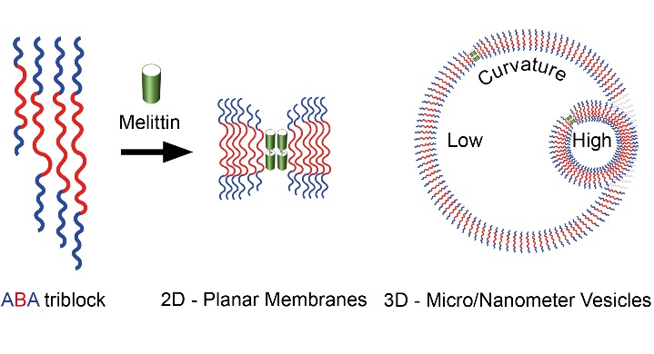
Table of content

