A sterically overcrowded, isopropyl-substituted lanthanide chelating tag for protein PCS NMR spectroscopy: Synthesis of its macrocyclic scaffold and benchmarking on ubiquitin S57C and hCA II S166C

Daniel Joss,^{[a]} Maria-Sophie Bertrams,^{[a]} and Daniel Häussinger*^{[a]}
[a] Daniel Joss, Maria-Sophie Bertrams, PD Dr. Daniel Häussinger
Department of Chemistry
University of Basel
St. Johanns-Ring 19
CH-4056 Basel
E-mail: daniel.haeussinger@unibas.ch
Supporting information for this article is given via a link at the end of the document.

Abstract: A sterically overcrowded lanthanide chelating tag was synthesized in order to investigate the influence on the obtained pseudocontact shifts and the anisotropic part of magnetic susceptibility tensor, when compared to the predecessor DOTA-M8-(4R4S)-SSPy. For the first time, a concise synthetic route is presented for isopropyl-substituted cyclen, the macrocyclic scaffold of the lanthanide chelating tag, delivering the macrocycle in overall yield of 6% over 11 steps. The geometry of the lutetium complex was assigned by ROESY experiments to adopt exclusively a Λ(δδδδ) conformation and DFT calculations confirmed a stabilization of 32.6 kJ⋅mol^{–1} compared to the Δ(δδδδ) conformer. The highly rigidified lanthanide chelating tag induces strong pseudocontact shifts of up to 6.5 ppm on ubiquitin S57C, shows significantly improved tensor properties when compared to its predecessor and constitutes a highly promising starting point for further developments of lanthanide chelating tags.

Introduction
Pseudocontact shifts (PCS) and residual dipolar couplings (RDC) generated by lanthanide chelating tags (LCT) yield valuable structural restraints for the analysis of structure, dynamics and ligand-binding of proteins in solution.¹⁻²⁰ In order to access valuable structural restraints by PCS measurements, stereo-specifically methyl substituted 1,4,7,10-tetraazacyclododecane-1,4,7,10-tetraacetic acid (DOTA)-based chelators present a suitable scaffold.^{9, 19, 21, 22} As investigated by Ranganathan et al., the methyl substituents on the nitrogen containing macrocycle in a lanthanide complex adopt an equatorial-upper position,^{23, 24} i.e. the substituents point away from the metal centre in order to accommodate the metal ion in the ligand cavity. In order to obtain only one signal set in ¹H-¹⁵N HSQC experiments and induce strong paramagnetic effects for the investigation of biomacromolecules in solution, it is mandatory to lock not only the 12-membered ring,⁹ but also the pendant arms of the chelator in one conformation. As shown by Joss et al., Tm- and Dy-DOTA-M8-(4R4S)-SSPy adopt a Λ(δδδδ) conformation resulting in a single set of peaks in ¹H-¹⁵N HSQC spectra.¹⁹
We supposed that introduction of isopropyl substituents on the macrocyclic scaffold yields a lanthanide chelating tag with improved tensor properties when compared to the DOTA-M8-(4R4S)-SSPy tag, since translational and rotational movements of the tag relative to the protein should be significantly hindered. Furthermore, any remaining small amplitude vibrations of the pendant arms should be decreased by the sterically more compact packing of the isopropyl groups. We therefore envisioned the synthesis of a new isopropyl-substituted lanthanide chelating tag (Figure 1) and its corresponding macrocyclic scaffold based on the presence of already published synthetic routes for related targets.^{8, 9, 21, 22, 25, 26}

Figure 1: Structure of a metal complex of P4M4-DOTA in SAP conformation.

However, published synthetic routes for the tetra-methyl analogue did not yield useful quantities in the case of the tetra-isopropyl cyclen. Therefore, we developed a new synthetic route with two reductive aminations as key steps to overcome the hampered reactivity due to highly sterically crowded substrates. Following the total synthesis of the macrocyclic scaffold, we produced Dy-, Tm-, and Lu-P4M4-DOTA (P4M4-DOTA: (2R,2'R,2''R)-2,2',2''-((2S,5S,8S,11S)-2,5,8,11-tetraisopropyl-10-((R)-1-oxo-1-((2-(pyridin-2-yldisulfaneyl)ethyl)amino)propan-2-yl)-1,4,7,10-tetraazacyclododecane-1,4,7-triyl)tripropionate) and conjugated each lanthanide complex to ubiquitin S57C and a selectively ¹⁵N leucine labelled human carbonic anhydrase II (hCA II) S166C protein construct. The obtained spectra, tensor sizes and orientations as well as tag mobility of the complexes when attached to the protein were analysed.

Results and Discussion

Synthesis of macrocyclic scaffold
In order to have synthetic access to the macrocyclic scaffold of the P4M4 tag, we attempted its synthesis based on published routes to related targets.^{21, 22, 25, 26} However, all previously used synthetic routes to related targets failed for our isopropyl-substituted macrocycle or gave only mixtures of products not useful for the generation of a lanthanide chelating tag suitable for PCS NMR spectroscopy. The stepwise aziridine synthesis published in 2009 by Kamioka et al. constitutes an intellectually very appealing approach, but the employed reagents are known to be very toxic and highly cancerogenic.⁸ We then decided to develop a new route towards this macrocyclic scaffold with the formation of the highly sterically crowded tetravaline-analogue by using reductive aminations as key reactions (Figure 2). For the high yielding macrocyclization, previous knowledge from our group was leveraged.²⁰

Figure 2: Retrosynthetic key steps of the synthesis of the new tetraisopropyl-substituted macrocyclic polyamine.

The reductive aminations were envisioned as ideal reactions to couple the different parts of the sterically overcrowded tetravaline-analogue, since a synthetic strategy based on a HATU coupling of two valine-derived dimers did not yield the tetravaline-analogue in sufficient quantities.
The final synthetic route of the new macrocycle comprises 11 steps and is depicted in Figure 3, 4 and 5.

Figure 3: Formation of the required sterically overcrowded tetravaline analogue (Part I).

Cbz protected valine (1) and valine methyl ester (2) were used as inexpensive and readily available chiral building blocks and coupled employing T3P to give dipeptide 3. Subsequent reduction to alcohol 4 and mild oxidation by IBX^{27, 28} furnished the corresponding aldehyde 5, which is then reacted in a reductive amination with valine tert-butyl ester in order to yield trimeric structure 6.

Figure 4: Formation of the required sterically overcrowded tetravaline analogue (Part II).

The trimeric peptide analogue 6 undergoes a Cbz deprotection by hydrogenation and is then reacted with Cbz-valinal in a reductive amination to give tetrameric peptide analogue 8. In order to yield the sterically overcrowded but flexible tetravaline analogue 9, the tetrameric structure 8 was benzylated with benzyl bromide using potassium iodide as catalyst, accelerating the reaction via an in situ Finkelstein reaction of benzyl bromide to benzyl iodide.

Figure 5: Cyclization of the flexible tetravaline analogue and subsequent steps towards the final product.

Tetravaline analogue 9 was deprotected using HBr in acetic acid and readily underwent cyclization in order to give bislactam 11. Bislactam 11 was then transformed in two steps, a TMSCl activated lithium aluminium hydride reduction²⁹ and a benzyl deprotection by transfer hydrogenation, to the final product (13).

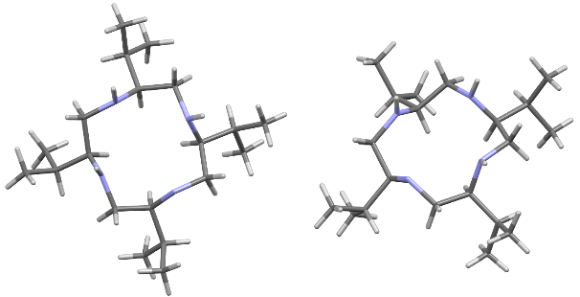
Figure 6: Crystal structure of isopropyl-substituted cyclen (CCDC 1917602): top view (left), diagonal view confirming the all-(S) configuration and the preferred conformation with all isopropyl substituents in the equatorial position (right).
The crystal structure obtained for the final product shows the positioning of the isopropyl-substituents in four-fold equatorial position (Figure 6). While the pro-(R) methyl group of the isopropyl substituent is arranged in a plus-synclinal conformation, the pro-(S) methyl group is positioned in an antiperiplanar fashion (dihedral angle N-C_{CH}-C_{CH}-C_{Me}).

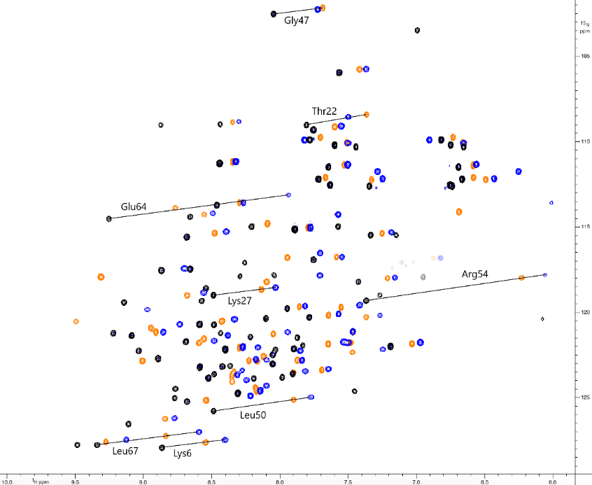

Figure 7: Overlay of ¹H-¹⁵N HSQC spectra of Tm-DOTA-M8-(4R4S)-Ub^{S57C} (pos. contours: orange, neg. contours: pale orange) with Tm- (pos. contours: blue, neg. contours: pale blue) and Lu-P4M4-DOTA-Ub^{S57C} (pos. contours: black, neg. contours: grey) measured in 10 mM phosphate buffer with pH 6.0 at a temperature of 298 K on a 600 MHz Bruker Avance III NMR spectrometer equipped with a cryogenic QCI-F probe. Annotated cross-peaks highlight large PCS and the increase in PCS when comparing Tm-P4M4-DOTA and Tm-DOTA-M8-(4R4S)-SSPy. Negative peaks with a ¹H shift around 7.0 ppm and a ¹⁵N shift around 117.5 ppm constitute aliased signals from arginine sidechains.

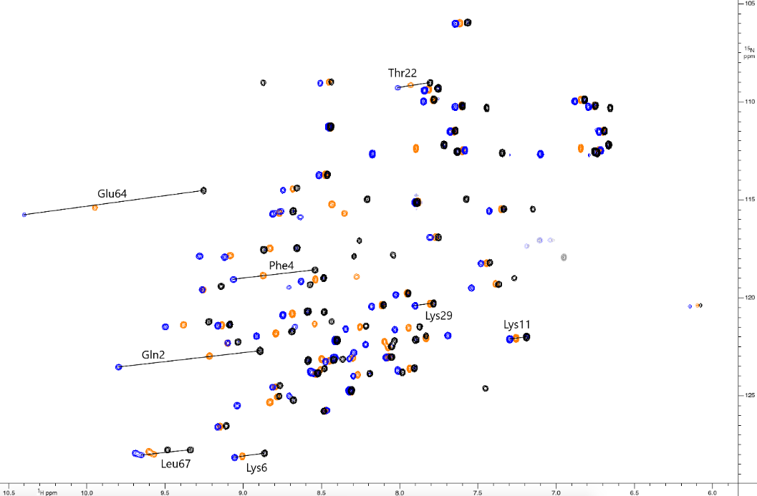
Figure 8: Overlay of ¹H-¹⁵N HSQC spectra of Dy-DOTA-M8-(4R4S)-Ub^{S57C} (pos. contours: orange, neg. contours: pale orange) with Dy- (pos. contours: blue, neg. contours: pale blue) and Lu-P4M4-DOTA-Ub^{S57C} (pos. contours: black, neg. contours: grey) measured in 10 mM phosphate buffer with pH 6.0 at a temperature of 298 K on a 600 MHz Bruker Avance III NMR spectrometer equipped with a cryogenic QCI-F probe. Annotated cross-peaks highlight large PCS and the increase in PCS when comparing Dy-P4M4-DOTA and Dy-DOTA-M8-(4R4S)-SSPy. Negative peaks with a ¹H shift around 7.0 ppm and a ¹⁵N shift around 117.5 ppm constitute aliased signals from arginine sidechains.
Table 1: Properties of the induced anisotropy of the magnetic susceptibility tensors of Ln-P4M4-DOTA measured on ubiquitin S57C at 298K and pH 6.0.

LCT | Nº PCS | Ln³⁺ | ∆χ_{ax} (10⁻³² m³) | ∆χ_{rh} (10⁻³² m³) | X_{metal} | Y_{metal} | Z_{metal} | α | β | γ | Q (%) | Ref.
P4M4-DOTA | 72 | Dy | -16.658 | -7.464 | 16.415 | 13.574 | 7.093 | 149.745 | 43.008 | 42.652 | 5.2 | This  work
 | 70 | Tm | 25.982 | 1.026 | 17.331 | 13.532 | 9.620 | 161.276 | 53.147 | 50.696 | 1.4
 | Nº PCS | Ln³⁺ | ∆χ_{ax} (10⁻³² m³) | ∆χ_{rh} (10⁻³² m³) | X_{metal} | Y_{metal} | Z_{metal} | α | β | γ | Q (%) | Ref.
DOTA-M8-(4R4S) | 74 | Dy | -8.7 | -4.1 | 16.8 | 14.6 | 9.0 | 160.0 | 37.6 | 37.2 | 13.6 | [19]
 | 68 | Tm | 19.6 | 3.0 | 16.8 | 14.6 | 9.0 | 174.7 | 44.9 | 83.9 | 6.2
 | Nº RDC | Ln³⁺ | ∆χ_{ax} (10⁻³² m³) | ∆χ_{rh} (10⁻³² m³) | X_{metal} | Y_{metal} | Z_{metal} | α | β | γ | Q (%) | Ref.
P4M4-DOTA | 72 | Dy | 14.054 | -4.818 | 16.415 | 13.574 | 7.093 | -106.53 | -131.81 | 158.00 | 31.4 | This  work
 | 70 | Tm | 20.022 | 7.336 | 17.331 | 13.532 | 9.620 | -115.2 | -126.3 | 160.6 | 30.1

Synthesis of Ln-P4M4-DOTA
Ln-P4M4-DOTA was synthesized using a similar reaction sequence as in the procedures reported in Häussinger et al. for the Lu-DOTA-M8-(4R4S)-SSPy tag.⁹ For the alkylation steps, solvents were modified and excess triflate was used. The final tag showed only one species for Lu-P4M4-DOTA, which was assigned by ROESY experiments to adopt a Λ(δδδδ) (SAP) conformation (Spectra in SI, p. 22). The two strongly paramagnetic complexes most likely adopt the same conformation based on the virtually identical retention time in HPLC measurements (HPLC traces in SI, Figure S4-S14) and the energetic bias of the LCT towards a SAP conformation of 26.6-32.6 kJ⋅mol⁻¹ estimated by DFT calculations using an implicit water solvent model (energies in Table S10).

Properties of the isopropyl substituted lanthanide chelating tag when attached to Ubiquitin S57C
In order to test the properties of the new lanthanide chelating tag, we attached it to an ubiquitin S57C construct and subjected it to HSQC experiments. Despite the increased hydrophobicity of Ln-P4M4-DOTA when compared to its methyl substituted predecessor (Ln-DOTA-M8-(4R4S)),¹⁹ Ln-P4M4-DOTA is entirely water soluble and causes no precipitation of the proteins investigated upon addition and conjugation of the LCT. In a first step we compared untagged protein to diamagnetic Lu-P4M4-DOTA-Ub^{S57C} and found only minor, and very localized shifts in the immediate vicinity of the tagging site (Figure S24). The tag shows pseudocontact shifts up to 6.5 ppm when attached to ubiquitin S57C and the PCS and tensor anisotropies observed for Ln-P4M4-DOTA upon attachment to the protein are significantly increased when compared to its methylated predecessor (Figures 7, 8, Table 1). The magnitude of the obtained PCS and anisotropy parameters as well as the straightforward application places Ln-P4M4-DOTA among the best performing LCT currently available.^{3, 9, 11, 17, 19, 30, 31}
The enhanced PCS could be attributed to one or more of the following factors: (i) decreased small amplitude vibrations of the scaffold, (ii) different positioning of the oxygen donor atoms of the side arms relative to the nitrogen donors of the basal cyclen, which was shown by Mironov et al.³² to significantly affect the observed anisotropies, (iii) altered mobility or rotation of the tag on the proteins surface. As can be seen from the calculated structure of the Lu-P4M4-DOTA complex, the isopropyl groups on the backbone lead to extreme overcrowding of the chelating cage (Figure 9).

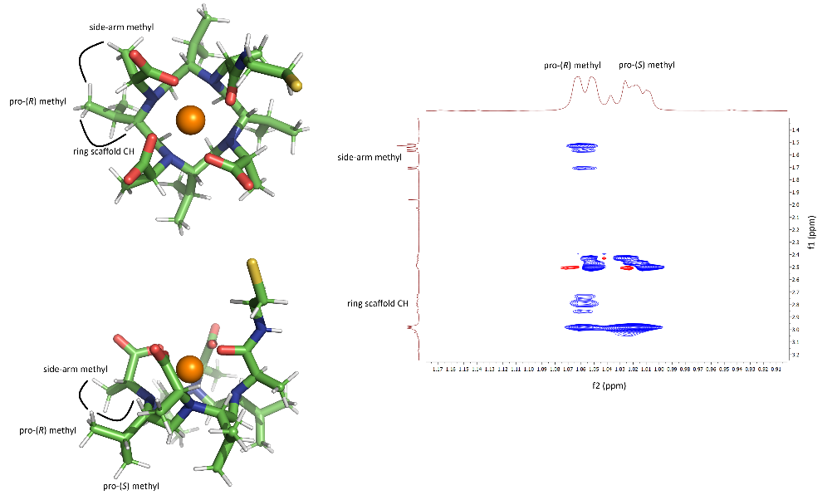
Figure 9: Left: Calculated DFT structure of Lu-P4M4-DOTA, top and side view, SPy activator omitted for clarity; Right: ROE correlations suggesting one preferred conformation of the isopropyl groups of Lu-P4M4-DOTA due to the steric overcrowding.

ROESY experiments support this view and show significantly stronger ROE correlations from the side-arm methyl groups and CH-groups of the basic ring scaffold to the pro-(R) methyl substituents of the isopropyl groups, indicating only one preferred conformation (Figure 9).

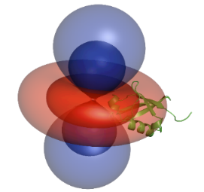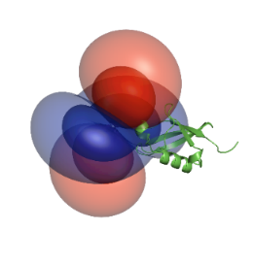
Figure 10: The tensors generated by the thulium (left) and dysprosium complex (right) and their relative orientation to ubiquitin S57C (PCS isosurfaces set to 0.2 ppm (outer layer) and 0.8 ppm (inner layer)).

In terms of the coordination geometry of the ligand, the performed DFT calculations show that the position of the donor atoms differs only by a distance of up to 0.11 Å when comparing the isopropyl and the methyl variant of the LCT (Figures S25, S26). These small changes in the geometry of the LCT are also reflected in the intrinsic proton shift range of Dy-P4M4-DOTA, which is enhanced by 70 ppm when compared with its predecessor, and the intrinsic shift range of Tm-P4M4-DOTA, which is contracted by 50 ppm (Spectra in SI, p. 23).
In order to investigate the mobility of the newly developed lanthanide chelating tag on the proteins surface, the metal centre distribution was modelled using a method developed by Suturina et al. (Figure 11).³³⁻³⁵ In PCS NMR spectroscopy, usually the point paramagnetic centre approximation is applied. Since the protein is measured in solution at room temperature and LCTs show remaining flexibility, the metal position can be more realistically described by using the probability density of the metal position. The approach by Suturina et al. allows to extract the metal position probability distribution by a Tikhonov-regularised 3D reconstruction and a partial differential equation, which is used to describe the PCS on the basis of a non-point electron probability density.^{34, 36}

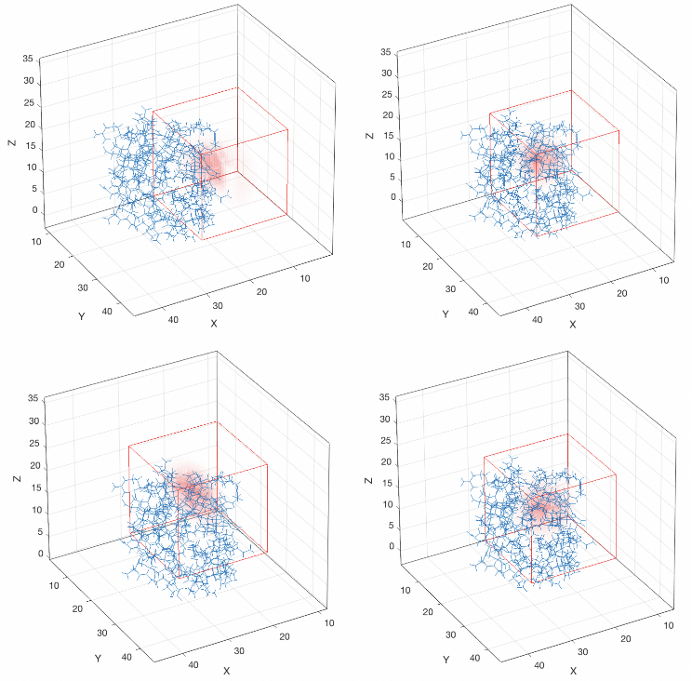
Figure 11: Distribution of the metal position for Tm-DOTA-M8-(4R4S)-Ub^{S57C} (upper left), Tm-P4M4-DOTA-Ub^{S57C} (lower left), Dy-DOTA-M8-(4R4S)-Ub^{S57C} (upper right) and Dy-P4M4-DOTA-Ub^{S57C} (lower right). The metal position distribution is depicted as colour gradient (red = high occupancy, white = very low occupancy. The metal position is restricted to the boundaries of the red cube. The centre of this cube is given by the initial metal position obtained from the point paramagnetic centre approximation resulting from the fitting of the PCS using Spinach. The blue wireframe represents the ubiquitin structure (PDB 1UBI³⁷).

The obtained results for the calculated metal distribution show that the tag is immobilized to the same extent for both P4M4-DOTA and DOTA-M8-(4R4S)-SSPy (Figure 11).
We can therefore conclude, that most likely the enhanced tensor properties for the P4M4-DOTA tag have their major origin in less averaging of the PCS by decreased rotation of the tag in its position on the surface of the protein. In addition, most likely the decrease of the remaining small amplitude vibrations of the donor atoms of the pendant arms of the ligand further enhances the size of the shifts obtained with the P4M4-DOTA tag.

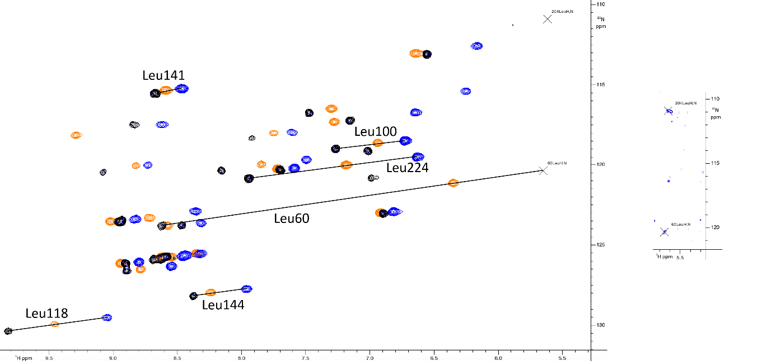

Figure 12: Overlay of ¹H-¹⁵N HSQC spectra of selectively ¹⁵N labelled hCA II S166C labelled with Tm-DOTA-M8-(4R4S)-SSPy (pos. contours: orange, neg. contours: pale orange) and Tm- (pos. contours: blue, neg. contours: pale blue) and Lu-P4M4-DOTA (pos. contours: black, neg. contours: grey) measured in 10 mM phosphate buffer with pH 6.8 at a temperature of 298 K on a 600 MHz Bruker Avance III NMR spectrometer equipped with a cryogenic QCI-F probe. Annotated cross-peaks highlight large PCS and the increase in PCS when comparing Tm-P4M4-DOTA and Tm-DOTA-M8-(4R4S)-SSPy. Crosspeaks close to the water resonance are shown in an extra panel to the right with lower contour levels.

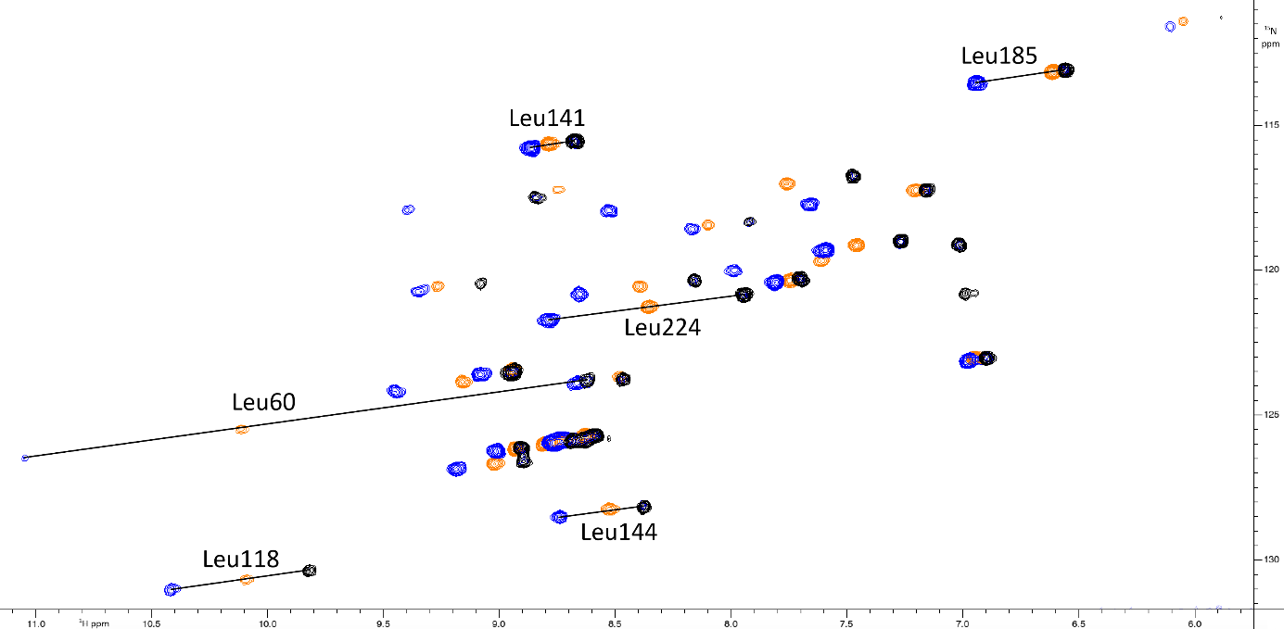

Figure 13: Overlay of ¹H-¹⁵N HSQC spectra of selectively ¹⁵N labelled hCA II S166C labelled with Dy-DOTA-M8-(4R4S)-SSPy (pos. contours: orange, neg. contours: pale orange) and Dy- (pos. contours: blue, neg. contours: pale blue) and Lu-P4M4-DOTA (pos. contours: black, neg. contours: grey) measured in 10 mM phosphate buffer with pH 6.8 at a temperature of 298 K on a 600 MHz Bruker Avance III NMR spectrometer equipped with a cryogenic QCI-F probe. Annotated cross-peaks highlight large PCS and the increase in PCS when comparing Tm-P4M4-DOTA and Tm-DOTA-M8-(4R4S)-SSPy.

Table 2: Properties of the induced paramagnetic susceptibility tensors measured on hCA II S166C at 298K and pH 6.8.
LCT | Nº PCS | Ln³⁺ | ∆χ_{ax} (10⁻³² m³) | ∆χ_{rh} (10⁻³² m³) | X_{metal} | Y_{metal} | Z_{metal} | α | β | γ | Q (%)
P4M4-DOTA | 44 | Dy | -29.698 | -11.539 | -15.527 | -2.893 | -11.375 | 144.072 | 76.845 | 93.570 | 3.2
 | 44 | Tm | 41.860 | 17.121 | -14.610 | -2.262 | -12.236 | 141.687 | 73.207 | 87.393 | 3.6
 | Nº PCS | Ln³⁺ | ∆χ_{ax} (10⁻³² m³) | ∆χ_{rh} (10⁻³² m³) | X_{metal} | Y_{metal} | Z_{metal} | α | β | γ | Q (%)
DOTA-M8-(4R4S) | 50 | Dy | -21.249 | -4.501 | -15.184 | -3.245 | -11.027 | 138.379 | 71.384 | 137.589 | 6.7
 | 50 | Tm | 29.719 | 7.561 | -14.475 | -3.048 | -10.753 | 142.284 | 66.493 | 117.570 | 5.8
 | Nº RDC | Ln³⁺ | ∆χ_{ax} (10⁻³² m³) | ∆χ_{rh} (10⁻³² m³) | X_{metal} | Y_{metal} | Z_{metal} | α | β | γ | Q (%)
P4M4-DOTA | 44 | Tm | 44.122 | -11.104 | -14.610 | -2.262 | -12.236 | -156.26 | -158.72 | -10.395 | 46.0

Benchmarking on selectively ¹⁵N leucine labelled human carbonic anhydrase II S166C
In order to investigate the applicability of the newly developed LCT to larger proteins, we tagged selectively ¹⁵N leucine labelled hCA II S166C, a 29 kDa protein construct, with both the dysprosium and thulium complex (Figures 12 and 13). Furthermore, we attached Tm- and Dy-DOTA-M8-(4R4S)-SSPy to hCA II S166C in order to have a comparison of Ln-P4M4-DOTA and its predecessor.
The obtained anisotropy of the tensors on selectively ¹⁵N leucine labelled hCA II S166C (Table 2) is enhanced, when compared to the tensors for ubiquitin S57C (Table 1). Furthermore, the observed PCS and tensor anisotropies of P4M4-DOTA when attached to hCA II S166C are significantly enhanced when compared to the hCA II S166C-DOTA-M8-(4R4S)-SSPy construct for both its dysprosium and thulium complex. The anisotropy of the Dy relative to the Tm tensor on the hCA II S166C protein construct remains similar when compared to the ratio obtained for P4M4-DOTA-Ub^{S57C} (Table 2, Figure 14).

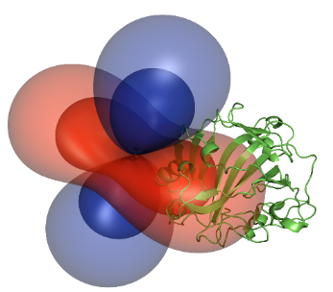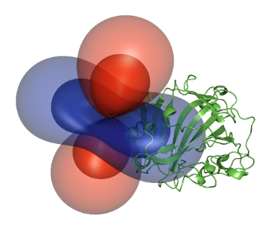
Figure 14: The tensors generated by the thulium (left) and dysprosium complex (right) and their relative orientation to human carbonic anhydrase S166C (PCS isosurfaces set to 0.3 ppm (outer layer) and 1.3 ppm (inner layer)).

The obtained results for ubiquitin S57C and hCA II S166C show that the Ln-P4M4-DOTA tag is applicable without restraints for PCS NMR spectroscopy of proteins as large as 29 kDa and shows promise to be also of value for larger proteins, protein-protein complexes and other biomacromolecules.

Conclusions
To conclude, two strongly paramagnetic lanthanide complexes of P4M4-DOTA are reported that adopt both Λ(δδδδ) (SAP) conformation in solution and provide only one set of signals in HSQC experiments when attached to a protein. A synthetic route towards isopropyl-substituted cyclen is presented, that comprises 11 steps, shows an overall yield of 6% and benefits from the use of readily available, inexpensive starting materials. The newly developed tag shows significantly enhanced anisotropy of the obtained tensors upon attachment to ubiquitin S57C and hCA II S166C when compared to its DOTA-M8-(4R4S)-SSPy analogue. Based on the mobility of the tag on the surface of ubiquitin S57C, the already very rigid basic ring scaffold of the predecessor, the similar position of the donor atoms and the similar intrinsic shift ranges in proton spectra, it can be concluded that the improvement can mainly be attributed to less averaging of the PCS by a decreased rotation of the tag when attached to the protein. The tag was shown to be applicable to proteins of 29 kDa in size and yields strong pseudocontact shifts up to 6.5 ppm. In order to enable challenging applications in biomolecular NMR, as e.g. the structural investigation of extremely large proteins, protein complexes and other biopolymers, the development of high-performance lanthanide chelating tags has to be continued.

Experimental Section

Synthesis
Lanthanide complexes were synthesized using a similar reaction sequence as in the procedures reported in Häussinger et al. for the Lu-DOTA-M8-(4R4S)-SSPy tag.⁹ For the macrocyclic scaffold, a new synthetic route was developed. The complete synthetic procedures as well as analytical data are available in the supporting information.

Expression of ubiquitin S57C and tagging reaction
Ubiquitin S57C was expressed as described previously by Sass et al.³⁸ A sample of ubiquitin S57C (0.1 mM) was incubated with TCEP (2 mM) at pH 7 overnight. The buffer was exchanged to 10 mM phosphate containing 0.1 mM TCEP (pH 7.0 for ubiquitin S57C, pH 6.8 for hCA II S166C) by ultra-filtration (Amicon Ultra-4 Ultracel-3K, cut-off 3 kDa). The remaining minimal amount TCEP was then removed by a PD MiniTrap G-25 column. The obtained protein solution was added to a six-fold excess of Ln-P4M4-DOTA, the mixture was shaken at rt overnight and completion of the reaction was confirmed by ESI-MS. The buffer was exchanged to 10 mM phosphate (pH 6.0 for ubiquitin S57C, pH 6.8 for hCA II S166C) by ultra-filtration (Amicon Ultra-4 Ultracel-3K, cut-off 3 kDa) and the sample was concentrated to 250 µL for NMR experiments.

NMR measurements and determination of the paramagnetic susceptibility tensor
¹H-¹⁵N HSQC spectra were measured in 10 mM phosphate buffer with pH 6.0 (ubiquitin S57C) or pH 6.8 (hCA II S166C) at a temperature of 298 K on a 600 MHz Bruker Avance III NMR spectrometer equipped with a cryogenic QCI-F probe. ¹H-¹⁵N HSQC IPAP spectra were measured in 10 mM phosphate buffer with pH 6.0 at a temperature of 298K on a 900 MHz Bruker Avance III NMR spectrometer equipped with a TXI probe (ubiquitin S57C) and in 10 mM phosphate buffer with pH 6.8 at a temperature of 298K on a 600 MHz Bruker Avance III NMR spectrometer equipped with a QCI-F probe (hCA II S166C). The assignments were transferred to the obtained NMR spectra using CcpNmr Analysis.^{33, 39, 40} The tensor properties were then obtained by fitting to the residues in secondary structure elements of ubiquitin (PDB 1UBI³⁷) or the leucine residues of hCA II (PDB 3KS3⁴¹) using Numbat.⁴² Q-factors were calculated according to the standard equation described by Nitsche et al.¹

DFT calculations
DFT calculations were performed with the ORCA program package⁴³ at the sciCORE facility of the University of Basel. For the calculations, BP86 was used as functional,^{44, 45} SARC-TZVP as basis set for the ligands, while SARC2-QZVP was used as basis set for the lanthanide metal. The calculations were performed using the relativistic ZORA approximation, as well as the RI approximation to speed up the calculations. To model the water solvent, CPCM solvent model was implemented into the calculations.⁴⁶

Acknowledgements
The Chemistry Department of the University of Basel and the Swiss National Science Foundation grant 200021_130263 are acknowledged for financial support. Calculations were performed at sciCORE (http://scicore.unibas.ch/) scientific computing core facility at University of Basel. Biological structures were generated using the open source software PyMOL (http://www.pymol.org/). We are indebted to A. Prescimone for acquiring and solving the crystal structure. C.E. Housecroft, E.C. Constable, T. Müntener and R. Vogel are acknowledged for helpful discussions.
Keywords: protein nuclear magnetic resonance spectroscopy • pseudocontact shift • paramagnetic • lanthanide • macrocycle
[1] C. Nitsche, G. Otting, Progress in Nuclear Magnetic Resonance Spectroscopy 2017, 98-99, 20-49.
[2] B.-B. Pan, F. Yang, Y. Ye, Q. Wu, C. Li, T. Huber, X.-C. Su, Chemical Communications 2016, 52, 10237-10240.
[3] T. Müntener, D. Häussinger, P. Selenko, F.-X. Theillet, J. Phys. Chem. lett. 2016, 7, 2821-2825.
[4] Y. Hikone, G. Hirai, M. Mishima, K. Inomata, T. Ikeya, S. Arai, M. Shirakawa, M. Sodeoka, Y. Ito, Journal of Biomolecular NMR 2016, 66, 99-110.
[5] W.-M. Liu, M. Overhand, M. Ubbink, Coordination Chemistry Reviews 2014, 273-274, 2-12.
[6] C. T. Loh, K. Ozawa, K. L. Tuck, N. Barlow, T. Huber, G. Otting, B. Graham, Bioconjugate Chemistry 2013, 24, 260-268.
[7] G. Otting, Annu. Rev. Biophys. 2010, 39, 387-405.
[8] S. Kamioka, T. Takahashi, S. Kawauchi, H. Adachi, Y. Mori, K. Fujii, H. Uekusa, T. Doi, Organic Letters 2009, 11, 2289-2292.
[9] D. Häussinger, J.-R. Huang, S. Grzesiek, Journal of the American Chemical Society 2009, 131, 14761-14767.
[10] X.-C. Su, B. Man, S. Beeren, H. Liang, S. Simonsen, C. Schmitz, T. Huber, B. A. Messerle, G. Otting, Journal of the American Chemical Society 2008, 130, 10486-10487.
[11] P. H. J. Keizers, A. Saragliadis, Y. Hiruma, M. Overhand, M. Ubbink, Journal of the American Chemical Society 2008, 130, 14802-14812.
[12] G. Pintacuda, A. Y. Park, M. A. Keniry, N. E. Dixon, G. Otting, Journal of the American Chemical Society 2006, 128, 3696-3702.
[13] K. D. Brewer, T. Bacaj, A. Cavalli, C. Camilloni, J. D. Swarbrick, J. Liu, A. Zhou, P. Zhou, N. Barlow, J. Xu, A. B. Seven, E. A. Prinslow, R. Voleti, D. Häussinger, A. M. J. J. Bonvin, D. R. Tomchick, M. Vendruscolo, B. Graham, T. C. Südhof, J. Rizo, Nat. Struct. Mol. Biol. 2015, 22, 555.
[14] V. Gaponenko, A. S. Altieri, J. Li, R. A. Byrd, Journal of Biomolecular NMR 2002, 24, 143-148.
[15] T. Ikegami, L. Verdier, P. Sakhaii, S. Grimme, B. Pescatore, K. Saxena, K. M. Fiebig, C. Griesinger, Journal of Biomolecular NMR 2004, 29, 339-349.
[16] J. Wöhnert, K. J. Franz, M. Nitz, B. Imperiali, H. Schwalbe, Journal of the American Chemical Society 2003, 125, 13338-13339.
[17] T. Müntener, J. Kottelat, A. Huber, D. Häussinger, Bioconjugate Chemistry 2018, 29, 3344-3351.
[18] F. Peters, M. Maestre-Martinez, A. Leonov, L. Kovacic, S. Becker, R. Boelens, C. Griesinger, J Biomol NMR 2011, 51, 329-337.
[19] D. Joss, R. M. Walliser, K. Zimmermann, D. Häussinger, J. Biomol. NMR 2018, 29-38.
[20] T. Müntener, F. Thommen, D. Joss, J. Kottelat, A. Prescimone, D. Häussinger, Chemical Communications 2019, 55, 4715-4718.
[21] R. S. Ranganathan, N. Raju, H. Fan, X. Zhang, M. F. Tweedle, J. F. Desreux, V. Jacques, Inorganic Chemistry 2002, 41, 6856-6866.
[22] R. S. Ranganathan, R. K. Pillai, N. Raju, H. Fan, H. Nguyen, M. F. Tweedle, J. F. Desreux, V. Jacques, Inorganic Chemistry 2002, 41, 6846-6855.
[23] A. C. L. Opina, M. Strickland, Y.-S. Lee, N. Tjandra, R. A. Byrd, R. E. Swenson, O. Vasalatiy, Dalton Trans. 2016, 45, 4673-4687.
[24] D. Parker, R. S. Dickins, H. Puschmann, C. Crossland, J. A. K. Howard, Chemical Reviews 2002, 102, 1977-2010.
[25] L. Dai, C. M. Jones, W. T. K. Chan, T. A. Pham, X. Ling, E. M. Gale, N. J. Rotile, W. C.-S. Tai, C. J. Anderson, P. Caravan, G.-L. Law, Nat. Comm. 2018, 9, 857.
[26] S. Tsuboyama, K. Tsuboyama, I. Higashi, M. Yanagita, Tetrahedron Letters 1970, 11, 1367-1370.
[27] M. Frigerio, M. Santagostino, Tetrahedron Letters 1994, 35, 8019-8022.
[28] M. Frigerio, M. Santagostino, S. Sputore, G. Palmisano, J. Org. Chem. 1995, 60, 7272-7276.
[29] B. Ravinder, Tetrahedron letters 2013, v. 54, pp. 4908-4913-2013 v.4954.
[30] J.-L. Chen, Y. Zhao, Y.-J. Gong, B.-B. Pan, X. Wang, X.-C. Su, Journal of Biomolecular NMR 2018, 70, 77-92.
[31] B. Graham, C. T. Loh, J. D. Swarbrick, P. Ung, J. Shin, H. Yagi, X. Jia, S. Chhabra, N. Barlow, G. Pintacuda, T. Huber, G. Otting, Bioconjugate Chemistry 2011, 22, 2118-2125.
[32] V. S. Mironov, Y. G. Galyametdinov, A. Ceulemans, C. Görller-Walrand, K. Binnemans, The Journal of Chemical Physics 2002, 116, 4673-4685.
[33] E. A. Suturina, D. Häussinger, K. Zimmermann, L. Garbuio, M. Yulikov, G. Jeschke, I. Kuprov, Chem. Sci. 2017, 8, 2751-2757.
[34] E. A. Suturina, I. Kuprov, Physical Chemistry Chemical Physics 2016, 18, 26412-26422.
[35] H. J. Hogben, M. Krzystyniak, G. T. P. Charnock, P. J. Hore, I. Kuprov, Journal of Magnetic Resonance 2011, 208, 179-194.
[36] G. T. P. Charnock, I. Kuprov, Physical Chemistry Chemical Physics 2014, 16, 20184-20189.
[37] R. Ramage, J. Green, T. W. Muir, O. M. Ogunjobi, S. Love, K. Shaw, The Biochemical journal 1994, 299 ( Pt 1), 151-158.
[38] J. Sass, F. Cordier, A. Hoffmann, M. Rogowski, A. Cousin, J. G. Omichinski, H. Löwen, S. Grzesiek, Journal of the American Chemical Society 1999, 121, 2047-2055.
[39] W. F. Vranken, W. Boucher, T. J. Stevens, R. H. Fogh, A. Pajon, M. Llinas, E. L. Ulrich, J. L. Markley, J. Ionides, E. D. Laue, Proteins: Struct., Funct., Bioinf. 2005, 59, 687-696.
[40] D. L. Di Stefano, A. J. Wand, Biochemistry 1987, 26, 7272-7281.
[41] B. S. Avvaru, C. U. Kim, K. H. Sippel, S. M. Gruner, M. Agbandje-McKenna, D. N. Silverman, R. McKenna, Biochemistry 2010, 49, 249-251.
[42] C. Schmitz, M. J. Stanton-Cook, X.-C. Su, G. Otting, T. Huber, Journal of Biomolecular NMR 2008, 41, 179.
[43] F. Neese, Wiley Interdiscip. Rev. Comput. Mol. Sci. 2012, 2, 73-78.
[44] A. D. Becke, Physical Review A 1988, 38, 3098-3100.
[45] J. P. Perdew, Phys. Rev. B 1986, 33, 8822-8824.
[46] Y. Takano, K. N. Houk, Journal of Chemical Theory and Computation 2005, 1, 70-77.

Entry for the Table of Contents (Please choose one layout)

Layout 1:

FULL PAPER
Pseudocontact shifts (PCS) generated by lanthanide chelating tags (LCT) yield valuable structural restraints for the analysis of structure, dynamics and ligand-binding of proteins in solution. We present a highly rigidified lanthanide chelating tag that induces strong pseudocontact shifts and residual dipolar couplings when attached to ubiquitin S57C and human carbonic anhydrase II S166C. |  | 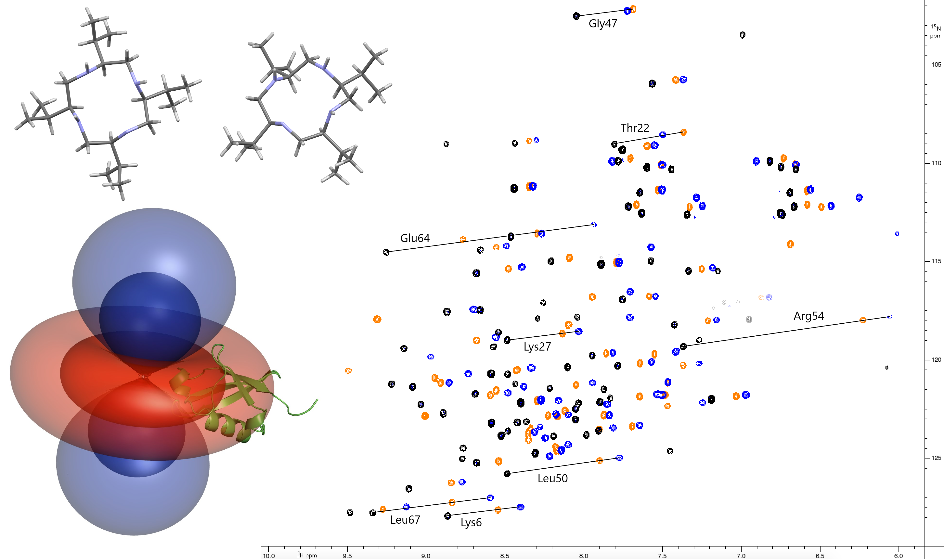 |  | Daniel Joss, Maria-Sophie Bertrams, Daniel Häussinger*  Page No. – Page No.  A sterically overcrowded, isopropyl-substituted lanthanide chelating tag for protein PCS NMR spectroscopy: Synthesis of its macrocyclic scaffold and benchmarking on ubiquitin S57C and hCA II S166C

