Supporting Information

Effect of Divalent Cation on Swelling Behavior of Anionic Microgels: Quantification and Dynamics of Ion Uptake and Release

Vittoria Chimisso, Csaba Fodor and Wolfgang Meier*
University of Basel, Department of Chemistry, Mattenstrasse 24a, BPR1096, 4002 Basel, Basel-Stadt, Switzerland

Table S1. Synthetic conditions for the polymerization of neutral microgels with various N-vinylcaprolactam (VCL) and dimethylitaconate (IADME) ratios.

Sample ID | VCL/IADME ratio | VCL |  | IADME |  | AMPA |  | BIS |  | CTAB
 |  | g | mmol | g | mmol | g | mmol | g | mmol | g | mmol
N0 | 100:0 | 2.087 | 15.00 | 0 | 0 | 0.053 | 0.19 | 0.060 | 0.38 | 0.010 | 0.027
N5 | 95:5 | 1.983 | 14.24 | 0.118 | 0.75 | 0.053 | 0.19 | 0.060 | 0.38 | 0.010 | 0.027
N10 | 90:10 | 7.879 | 13.50 | 0.237 | 1.50 | 0.053 | 0.19 | 0.060 | 0.38 | 0.010 | 0.027
N15 | 85:15 | 1.774 | 12.75 | 0.355 | 2.25 | 0.053 | 0.19 | 0.060 | 0.38 | 0.010 | 0.027
N20 | 80:20 | 1.670 | 12.00 | 0.474 | 3.0 | 0.053 | 0.19 | 0.060 | 0.38 | 0.010 | 0.027
N30 | 70:30 | 1.461 | 10.50 | 0.711 | 4.5 | 0.053 | 0.19 | 0.060 | 0.38 | 0.010 | 0.027

Table S2. Amount of dimethylitaconate (IADME) incorporated and itaconic acid (IA) groups.

Sample ID | Theoretical value | NMR value | ATR-FTIR value | Sample | IR value | TITRATION
N0 | 0 | 0 | 0 | NA | NA | NA
N5 | 5 | 5 | 5.775 | M4 | 4.089 | 3.8
N10 | 10 | 10 | 9.395 | M7 | 5.471 | 6.5
N15 | 15 | 15 | 16.013 | M11 | 7.429 | 11
N20 | 20 | 20 | 22.950 | M13 | 10.474 | 12.5
N30 | 30 | 30 | 31.068 | M15 | 15.711 | 14.5

Table S3. Rg/RH of P(VCL-co-IADME) (Nn) microgels in pure water at pH 7 and P(VCL-co-IA) (Mn) microgels in pure water at pH 7 and pH 3.

Sample ID | Rg/RH  (pH=7) | Code | Rg/RH  (pH=3) | Rg/RH  (pH=7)
N0 | 0.55
N5 | 0.52 | M4 | 0.63 | 0.37
N10 | 0.61 | M7 | 0.60 | 0.38
N15 | 0.61 | M11 | 0.63 | 0.42
N20 | 0.66 | M13 | 0.63 | 0.52
N30 | 0.74 | M15 | - | 0.37

Table S4. Comparison of the DH of P(VCL-co-IA) (M) microgels in the presence of Ca²⁺ and at pH 3 at T=20 °C.

Sample ID | DH  [Ca2+]= 10 mM  (pH= 7) | Rg/RH  [Ca2+]= 10 mM  (pH= 7) | DH  [Ca2+]=0 mM (pH= 3)
M4 | 319 ± 18 | 0.66 | 244 ± 2
M7 | 320 ± 10 | 0.64 | 264 ± 4
M11 | 298 ± 8 | 0.62 | 230 ± 4
M13 | 308 ± 3 | 0.43 | 204 ± 2
M15 | 278 ± 4 | 0.53 | NA

Table S5. ζ-potential of P(VCL-co-IA) (Mn) microgels samples in pure water and loaded with Ca2+ ions.

Ζ-potential (mV)
Sample ID | empty gels | loaded gels
M4 | -16.2 ± 0.5 | -11.9 ± 0.8
M7 | -18.8 ± 0.4 | -16.9 ± 0.3
M11 | -19.8 ± 0.6 | -18.4 ± 0.2
M13 | -24.3 ± 0.6 | -20.3 ± 1.0
M15 | -28.9 ± 0.9 | -26.6 ± 0.8

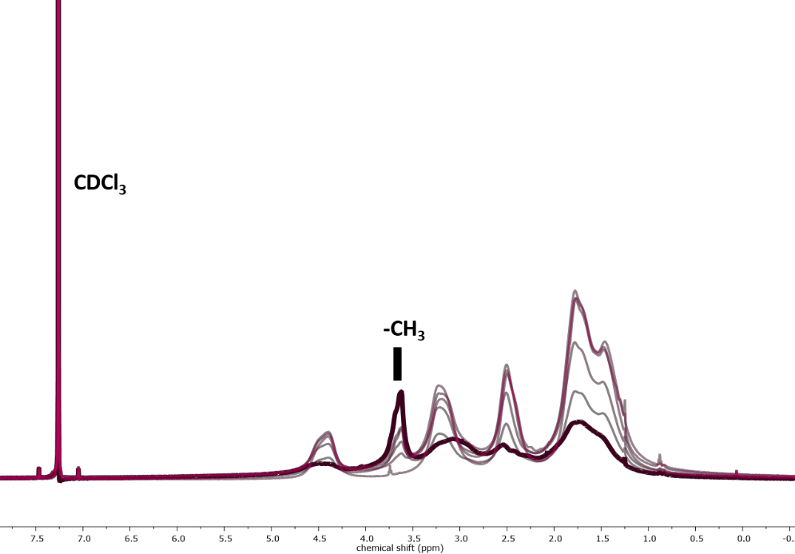

Figure S1 1H-NMR spectrum of PVCL (pale pink) no signal at 3.64 ppm, P(VCL-co-IADME) 5 mol% (pale pink), 10 mol% (pale violet), 15 mol% (violet), 20 mol% (purple) and 30 mol% (black).

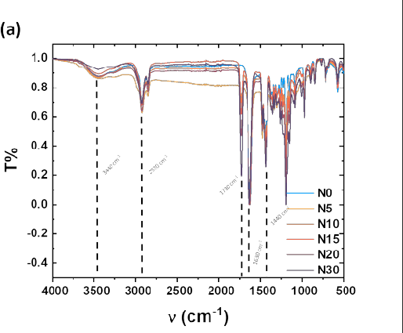
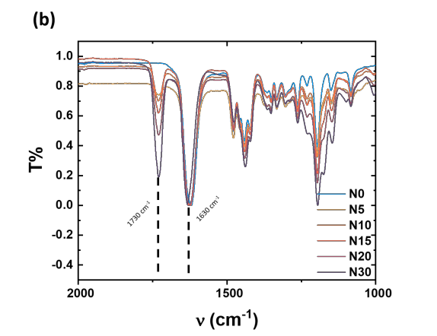
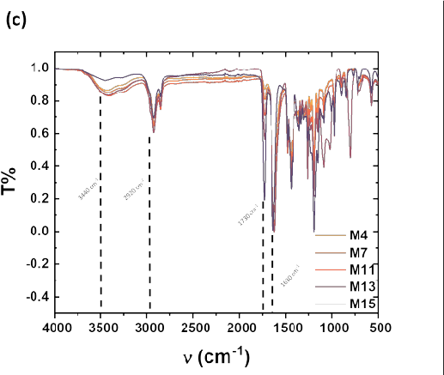
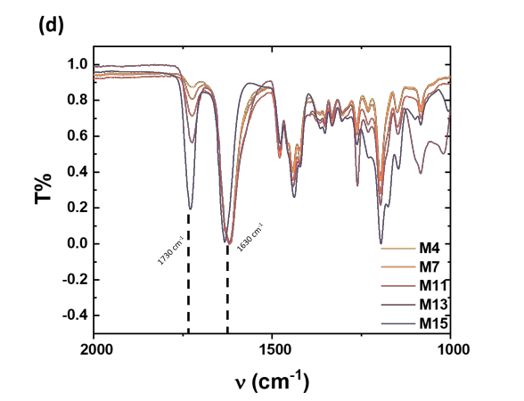

Figure S2 (a) full ATR-FTIR spectra of P(VCL-co-IADME) (b) ATR-FTIR spectra of P(VCL-co-IADME) zoomed on relevant ester groups of itaconate (1730 cm-1) and amide band of VCL (1630 cm-1) (c) full ATR-FTIR spectra of P(VCL-co-IA) (d) ATR-FTIR spectra of P(VCL-co-IA) zoomed on relevant ester groups of itaconate (1730 cm-1) and amide band of VCL (1630 cm-1) .

550
N Microgel M Microgel

500

450
DH (nm)

400

350

300

250

200

0 5 10 15 20 25 30 35
mol% (a.u.)

Figure S3. DH of P(VCL-co-IADME) (Nn) and P(VCL-co-IA) (Mn) microgels in water at T= 10 °C according to the IADME mol% (N microgels) and COOH moieties (M microgels) measured at pH=7.

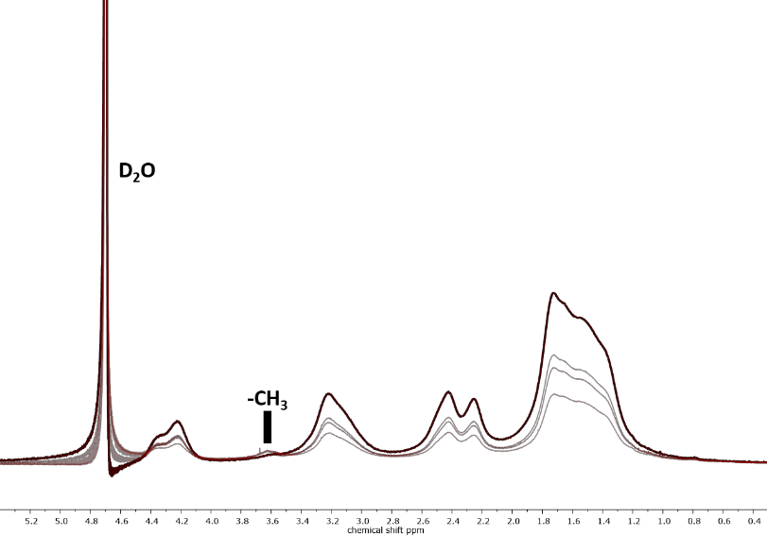

Figure S4. ¹H NMR of P(VCL-co-IA) in D2O, peak at 3.65 ppm corresponds to the remaining methoxy protons of dimethylitaconate.

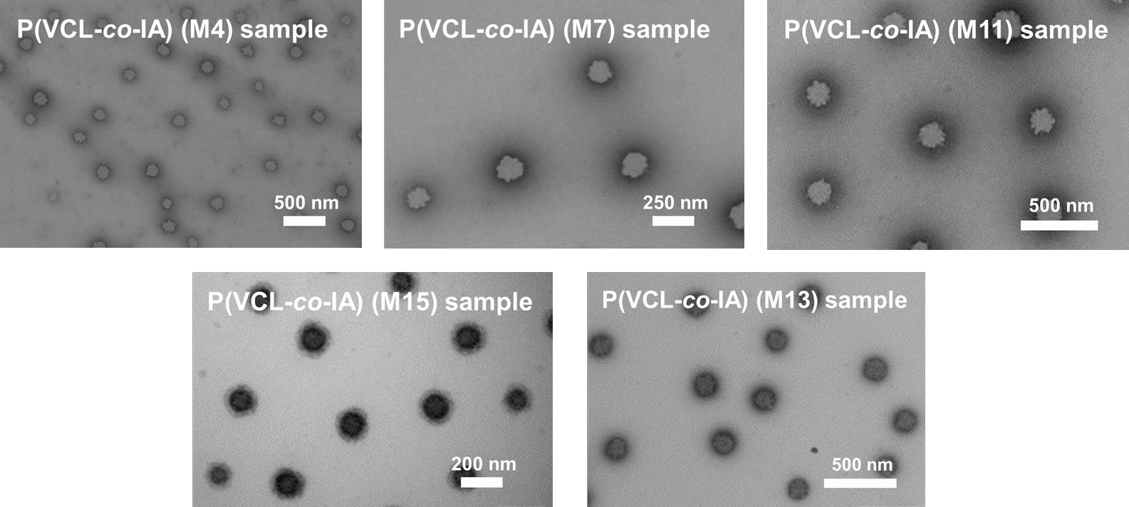

Figure S5. TEM images recorded of P(VCL-co-IA) M4, M7, M11, M13 and M15 microgels by staining them with PTA.

550

N sample 0 mM Ca²⁺ N sample 10 mM Ca²⁺ M sample 0 mM Ca²⁺ M sample 10 mM Ca²⁺

500

450

400
DH (nm)

350

300

250

200

0 5 10 15 20 25 30

COO⁻ mol%

Figure S6. DH of P(VCL-co-IADME) (Nn) microgels (orange) and P(VCL-co-IA) (Mn) microgels (purple) recorded in pure water at pH=7 (hollow symbols) and in 10 mM Ca2+ solution, recorded at T= 10°C.

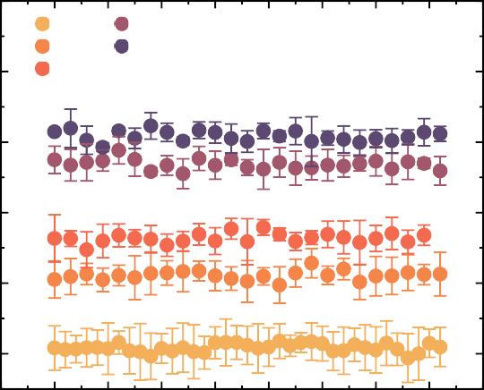
340
M4 M13
M7 M15
320 M11

300
DH (nm)

280

260

240

-50 0 50 100 150 200 250 300 350 400

t (s)

Figure S7. DH of P(VCL-co-IA) (Mn) microgel samples against time, at a Ca²⁺ concentration of 10 mM and T= 32 °C.

(a)

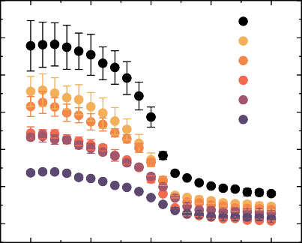
450

400

350
DH (nm)

300

250

200

150

N0 N5 N10 N15 N20 N30
(b)

550

500

450
DH (nm)

400

350

300

250

200

M4 M7 M11 M13 M15

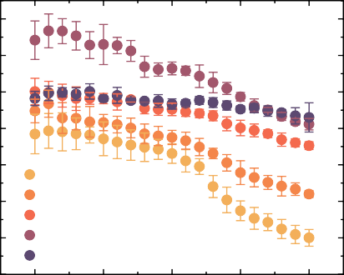
10 20
30 40 50

T (°C)
10 20 30 40 50

T (°C)

Figure S7. DH of P(VCL-co-IADME) (Nn samples) against temperature measured in pure water and (b) DH of P(VCL-co-IA) (Mn samples) against temperature measured in pure water at pH=7.

18
M11
M13 M15
M4 M7

16

14
[Ca²⁺] (ppm)

12

10

8

6

4
-200 0 200 400 600 800 1000 1200 1400
t (s)

Figure S9. Amount of Ca2+ retained overtime at pH 7 and T= 20 °C of P(VCL-co-IA) (Mn) microgels.

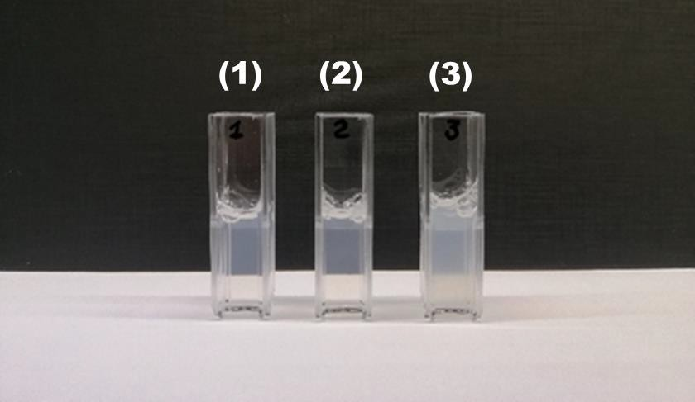

Figure S10. Turbidity of 0.1 wt% P(VCL-co-IA) (M15) microgel samples in (1) water, (2) after the addition of 1 mM Ca2+ to the solution and (3) after the addition of acid to equilibrate to pH 3.

(a)
(b)

0.2
M4 10 mM Ca²⁺ M4 pH 3

0.15
M4 10 mM
M4 1 mM
M4 0.1 mM
Abs
Abs

0.10

0 10 20 30 40 50 60
t (s)
0.1

0 10 20 30 40 50 60

t (s)

(c)

0.25

(d)

0.3
M7 10 mM Ca²⁺ M7 pH 3

0.20
M7 10 mM
M7 1 mM
M7 0.1 mM

0.2
Abs
Abs

0.15

0.10

0 10 20 30 40 50 60

t (s)

0.1

0 10 20 30 40 50 60
t (s)

(e)

0.25
(f)

0.4

M11 10 mM Ca²⁺ M11 pH 3

0.20
Abs
0.3

0.15 0.2
Abs

0.10

0 10 20 30 40 50 60
M11 10 mM
M11 1 mM
M11 0.1 mM

t (s)
0.1

0 10 20 30 40 50 60

t (s)

(g)

0.45
M13 10 mM M13 1 mM
M13 0.1 mM
0
10
20
30
40
50
60
(h)

0.4
M13 10 mM Ca²⁺ M13 pH 3

0.40

0.35
Abs
0.25
0.3

0.20
Abs
0.2

0.15

0.10

t (s)

0.1

0 10 20 30 40 50 60

t (s)

(i)

0.45
(j)

1.0

0.40

0.9

0.35 0.4
Abs
Abs
0.25

0.20

0.3

0.15

0.10

M15 10 mM M15 1 mM
0 10 20 30 40 50 60
t (s)
0.2

0.1

M15 10 mM Ca²⁺ M15 pH 3
0 10 20 30 40 50 60
t (s)

Figure S11. Absorbance spectra measured in function of time of a 0.1 wt% microgel solution, measured with a scanning rate of 1 measurement per second; (a),(c),(e),(g),(i): measurements were made at T= 20°C and pH= 7, (b),(d),(f) and (j): measurements were performed in the same cuvette at T= 20 °C, with a starting pH= 7.

