Effect of Divalent Cation on Swelling Behavior of Anionic Micro-gels: Quantification and Dynamics of Ion Uptake and Release
Vittoria Chimisso, Csaba Fodor and Wolfgang Meier*
University of Basel, Department of Chemistry, Mattenstrasse 24a, BPR1096, 4002 Basel, Basel-Stadt, Switzerland
KEYWORDS: anionic microgel, gel collapse, calcium ion, vinylcaprolactam, itaconic acid

ABSTRACT: Poly(N-vinylcaprolactam-co-itaconate) (P(VCL-co-IADME) microgels were synthesized varying the molar ratio between VCL and IADME via free radical precipitation polymerization in the presence of quaternary ammonium surfactant. In order to determine the effect of the divalent metal ions on the structure and the swelling behavior of the microgel systems, both neutral and charged forms of the hydrogels after hydrolysis were investigated. The triggered gel collapse caused by the divalent metal ion together with the quantification of the metal ion uptake was studied in detail by titration and ion chromatography methods and revealed the minimum concentration around 0.1 mM to trigger gel collapse on the treated gels. Uptake and release dynamics of the gels were followed by turbidity measurements and were in the time-range of 2 and 17 seconds, depending on the composition and the concentrations.

INTRODUCTION
Microgels are known as cross-linked polymeric networks that swell in a good solvent and are characterized by a size that goes from hundreds of nanometer to tens of micrometer.¹ This class of soft materials displays high application versatility due to their porosity, high surface area and stimulus responsive behavior. By tuning their chemical composition, moieties reactive to external triggers can be introduced to change their swelling degree and solvent affinity, making the gel responsive to temperature,² pH,³⁻⁶ light,⁷ ionic strength,⁸ hydrostatic pressure,⁹ electrochemical potential¹⁰ and solvent composition.^{3, 11-12} The possibility to fine-tune their size and responsiveness along with their proven biocompatibility makes them excellent candidates for drug delivery,¹³⁻¹⁴ sensor¹⁵⁻¹⁶ and catalytic applications.¹⁷⁻¹⁸ Charged gels such as polyelectrolyte and polyampholytic gels have shown great uptake and release properties for drugs,¹⁹ surfactants,²⁰ small molecules,²¹ polyelectrolytes²² and small proteins such as Cytochrome C (CytC).²³ Even though the uptake and release are generally diffusion driven, the introduction of charged moieties that can be modulated by pH changes enables the system to a higher degree functionality for controlled release.^{19, 23} For all these classes of molecules, extensive studies have been performed on microgels bearing both temperature and pH responsive behavior.²⁴ Some of the most popular gels are composed of either poly(N-isopropylacrylamide) (PNIPAM) or poly(N-vinylcaprolactam) (PVCL) that act for the part, and poly(acrylic acid) (PAA) or poly(itaconic acid) (PIA) that bear the ionic thus pH responsive functionality.²⁵⁻²⁷ In fact, the combination of multiple stimuli allows the controlled release in different environments, which makes them strong candidates for in vivo applications.
A multitude of biological processes ranging from muscle contraction,²⁸ transmission, nerve impulse,²⁹ and fluid balance³⁰ in cells are activated and regulated by the presence or release of divalent ions, such as Ca²⁺ or Mg²⁺. Moreover, the presence of Ca²⁺ in lysosomes regulates their behavior and action within the cell environment.³¹ Muscle contraction is triggered by the 10-fold increase of the cytosolic concentration, rising from 100 nM at the resting condition to 2-4 mM.³² One of the challenges in cell biology is to deliver with high specificity a stimulus within the cell without triggering other factors. A very popular approach is to use stimuli sensitive polymerosomes for the triggered release of water-soluble drugs,³³ or microgels.³⁴ However, little research has been done on the capability of gels to deliver an ionic stimulus, even though extensive data is available on their responsiveness towards alkali ions. In fact, in comparison to small molecules or proteins, very little studies have been done on the capability of microgels to uptake and release Ca²⁺.
Early studies performed on PAA microgels showed how the addition of divalent ions such as Ca²⁺ triggered microgel collapse, yet the strength of the ion binding was not high enough to form a supramolecular colloidal gel from them.³⁵ This might be attributed to the presence of the cationic initiator at the periphery of the gel that prevents significant intermicrogel bridging. The binding affinity was also estimated via isothermal titration calorimetry (ITC) measurements, showing the formation of complexes with high binding affinity within the network, which however formed weak field sites due to steric constraint.³⁶ The introduction of a thermoresponsive moiety such as VCL, lead to similar results in the presence of Ca²⁺ ions as shown by Saunders et al., yet at temperatures above the volume phase transition temperature (VPTT= 32 °C) and neutral pH, aggregation of the
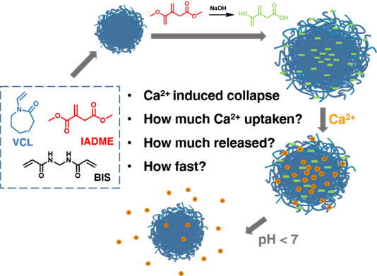
Scheme 1. Synthetic process of thermo- and pH responsive anionic microgels for the complexation and release of Ca²⁺ ions.
gels could be observed over time.³⁷ This was explained through the increase of local density of complexing free groups on the gel surface, which would lead to an increase of the available coordination sites for Ca²⁺ bind, also between multiple microgels.³⁷⁻³⁸ However, to the best of our knowledge, there are no studies available on the quantification of Ca²⁺ ions that can be up taken and released by a thermoresponsive anionic microgel. For this reason, we designed a thermo- and pH responsive anionic microgel, composed of VCL and IA, which is already known to be biocompatible and has shown good potential as carrier for small cationic molecules and proteins, yet its behavior towards Ca²⁺ or in general towards divalent ions has not been studied.²³ We design it to have a pseudo core-shell structure, in which the microgel is still statistical but there is a progressive enrichment of the core with the IA moieties.²⁶ This should prevent the gels from any temperature-triggered aggregation above its VPTT of 32 °C and provide a stable system for eventual in vivo applications. The novelty in this study consists in the quantification of Ca²⁺ that can be coordinated by an anionic microgel whilst keeping the system stable towards ionic strength, and the release of the ions stimulated by a pH trigger (Scheme 1). We investigate the effect of chemical composition on the uptake and release capability of the microgels, progressively enriching the gel in its anionic content until a threshold is reached. We also perform the kinetics of uptake and release of the Ca²⁺ ions, which plays a fundamental role for the choice in its future application as ion delivery system or as sensor.

MATERIALS AND METHODS
Materials. N-Vinylcaprolactam (VCL, 98%), dimethylitaconate (IADME ≥99%), N,N’-methylene(bis)acrylamide (BIS, 99%), hexdecyltrimethylammonium bromide (CTAB, 99%), calcium chloride dihydrate (CaCl₂.x2H₂O, 99%) were purchased from Sigma Aldrich. 2’-azobis[2-methylproprionamide]dihydrochloride (AMPA, granular, 97%) was obtained from Acros Organic. Deuterated chloroform (CDCl₃-d1, 99.8 atom% D) and deuterated water (D₂O, 99.9 atom% D) were obtained from Cambridge Isotope Laboratories, Inc. All the chemicals were used as received without any treatment if not otherwise specified. VCL was purified under reduced pressure distillation (128 °C) prior to use. All experiments were performed using Millipore pure water with a resistivity of 18.2 MΩ cm⁻¹ filtered with a 450 µm filter, and if not stated otherwise at pH= 7 in absence of buffer.
Synthesis of P(VCL-co-IADME) microgels. Microgels were synthesized via free radical precipitation polymerization. The procedure was adapted from the literature.²³ Briefly, in a typical reaction stock solutions of BIS and CTAB in water were prepared, and adequate amounts of VCL and IADME were solubilized in the solution mixture (140 ml) in a 250 ml three neck round bottom flask equipped with a mechanical stirrer, a thermometer and an inlet for inert gas. The solution was left stirring at 300 rpm for 60 min, heated up to 70°C and N₂ was bubbled through for 1 h to ensure complete degassing of the solution. A solution of AMPA in water (10 ml) was degassed for 15 min and then added in one shot to the VCL solution. The reaction was allowed to proceed for 3 h under inert atmosphere at 70°C, and was subsequently quenched by allowing air in the solution and cooling down to room temperature. The formed gels were purified by dialysis (Spectra /Por(R)7 Dialysis Membrane, Pre-treated RC Tubing, MWCO: 50 kDa) against Millipore pure water for 6 days. The gels were then collected and stored in water as stock solutions for further use.
Hydrolysis of P(VCL-co-IADME) to obtain P(VCL-co-IA) microgels. Microgels were left stirring for 3 to 7 days in 0.1 M NaOH solution to ensure the hydrolysis of the itaconate moieties to itaconic acid (IA), followed by dialysis (Spectra /Por(R)7 Dialysis Membrane, Pre-treated RC Tubing, MWCO: 50 kDa) against Millipore pure water for 4 days and left in water as stock solutions for further use. To determine the weight concentration 2 ml of microgel solution were lyophilized and weighted on a high precision balance.
Ca²⁺ triggered gel collapse. The microgels were dispersed in a Ca²⁺ ions solution at different dilutions (100, 10, 1, 0.5, 0.1, 0.05, 0.01 and 0.001 mM) to a final concentration of 0.02 wt% of microgels at pH= 7. The equilibration time of the microgels were set on 12 h during shaking and subsequently analyzed via light scattering.
Ca²⁺ loading experiments. Microgels were dispersed in a Ca²⁺ solution with a final concentration of 0.1 wt% (5 ml water) at pH= 7, and left agitating on a shaker overnight. Microgels and blank Ca²⁺ solutions were centrifuged in a Vivaspin 20 centrifuge filter (Sartorius Stedim biotech, Vivaspin 20, MWCO PES: 10 kDa) at 2000 rpm for 40 min to obtain 4 mL of filtered sample. The filtrate was collected for further analysis. The concentrated Ca²⁺ loaded microgels (remaining 1 ml) were diluted back to 5 mL to obtain final pH of 2, 3, 4 and 5. The samples were left shaking followed by centrifugation (2000 rpm for 1h at 20 °C) and the filtrate was collected for further analysis.
Ca²⁺ leaching experiments. Microgels were loaded with Ca²⁺ and washed once with Millipore pure water by centrifuging utilizing Vivaspin 20 centrifuge filters (Sartorius Stedim biotech, Vivaspin 20, MWCO PES: 10 kDa). The gels were left shaking for 30 minutes in Millipore pure water (5mL) at pH= 7, and centrifuged for 30 min. The procedure was repeated 10 times. The filtrate was analyzed via ion chromatography to determine the amount of Ca²⁺ released from the gels over time.
Ca²⁺ release experiments. Loaded microgels were transferred to solutions at pH 2, 3, 4 and 5, with an equilibration time of 10 minutes. The gels where then centrifuged in a Vivaspin 20 centrifuge filter (Sartorius Stedim biotech, Vivaspin 20, MWCO PES: 10 kDa) and the filtered water was analyzed via Ion Chromatography.
Ion chromatography. The Ca²⁺ uptake by the microgels was measured via ion chromatography with a 940 Professional IC Vario (Metrohm). 30 μl samples were eluted on a 250mmx40mm column with an elution flux of 0.8 ml/min in HNO₃ (7.25 mM) at 30°C. Three independent measurements were used to evaluate one data point.
Light scattering. Dynamic light scattering (DLS) was applied to measure the hydrodynamic diameter (D_{H}) of the microgels by using a Zetasizer Nano ZsP (Malvern Instruments). Measurements were taken at 10 °C, after an equilibration time of 420 s with a back scattering angle of 173°. pH dependent size measurements were performed using a MPT-2 Multipurpose titrator (Malvern Instruments) and a MV114-SC Malvern Comb Glass Electrode , and titrated with an at increments with an interval of 0.5 from pH 2 to 12. Static light scattering (SLS) measurements were performed with an LS spectrometer from LS Instrument (Switzerland) with a HeNe laser (633 nm) with varying scattering angles in 2D/pseudo cross-correlation mode. All measurements were carried out at 25.0 °C and averaged over 3 measurements of 60 seconds each.
Transmission Electron Microscopy (TEM). Microgel morphologies and group distribution were determined via TEM imaging with a Philips Morgagni 268D microscope. Microgel solutions in water at 0.01 wt% were negatively stained with a solution of 0.015% sodium phosphotungstate (PTA) solution and deposited on a carbon-coated copper grid. The samples were blotted, washed and negatively stained before TEM imaged.
Nuclear Magnetic Resonance (NMR). NMR spectra were acquired in deuterated solvents (Chloroform-d or deuterated water) on a Bruker 400 MHz (1H: 400 MHz; 13C: 100 MHz) spectrometer at room temperature utilizing 256 scans with a 0.1 wt% microgel concentration. Chemical shifts (δ) are reported in ppm, whereas the chemical shifts are calibrated to the main solvent residual peaks. The collected spectra were analyzed using MestReNova (v9.1) (Mestrelab Research S.L).
Fourier Transform Infrared Spectroscopy (FT-IR). Background corrected attenuated total reflection-Fourier transform infrared spectroscopy (ATR-FTIR) spectra were recorded on a Bruker spectrophotometer in the range of 4000-400 cm-1, using 128 scans at a nominal resolution of 4 cm⁻¹ using a diamond single reflection ATR. Atmospheric compensation and offset correction were applied on the collected spectra to determine the degree of hydrolysis by following the presence of the methyl groups relative the IADME monomer on freeze-dried samples. The ATR-FTIR spectra were evaluated with the use of OPUS spectroscopy software (v7.0) (Bruker Optics).
Potentiometric titration. The pH sensitivity, the determination of the acid groups of the resulting microgels were evaluated by potentiometric titrations and the pKa values were determined in the pH value range of 5-9 using a Zetasizer Nano ZsP (Malvern Instruments). For the titration and pH detection of 0.1 wt% microgel solutions, prepared by using Millipore pure water MPT-2 multi-purpose titrator (Malvern Instruments) with a MV114-SC Malvern Comb Glass Electrode were used. The aqueous solutions were titrated with NaOH solution (0.01 M) at increments with an interval of 0.5. The ζ-potential as well as the change of the particle size were determined at room temperature as the average of 3 measurements. The collected datasets were analyzed using Zetasizer Software (v7.0) (Malvern Instruments).
Sample identification. The P(VCL-co-IADME) microgel samples are coded with the N, the (VCL-co-IA) microgels were labelled with M, where the additional number n in the sample identification stands for the theoretical IADME and the IA content in mol%, respectively, i.e. N10 denotes the P(VCL-co-IADME) sample with 10 mol% of IADME and M12.5 denotes the sample with 12.50 mol% of IA. The exact composition of the Nn and the Mn microgels is displayed in Table S1.

RESULTS and DISCUSSION
Preparation and characterization of neutral and charged microgels. P(VCL-co-IADME) microgels were prepared by precipitation polymerization in the presence of a quaternary ammonium surfactant, by varying the molar ratio between VCL and IADME, whilst keeping the cross-linker and surfactant constant to stabilize the gels, as shown in Table S1, named N0 to N25 according to their IADME mol% content. Microgel sample (N0) was prepared without IADME, to be used as a reference system in the Ca²⁺ uptake studies. ¹H NMR spectra were recorded to determine the molar ratio between VCL and IADME moieties, and the results were compared with the relative intensities of the signals recorded in the ATR-FTIR transmission spectra (Figure S1 and S2 in the Supporting Information). Integration in the ¹H NMR spectra showed progressive enrichment of the comonomer ratio consistent with the comonomer feed, and the integration areas of the IADME methyl protons showed almost a quantitative integration of IADME within the VCL chain. These results were consistent with the results obtained by ATR-FTIR data. The main characteristic absorption bands in PVCL is assigned to the carbonyl (C=O, stretching) which appeared at 1630 cm⁻¹, whilst the characteristic band for IAMDE were assigned to the ester moiety which appear at 1720 cm⁻¹ (C=O stretching). The D_{H} of the gels was recorded in water at 10 °C to determine their swollen size, and the D_{H} decrease with the increase of comonomer enrichment. The homopolymeric N0 is characterized by a D_{H} = (387 ± 39) nm, which steadily decreases to a D_{H} = (218 ± 3) nm for N25 (Figure S7).
The subsequent hydrolysis in NaOH of the IADME ester group was done to obtain negatively charged P(VCL-co-IA) microgels bearing the carboxylic acid moieties able to bond divalent ions. Each Nn was hydrolyzed into the correspondent Mn microgel. The hydrolysis was performed only for a limited time and not allowed to completion, as the partially hydrolyzed gels proved to be more stable than the fully hydrolyzed ones. The chemical structure was also evaluated via ¹H NMR by following the disappearance of the ester methyl signals, however the scarce solubility of the methoxide groups of unreacted IADME in D₂O gave only qualitative information about the partial hydrolysis (Figure S3). ATR-FTIR was instead used focusing on the disappearance of the ester signals meaning the formation of new carboxylic acid functional groups, whose band is however overlapping with the amide group relative to the VCL comonomer. (Figure S2 (b)). Nevertheless, the integration of the ester group belonging to IA against the normalized peak corresponding to the C=O stretching in the VCL was performed, and allowed an estimation of degree of hydrolysis and thus the carboxy groups. Due to the uncertainty in the final molar values due to the band overlap, the amount of -COOH groups was determined by potentiometric titration, as shown in Table S2. The results show a partial hydrolysis of the ester moieties of around 50%. Since the two ester groups of IADME are not fully equivalent and possess different reactivity, these results suggest that the ester group further away from the C=C mostly undergoes the saponification process (pK_{a1}= 3.84, pK= 5.55).²³
The dry morphology of all microgels was determined by TEM (Figure 1 and Figure S3), whereas the swollen size was measured via DLS (Figure S7). The higher the amount of hydrolyzed comonomer, the higher the degree of swelling due to the hydrolysis. In fact, M4 is characterized by a D_{H} = (392 ± 27) nm and the D_{H} increases along the series until M13 (D_{H} = (520 ± 26) nm). The D_{H} relative to M15 is lower even though the amount of COOH moieties is higher as the still present ester groups still contribute significantly to the overall hydrophobic character of the chain. The neutral gels are uniformly stained by the uranyl acetate, meaning that there is no charge accumulation within the gel. On the other hand, anionic microgels show a transition from a homogenous structure to a core shell one, consistent with what has been previously reported when using this synthetic sequence.²⁶
Direct copolymerization of IA with VCL would lead to a more statistical microgel structure, which however wants to be avoided in the present study. In fact, having a more homogenous distribution of the anionic moieties would lead to temperature-induced aggregation of the gels in the presence of Ca²⁺ ions as previously reported in the literature.³⁷ To prove their stability, the D_{H} of the gels was measured over a period of 7 h at 32 °C, at a Ca²⁺ concentration
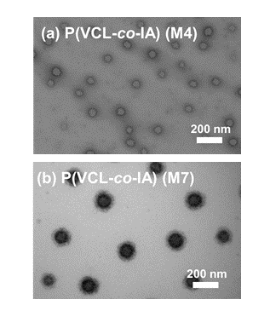Figure 1. TEM images of P(VCL-co-IA) samples: (a) M4 and (b) M7 stained with PTA.
of 10 mM, showing no change in the size nor dispersity of the sample (Figure S5).
The resulting pseudo core-shell structure can be explained by the different reactivity of IADME compared to VCL. In the case of low molar ratio between the two comonomers (up to 15 mol% of IADME), even though VCL reacts slower, the higher content increases the probability to react and thus the microgels chemical composition results quite homogenous in the TEM images. By increasing the relative concentration of highly reactive monomer, IADME tends to accumulate to a higher extent within the core of the microgel structure, which becomes visible after hydrolysis in the TEM images. The accumulation of IADME within the core was shown in similar systems by Schachschal et al. via magic angle sample spinning (MAS) NMR.²⁶ To determine the temperature and the pH responsiveness of the ionic microgel systems the D_{H} in pure water was determined in function of temperature in the range of 10 to 50 °C and at different pH values, respectively (Figure S6 for temperature and Table S4 for pH). Increasing the IADME molar ratio leads to a decreased D_{H} values due to an increased hydrophobic character of the formed polymer chains that compose the microgel. After having reached 30 mol%, the size does not significantly decrease any further, meaning that the hydrophilic contribution of VCL becomes negligible (Figure S6). The thermal responsiveness characteristic for VCL gels can be observed for the microgels containing up to 30 mol% of IADME (Figure S6a). After the hydrolysis of the microgels the D_{H} was measured, showing an increase of size, due to an increase of hydrophilicity given by the anionic content and the internal chain repulsion expected by the presence of the negative charges. Their temperature responsiveness of the hydrolyzed microgel systems showed less abrupt de-swelling character compared to the neutral gel ones. The temperature dependent swelling diminishes with the increase IA content, until the microgel does not show any temperature related responsiveness anymore. The microgels loose completely their responsiveness towards temperature at an ionic content of 30 mol% (sample M15, Figure S6). In other words, the amount of comonomer has an influence on the degree of swelling rather the VPTT itself, which is retained around 32°C.
The swollen microgels structures were examined by different (dynamic and static) light scattering methods, which respectively give the hydrodynamic radius (R_{H}) and the radius of gyration (R_{g}). The ratio between R_{g} and R_{H} allows obtaining information about the density structure of a spherical object.³⁹ As shown in Table S3, neutral gels show R_{g}/R_{H} ratios going from 0.55 to 0.74, which increase along with the IADME molar content. The literature value typical for a hard sphere is 0.775, and in the case of microgels the value is generally considerably lower, due their porous structure.³⁹ Microgels composed of more hydrophilic chains are expected to have values around 0.55, due to their high swelling. Increasing the hydrophobic content in the gel triggers the partial collapse of the chains, which subsequently has an effect on the R_{g} and R_{H} ratio, which approaches the hard sphere model value. After the hydrolysis of the methyl groups, the microgel is composed of VCL, itaconic acid and the remaining IADME. The R_{g}/R_{H} drops to a value around 0.40 for every corresponding gel, and shows the lowest values for the M4 and M7 samples, in which the hydrolysis has been more efficient, thus a more porous/inhomogeneous structure can be expected. The R_{g}/R_{H} of the charged microgels were investigated at pH 3, in order to investigate the structural changes that the gels undergo when the protonation of the carboxylic acid groups takes place. The ratio results in higher R_{g}/R_{H} values, which are consistent with the collapse of the microgel structure due to the protonation of the carboxylic groups together with the reduction of the repulsion given by the negative charges. Only one sample (M15) could not be measured as this sample aggregates at pH 3 in pure water.
Ca²⁺ triggered gel collapse. The D_{H} of neutral and charged gels were first measured in the presence of a Ca²⁺ concentration of 10 mM, in order to show that the presence of -COO⁻ groups is necessary to complex Ca²⁺ ions (Figure S4). Moreover, the D_{H} of the neutral microgels were also determined to show that the de-swelling does not depend on the ionic strength of the solution but rather on the presence of divalent ions. As shown in Figure S4, only Mn microgels de-swell in the presence of Ca²⁺ ions, whereas the D_{H} of Nn microgels remains unchanged despite the high Ca²⁺ concentration. Thence, the presence of the -COO⁻ groups is fundamental for the divalent ions to bond, as shown by isothermal titration calorimetry (ITC) measurements in previous work of Eichenbaum et al.³⁶ The release of monovalent ions when being replaced by divalent ones also increases the translational entropy of the whole system, promoting the uptake of Ca²⁺ ions.⁴⁰ Moreover, Ca²⁺ acts as a cross-linker between the charged groups, as it can bond at least two -COO⁻, moieties, which on the contrary
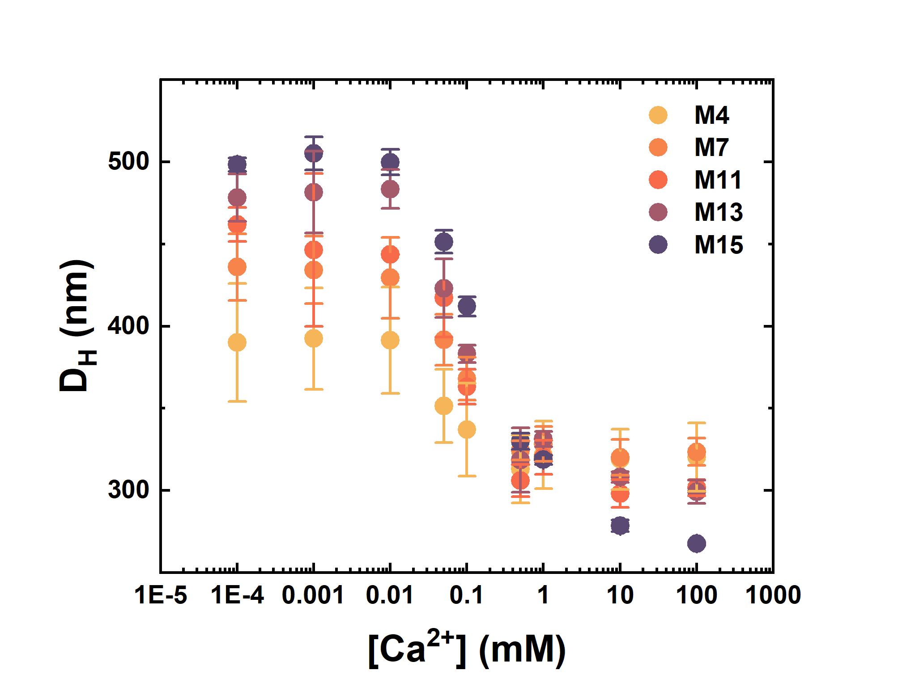
Figure 2. D_{H} of P(VCL-co-IA) (Mn) microgels measured at T= 10°C in water at different Ca²⁺ concentrations.
monovalent ions like Na⁺ are unable to do.³⁸ This additional cross-linking might force the -COO⁻ groups to move closer and change the conformation of the polymer chains within the network, which will cause shrinking of the system. In addition, Ca²⁺ ions screen the negative charges, diminishing the electrostatic repulsion between the chains. The concentration range at which the microgels start to react to the presence of Ca²⁺ ions by collapsing and shrinking in size was determined by DLS at different Ca²⁺ concentrations (Figure 2) which varied within the physiological muscle resting/contraction range.²⁸ For all gels, regardless of their molar composition, the minimum concentration to trigger gel collapse starts at concentrations higher than 0.1 mM and is completed after 1 mM. Remarkably, the gels do not shrink at the cytosolic concentration of a resting muscle cell, and undergo dramatic de-swelling at the physiological concentrations at which muscle contraction occurs. As it is apparent from Figure 2, the microgel systems are fully collapsed at a final concentration of 1 mM, and stay colloidal stable up to a 100 mM concentration of the divalent ions.
The degree of de-swelling is higher with increasing anionic content, as the amount of possible cross-links between the chains increases. Comparing these results with microgels 10 times bigger in size and macroscopic hydrogels, the amount of divalent ions necessary to trigger the gel collapse increases with the size of the gel and with the amount of charged groups.³⁷
The D_{H} of the microgels containing Ca²⁺ is larger than the one measured for the microgels at pH 3, in which the carboxylic groups are fully protonated. By comparing the radius of the protonated gels (Table S4), it is apparent how the presence of Ca²⁺ does not fully screen the negative charges, which are neutralized at low pH. This might suggest that the de-swelling of the system largely depends on the polyelectrolyte effect, rather than to a possible bridging between the -COO⁻ groups and the Ca²⁺ ions.
Quantification of Ca²⁺ uptake. The amount of Ca²⁺ bonded was determined via ion chromatography. The microgels were added to solution of Ca²⁺ in the range of the
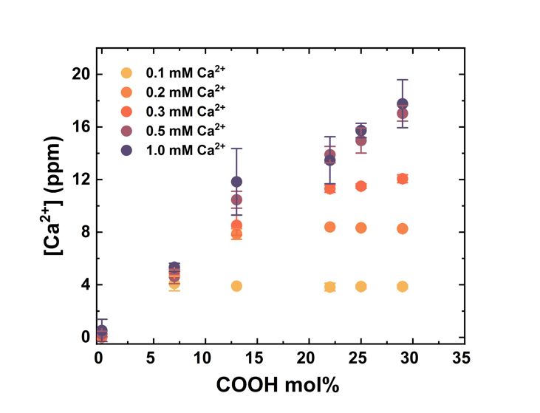
Figure 3. Amount of Ca²⁺ ions bonded by a solution of 0.1 wt% of P(VCL-co-IA) (Mn) samples at room temperature according to the -COO⁻ mol% of each microgel at three different initial Ca²⁺ concentrations (0.1, 1 and 10 mM).
gel collapse region, located between 0.1 and 1 mM, and in which would go from an excess of the IA content to an excess of the Ca²⁺ content (Figure 3). The measurements were performed with microgel with increasing -COOH content, containing up to 29 mol% of -COOH groups, and including a homopolymeric VCL microgel as the reference (N0). The reference microgel showed no bonding capability at all, whereas the microgel containing IA could retain Ca²⁺ ions, quantitatively in respect to the total amount of IA present, if we assume that the ion can bind from 1 to 4 -COO⁻ groups, according to the flexibility of the chains bearing the groups and their freedom to optimize the coordination geometry.⁴¹⁻⁴² The microgels, regardless of their comonomer composition quantitatively take up all the Ca²⁺ ions present in solution, when the Ca²⁺ concentration remains below 0.5 mM. Above that concentration, the gels are saturated by the ions and are unable to bind the all the Ca²⁺ ions present in solution. Above 0.5 mM of Ca²⁺, the amount of Ca²⁺ bonded increases linearly with the IA content. As stated in previous works, Ca²⁺ can coordinate either 2 carboxylic moieties due to simple bridging between

Table 1. Amount of –COOH groups in solution, Ca²⁺ ions bonded at pH= 7 and bonding ratio between the two.
Sample ID | [COOH]  (mM) | [Ca²⁺]  (mM) | [COOH]/[Ca²⁺]
N0 | 0.00 | 0.00 | -
M4 | 0.10 | 0.10 | 1.00
M7 | 0.20 | 0.25 | 0.80
M11 | 0.32 | 0.33 | 0.95
M13 | 0.36 | 0.38 | 0.94
M15 | 0.42 | 0.43 | 0.97
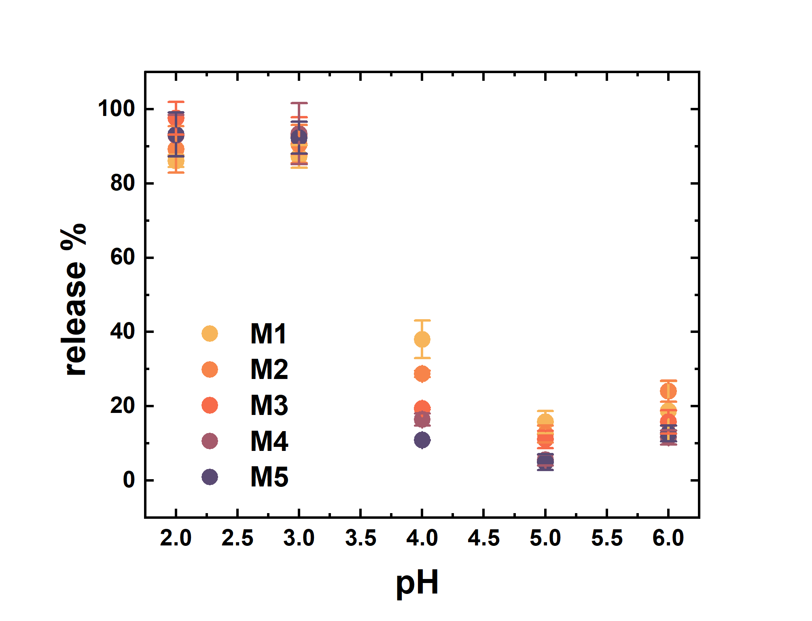
Figure 4. Amount of Ca²⁺ ions released by a 0.1 wt% P(VCL-co-IA) (Mn) microgel samples solution at different pH in pure water at room temperature.
polyelectrolyte chains or 4 -COO⁻ for highly charged gels whose chains are less flexible caused by covalent cross-linking.
Since all studies are on highly charged acrylic acid based gels or microgels, it is difficult to discern if there is an actual contribution by other local groups or not, which would not really be possible for VCL based microgels.
Unexpectedly in this case, the ratio between -COO⁻ moieties and Ca²⁺ ions results to be always slightly lower than 1 (Table 1), outweighing the expected maximum ratio of 2 by almost a factor of 2.
This might be explained by the relative stiffness of the gels that are unable to provide the spatial presence of enough -COOH moieties to bond Ca²⁺. Eichenbaum et al. measured the bonding energy of Ca²⁺ ions with PAA microgels, and by using the Eisenman model for ion bonding selectivity, suggested that the microgels possess “weak field” bonding, in which the binding sites are partially hydrated.³⁶ This suggests that weak binding occurs when the ions are sterically constrained in a highly cross-linked microgel, as for the case described herein, thus the strength with which the gels are able to bond Ca²⁺ ions decreases, and the bridging might not take place. However, due to extremely high affinity of Ca²⁺ towards -COO⁻ groups, the microgels are still capable of taking up the metal ions, yet with a coordination number of 1.⁴¹ Moreover, the incomplete hydrolysis process that the ester groups undergo during the saponification process probably leads to the formation of a pendant side group in the chain carrying both an ester and a carboxy group. These particular chemical disposition is able to coordinate Ca²⁺ where only COO⁻ is necessary. This results in the maximum loading ability that a charged gel can uptake pro functional binding site.
Release and leaching of Ca²⁺ ions. pH dependent DLS showed how the D_{H} of the microgels at pH below the isoelectric point is smaller compared to the ratio of the D_{H} of the Ca²⁺ containing gels. This suggests that the dehydration due to proton bonding is much higher, compared to the affinity to Ca²⁺. In order to determine the amount of Ca²⁺ ions released in function of the pH, ion chromatography was used. Initially, we measured the leaching of the gels, by subjecting to several cycles of washing with pure water at pH 7 (Figure S8). All microgels showed to retain the Ca²⁺ ions within time.
When the gels are subjected to pH 2 and 3, the gels release the up taken ions quantitatively, whereas at higher pH the
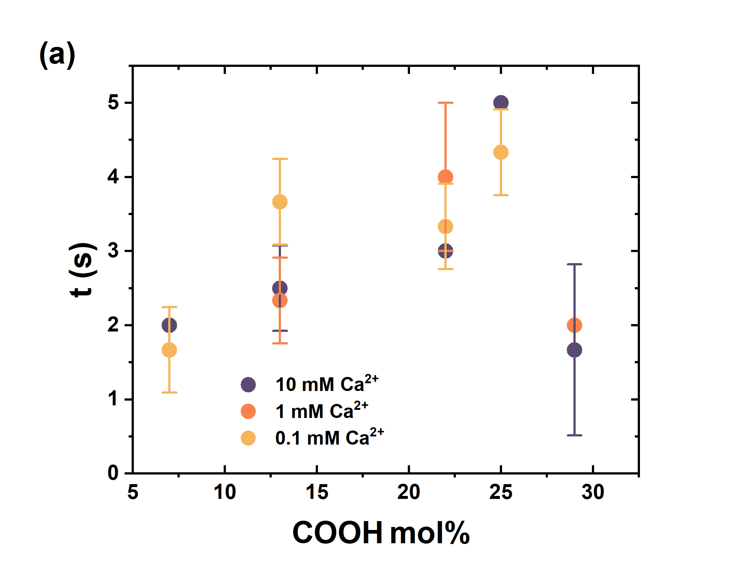
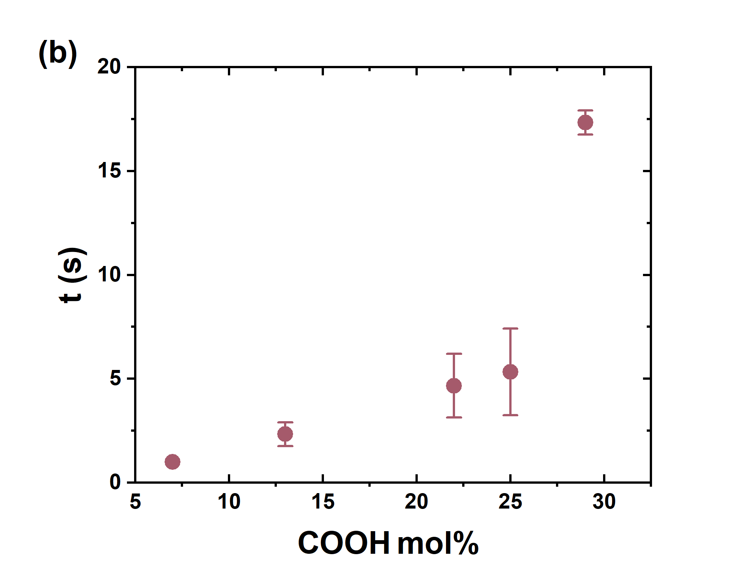
Figure 5. Uptake and release dynamics: (a) bonding and (b) release time of Ca²⁺ of a 0.1 wt% P(VCL-co-IA) (Mn) microgel samples at room temperature.
amount released decreases for pH 4 and they retain almost all Ca²⁺ at pH 5 (Figure 4). However, when comparing the amount release in function of the IA moieties, it is apparent how lower mol% of -COO⁻ release a higher amount of of Ca²⁺.
Uptake dynamics. Studies of uptake and release in microgels are generally performed by using polyelectrolytes or small proteins such as CytC.²³ The release times, regardless of the trigger used such as pH or temperature, span in hours, and quantitative release is normally achieved between 6 and 48 h.²²⁻²³ The quantitative release of Ca²⁺ ions in P(VCL-co-IA) microgels occurs in the range of seconds. Turbidimetry experiments were performed by the help of an automatized injector coupled to a SpectraMax® device. The gels with increasing anionic content were measured at three different Ca²⁺ concentrations, in the gel collapse region, so that the diffusion of ions within the network is made visible by the collapse of the 3D structure. This collapse increases the density of the microgel network, which scatters more light and consequently increases the turbidity of the solution, effect which is not only visible by the naked eye (Figure S9) but is it confirmed by the increase of R_{g}/R_{H} ratio (Table S4). The collapse of the network reaches an equilibrium within a maximum of 5 seconds, in which we assume that all the Ca²⁺ has been bonded. This assumption is based on the fact that the added Ca²⁺ ions are in slight excess compared to the -COO⁻ groups, and that a complete collapse of the gel is observed at ion concentrations located between 1 and 10 mM. Since there is no consistent difference between the collapse times of the gels according to the Ca²⁺ concentrations, we assume that the reaching of the plateau in the absorbance curve corresponds to the full coordination of Ca²⁺ within the gels. The change in absorbance observed in each experiment is not abrupt, and reaches a plateau smoothly, qualitatively showing how the network collapses whilst the ions are diffusing within (Figure S10). Until a mol% of 25% of -COO⁻ the amount of time necessary to collapse the network increases with the -COO⁻ mol%, as expected, and all three Ca²⁺ concentrations are sufficient to monitor the network collapse. Consistently, higher mol% of the charged groups requires a higher time to allocate all Ca²⁺ ions, as the divalent ion has to diffuse within the gels and coordinate them. Comparatively, the amount of Ca²⁺ concentration has no significant impact on the bonding times even though the available Ca²⁺ for bonding is higher around the gel. This suggest that the kinetic is merely diffusion driven.
When it comes to M15 instead, only concentrations of Ca²⁺ 10 and 1 mM are sufficient to trigger the microgel collapse, and no change in absorbance is observed for concentrations of 0.1 mM. This can be explained by a possible different functional group distribution, where the -COO⁻ are rather more concentrated within the core of the microgel, visualized by TEM (Figure S4), and thus the de-swelling of the network triggered by ion bonding is much faster compared to the rest of the microgels.
The release of Ca²⁺ ions was performed by loading the microgels samples and subjecting them to one cycle of washing via centrifugation to ensure that no excess Ca²⁺ ions are left in solution. The turbidimetry measurements were performed by adding an acidic solution of HCl for a final pH of 3. The de-bonding pH was chosen to be 3 as at higher pH the release % is not quantitative and would lead to a lesser degree of absorbance change. When looking at Figure 5b, all microgel systems show fast de-bonding dynamics, ranging from 1 to 5 s, according to the -COO⁻ molar content, with the exception of M15, with a -COO⁻ content of 15 mol%. Microgels M4-M13 de-swell further by the addition of acid with a comparable speed at which they de-swell in the presence of Ca²⁺, whereas M15 requires almost 20 s to de-swell, indicating a different internal structure compared to the rest of the gels.

CONCLUSION
In this study, we present the quantification of divalent ion uptake and release of thermoresponsive poly(N-vinylcaprolactam-co-dimethylitaconate) (P(VCL-co-IADME)) anionic microgels with the dynamics of the Ca²⁺ ion bonding and de-bonding. In summary, we introduce the concept divalent metal ions not only can serve as a trigger to change the size and conformation of a gel, but can also be loaded within the microgels and instantly be released upon a pH trigger. The microgels are designed to retain the ionic cargo overtime unless the pH is varied to protonate the Ca²⁺ coordination sites. Neutral gels were first synthesized and fully characterized for their chemical and physical structure and used as reference system towards the ionic gels. Each neutral gel was subsequently hydrolyzed to form anionic gels with different degrees of anionic content whilst retaining some hydrophobic moieties to ensure stability against spontaneous aggregation. Each anionic microgel was also fully characterized for its composition, structure and responsiveness towards temperature, pH and divalent ion concentration. The swelling and collapse of the microgels in the presence of divalent ions, such as Ca²⁺ was first investigated, to optimize the conditions at which uptake and release studies were performed. Remarkably, the loading conditions were within the cytosolic muscle contraction concentration, and the microgels resulted stable even at higher concentrations up to a -COO⁻ mol% of 29%. The microgels were then loaded with Ca²⁺ ions at ambient conditions and the amount of coordinated Ca²⁺ was determined. Due to the special chemical composition distribution in these gels and their relative low amount of charged moieties compared to pure PAA microgels, the resulting coordination number of Ca²⁺ was equal to 1 instead of the expected 2 or 4. The release experiments were conducted at pH 2, 3, 4 and 5. Quantitative release was obtained at pH 2 and 3, whereas only partial release according to the amount of –COO⁻ moieties and minimum release was observed for pH 4 and 5. These results showing how the release is influenced not only the amount of protons present in solution, but also by the amount of total ionizable groups, thus the release can be fine-tuned for the desired applications. Finally, the dynamics of bonding and de-bonding were investigated, revealing fast dynamics of uptake and release, which opens the way for those gels for sensing applications, desalination membranes and application in synthetic biological systems. The same method proposed within this work can be further widened to more divalent cations with biological relevant activity, such as Mg²⁺ and Cu²⁺, and trivalent ions such as Fe³⁺.
ASSOCIATED CONTENT
Supporting Information. Synthetic procedure tables, microgel chemical characterization: NMR, IR, potentiomentric titration, DLS, SLS, Zeta potential, TEM, Ion chromatography, Absorbance spectra. This material is available free of charge via the Internet at http://pubs.acs.org.
AUTHOR INFORMATION
Corresponding Author
* Tel +41 (0)61 207 38 02, e-mail wolfgang.meier@unibas.ch (W.M.)
Notes
The authors declare no competing financial interest.

ACKNOWLEDGMENT
We gratefully acknowledge financial support from the Swiss National Science Foundation, NCCR-MSE and University of Basel. The authors are thankful to Ms. Judith Kobler Waldis (University of Basel) for the ion chromatography measurements.
REFERENCES
1. Plamper, F. A.; Richtering, W., Functional microgels and microgel systems. Accounts of chemical research 2017, 50 (2), 131-140.
2. Schmid, A. J.; Dubbert, J.; Rudov, A. A.; Pedersen, J. S.; Lindner, P.; Karg, M.; Potemkin, I. I.; Richtering, W., Multi-Shell Hollow Nanogels with Responsive Shell Permeability. Scientific Reports 2016, 6, 22736.
3. Saunders, B. R.; Crowther, H. M.; Vincent, B., Poly [(methyl methacrylate)-co-(methacrylic acid)] microgel particles: swelling control using pH, cononsolvency, and osmotic deswelling. Macromolecules 1997, 30 (3), 482-487.
4. Sorrell, C. D.; Carter, M. C. D.; Serpe, M. J., Color Tunable Poly (N-Isopropylacrylamide)-co-Acrylic Acid Microgel–Au Hybrid Assemblies. Advanced Functional Materials 2011, 21 (3), 425-433.
5. Tan, B. H.; Ravi, P.; Tam, K. C., Synthesis and Characterization of Novel pH-Responsive Polyampholyte Microgels. Macromolecular Rapid Communications 2006, 27 (7), 522-528.
6. Go, D.; Rommel, D.; Liao, Y.; Haraszti, T.; Sprakel, J.; Kuehne, A. J., Dissipative disassembly of colloidal microgel crystals driven by a coupled cyclic reaction network. Soft matter 2018, 14 (6), 910-915.
7. Zhu, L.; Zhao, C.; Zhang, J.; Gong, D., Photocontrollable volume phase transition of an azobenzene functionalized microgel and its supramolecular complex. RSC Advances 2015, 5 (102), 84263-84268.
8. Snowden, M. J.; Chowdhry, B. Z.; Vincent, B.; Morris, G. E., Colloidal copolymer microgels of N-isopropylacrylamide and acrylic acid: pH, ionic strength and temperature effects. Journal of the Chemical Society, Faraday Transactions 1996, 92 (24), 5013-5016.
9. Lietor-Santos, J.-J.; Sierra-Martin, B.; Vavrin, R.; Hu, Z.; Gasser, U.; Fernandez-Nieves, A., Deswelling microgel particles using hydrostatic pressure. Macromolecules 2009, 42 (16), 6225-6230.
10. Mergel, O.; Schneider, S.; Tiwari, R.; Kühn, P. T.; Keskin, D.; Stuart, M. C.; Schöttner, S.; de Kanter, M.; Noyong, M.; Caumanns, T., Cargo shuttling by electrochemical switching of core–shell microgels obtained by a facile one-shot polymerization. Chemical science 2019, 10 (6), 1844-1856.
11. Scherzinger, C.; Lindner, P.; Keerl, M.; Richtering, W., Cononsolvency of Poly (N, N-diethylacrylamide)(PDEAAM) and Poly (N-isopropylacrylamide)(PNIPAM) Based Microgels in Water/Methanol Mixtures: Copolymer vs Core− Shell Microgel. Macromolecules 2010, 43 (16), 6829-6833.
12. Maccarrone, S.; Scherzinger, C.; Holderer, O.; Lindner, P.; Sharp, M.; Richtering, W.; Richter, D., Cononsolvency effects on the structure and dynamics of microgels. Macromolecules 2014, 47 (17), 5982-5988.
13. Lai, W.-F.; Susha, A. S.; Rogach, A. L., Multicompartment microgel beads for co-delivery of multiple drugs at individual release rates. ACS applied materials & interfaces 2015, 8 (1), 871-880.
14. Das, M.; Mardyani, S.; Chan, W. C. W.; Kumacheva, E., Biofunctionalized pH-Responsive Microgels for Cancer Cell Targeting: Rational Design. Advanced Materials 2006, 18 (1), 80-83.
15. Zhang, Q. M.; Berg, D.; Mugo, S. M.; Serpe, M. J., Lipase-modified pH-responsive microgel-based optical device for triglyceride sensing. Chemical Communications 2015, 51 (47), 9726-9728.
16. Gao, Y.; Li, X.; Serpe, M. J., Stimuli-responsive microgel-based etalons for optical sensing. RSC Advances 2015, 5 (55), 44074-44087.
17. Borrmann, R.; Palchyk, V.; Pich, A.; Rueping, M., Reversible Switching and Recycling of Adaptable Organic Microgel Catalysts (Microgelzymes) for Asymmetric Organocatalytic Desymmetrization. ACS Catalysis 2018, 8 (9), 7991-7996.
18. Seto, H.; Imai, K.; Hoshino, Y.; Miura, Y., Polymer microgel particles as basic catalysts for Knoevenagel condensation in water. Polymer Journal 2016, 48 (8), 897.
19. Sivakumaran, D.; Maitland, D.; Hoare, T., Injectable Microgel-Hydrogel Composites for Prolonged Small-Molecule Drug Delivery. Biomacromolecules 2011, 12 (11), 4112-4120.
20. Bradley, M.; Vincent, B., Poly(vinylpyridine) Core/Poly(N-isopropylacrylamide) Shell Microgel Particles: Their Characterization and the Uptake and Release of an Anionic Surfactant. Langmuir 2008, 24 (6), 2421-2425.
21. Gao, Y.; Zago, G. P.; Jia, Z.; Serpe, M. J., Controlled and Triggered Small Molecule Release from a Confined Polymer Film. ACS Applied Materials & Interfaces 2013, 5 (19), 9803-9808.
22. Gelissen, A. P.; Scotti, A.; Turnhoff, S. K.; Janssen, C.; Radulescu, A.; Pich, A.; Rudov, A. A.; Potemkin, I. I.; Richtering, W., An anionic shell shields a cationic core allowing for uptake and release of polyelectrolytes within core–shell responsive microgels. Soft matter 2018, 14 (21), 4287-4299.
23. Xu, W.; Rudov, A. A.; Schroeder, R.; Portnov, I. V.; Richtering, W.; Potemkin, I. I.; Pich, A., Distribution of Ionizable Groups in Polyampholyte Microgels Controls Interactions with Captured Proteins: From Blockade and “Levitation” to Accelerated Release. Biomacromolecules 2019, 20 (4), 1578-1591.
24. Karg, M.; Pich, A.; Hellweg, T.; Hoare, T.; Lyon, L. A.; Crassous, J. J.; Suzuki, D.; Gumerov, R. A.; Schneider, S.; Potemkin, I. I.; Richtering, W., Nanogels and Microgels: From Model Colloids to Applications, Recent Developments, and Future Trends. Langmuir 2019, 35 (19), 6231-6255.
25. Schroeder, R.; Rudov, A. A.; Lyon, L. A.; Richtering, W.; Pich, A.; Potemkin, I. I., Electrostatic Interactions and Osmotic Pressure of Counterions Control the pH-Dependent Swelling and Collapse of Polyampholyte Microgels with Random Distribution of Ionizable Groups. Macromolecules 2015, 48 (16), 5914-5927.
26. Schachschal, S.; Balaceanu, A.; Melian, C.; Demco, D. E.; Eckert, T.; Richtering, W.; Pich, A., Polyampholyte microgels with anionic core and cationic shell. Macromolecules 2010, 43 (9), 4331-4339.
27. Erbil, C.; Yıldız, Y.; Uyanık, N., Effects of synthesis‐solvent composition and initiator concentration on the swelling behaviour of poly (N‐isopropylacrylamide) P (NIPAAM), poly (NIPAAM‐co‐dimethyl itaconate), and poly (NIPAAM‐co itaconic acid) gels. Polymer international 2000, 49 (7), 795-800.
28. Ebashi, S.; Endo, M., Calcium and muscle contraction. Progress in biophysics and molecular biology 1968, 18, 123-183.
29. Hindmarsh, J.; Rose, R., A model of the nerve impulse using two first-order differential equations. Nature 1982, 296 (5853), 162.
30. Shuttleworth, T. J., Intracellular Ca2+ signalling in secretory cells. Journal of Experimental Biology 1997, 200 (2), 303-314.
31. Rodríguez, A.; Webster, P.; Ortego, J.; Andrews, N. W., Lysosomes behave as Ca2+-regulated exocytic vesicles in fibroblasts and epithelial cells. The Journal of cell biology 1997, 137 (1), 93-104.
32. Kuo, I. Y.; Ehrlich, B. E., Signaling in muscle contraction. Cold Spring Harb Perspect Biol 2015, 7 (2), a006023-a006023.
33. Onaca, O.; Enea, R.; Hughes, D. W.; Meier, W., Stimuli‐responsive polymersomes as nanocarriers for drug and gene delivery. Macromolecular bioscience 2009, 9 (2), 129-139.
34. Das, M.; Mardyani, S.; Chan, W. C.; Kumacheva, E., Biofunctionalized pH‐responsive microgels for cancer cell targeting: rational design. Advanced Materials 2006, 18 (1), 80-83.
35. Dalmont, H.; Pinprayoon, O.; Saunders, B. R., Study of pH-responsive microgels containing methacrylic acid: effects of particle composition and added calcium. Langmuir 2008, 24 (6), 2834-2840.
36. Eichenbaum, G. M.; Kiser, P. F.; Shah, D.; Meuer, W. P.; Needham, D.; Simon, S. A., Alkali earth metal binding properties of ionic microgels. Macromolecules 2000, 33 (11), 4087-4093.
37. Peng, S.; Wu, C., Ca2+-induced Thermoreversible and Controllable Complexation of Poly(N-vinylcaprolactam-co-sodium acrylate) Microgels in Water. The Journal of Physical Chemistry B 2001, 105 (12), 2331-2335.
38. Peng, S.; Wu, C., Comparison of the Ca2+/COO- Complexation Induced Controllable Aggregation of P(VCL-co-NaA) Spherical Microgels and Linear Chains. Macromolecules 2001, 34 (19), 6795-6801.
39. Senff, H.; Richtering, W., Influence of cross-link density on rheological properties of temperature-sensitive microgel suspensions. Colloid and Polymer Science 2000, 278 (9), 830-840.
40. Gadam, S. D.; Jayaraman, G.; Cramer, S. M., Characterization of non-linear adsorption properties of dextran-based polyelectrolyte displacers in ion-exchange systems. Journal of Chromatography A 1993, 630 (1-2), 37-52.
41. Lopez, C. G.; Richtering, W., Influence of divalent counterions on the solution rheology and supramolecular aggregation of carboxymethyl cellulose. Cellulose 2019, 26 (3), 1517-1534.
42. Lindsay, W.; Norvell, W., Equilibrium Relationships of Zn2+, Fe3+, Ca2+, and H+ with EDTA and DTPA in Soils 1. Soil Science Society of America Journal 1969, 33 (1), 62-68.

Table of Contents artwork
