Supporting Information

Investigation of horseradish peroxidase kinetics in an “organelle like” environment

Patric Baumann, Mariana Spulber, Ozana Fischer, Anja Car, Wolfgang Meier



**Figure S1.** EPR spectra of 5 DSA in Ficoll aqueous solution experimental (1) and simulated (2), and in Ficoll loaded polymeric vesicles, experimental (3), and simulated (4) obtained from the sum of the isotropic component (5) and anisotropic component (6).

HRP labelling

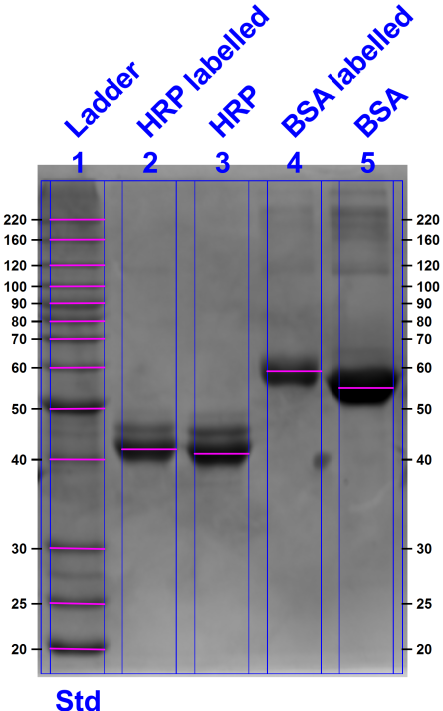

**Figure S2.** SDS Page of labelled HRP and BSA. In both cases the labelling caused a shift towards higher molecular weight. For HRP the shift is smaller due to the smaller degree of labelling.

Fluorescence correlation spectroscopy **(**FCS)



**Figure S3.** Normalized autocorrelation curves for nanoreactors loaded with labelled HRP, labelled HRP and free Oregon Green and the corresponding fitting curves.

Table S1. Data obtained from FCS measurement, where values marked with * are fixed, so that only one component could be determined per measurement.

|  |  |  |  |  |  |  |  |  |
| --- | --- | --- | --- | --- | --- | --- | --- | --- |
|  | Count rate [kHz] | CPM [kHz] | C1 [µs] | C1 % | C2 [µs] | C2 % | C3 [µs] | C3 % |
| Oregon green | 77 | 13.2 | 48.8 | 100 |  |  |  |  |
| Oregon Green in PEG | 77 | 15.2 | 53.2 | 100 |  |  |  |  |
| Oregon Green in Ficoll | 76 | 14.7 | 53.8 | 100 |  |  |  |  |
| HRP labelled | 22 | 10.7 | *48.8 | 70 | 265 | 30 |  |  |
| ABATH encapsulating labelled HRP | 18 | 36.5 | *48.8 | ≈0 | *265 | ≈0 | 2555 | 100 |
| ABATH Ficoll encapsulating labelled HRP | 26 | 39.0 | *48.8 | ≈0 | *265 | ≈0 | 2607 | 100 |
| ABATH PEG encapsulating labelled HRP | 8 | 36.5 | *48.8 | ≈0 | *265 | ≈0 | 2512 | 100 |

Number of HRP per vesicle

$\frac{{CPM}_{free dye}}{{DOL×CPM}_{nanoreactor}}=\#{HRP}_{per nanoreactor}$

Where the CPM (counts per molecules) for Oregon Green in absence and presence of crowding agent was taken and a degree of labelling (DOL) of 0.7.

# HRP per ABA nanoreactor: 3.95

# HRP per ABA nanoreactor co-encapsulating Ficoll: 3.79

# HRP per ABA nanoreactor co-encapsulating PEG: 3.43

EE% HRP

$$EE\%=\frac{100*\#HRP per NR}{C_{0}* N_{A}*V_{NR}}$$

where C0 is the initial concentration, NA Avogadro Number and VNR the volume of the nanoreactor.

EE% ABA nanoreactors: 11.2 %

EE% ABA nanoreactors co-encapsulating Ficoll: 10.7%

EE% ABA nanoreactors co-encapsulating PEG: 9.7%

Molecules per nanoreactor

$${\# {molecules}_{per nanoreactor} =C}_{NR}*N_{A}*V_{NR}$$

where C is the concentration inside the nanoreactor, NA Avogadro Number and VNR the volume of the nanoreactor.

**Figure S4.** Intensity-based DLS distribution curves of empty polymersomes and polymersomes in the presence of crowding agent.